Chapter 20
Social Insurance
 Social Insurance Policies and Social Programs
 Historical Roots of Social Insurance
 Affordable Care Act (ACA) of 2010
 Medicare and Medicaid in the United States
 Public Insurance and Health
 The Effects of Medicare and Medicaid
 Conclusions
Throughout this book, we have emphasized the role that markets can play in providing health care. We have also generally used economic efficiency, provided in theory by perfectly competitive markets, as a standard against which to judge the costs and benefits of policies. In this chapter, we address instead the issues that arise when a society considers providing for health care by offering health insurance, to some significant degree, at the public’s expense. Such insurance programs provided through taxes or regulations are called social insurance programs. Having provided an overview of the rationales for social insurance in health care, we now turn to an examination of social insurance. We begin by considering the history of health care social insurance throughout the world, with emphasis on the United States. We then examine Medicare, Medicaid, and CHIP, and their effects, and we close with prospects and issues for the future.
Social Insurance Policies and Social Programs
Social insurance programs can be broken down into five categories. While not mutually exclusive, programs of the following five types exist in the United States and in other countries.
1. Poverty: Poor people lack purchasing power to buy the goods considered necessary to provide the minimal standards of decent life. Programs directed toward persons experiencing poverty involve either cash (more recently, debit cards) or goods “in kind,” such as rent vouchers or food stamps.
2. Old Age: The elderly have attained a certain age, generally coinciding with retirement from active employment. Programs include income maintenance, such as Social Security, as well as services and considerations (such as assisted housing, Meals on Wheels, or transportation) that may address their generally decreased mobility.
3. Disability: The disabled have either temporary or permanent inability to work because of illness or work-related injuries. Programs generally provide cash benefits. Disability programs were among the earliest social insurance programs available.
4. Health: Programs cover illness or well-care financing and/or provide facilities for various groups. In the United States, most programs have targeted children, the elderly, and/or the poor, with the government financing the individual’s health care either entirely or in part. In other countries, governments have more direct involvement in the financing and delivery of health services for larger segments (or all) of the population.
5. Unemployment: The unemployed receive assistance due to a temporary loss of work. While unemployment-related programs generally provide short-term cash benefits, in many countries, longer-term unemployment may lead into poverty-related welfare programs.
Analysts find several other definitions useful in considering social insurance programs. Some programs, termed entitlements, are available to all who qualify. Food assistance in the form of stamps or debit cards, for example, is available in the United States to all households whose incomes fall below specified levels, related in part to income, family size, and geographic location. Medicaid, or financed health care for the poor (discussed later in this chapter), is also an entitlement program for all who meet particular qualifications. In contrast, US housing programs are not entitlements. Only limited numbers of subsidized units (on the supply side) or vouchers (on the demand side) are available.
Many programs are means-tested in that they are available only to individuals or households who meet certain income criteria. Households that receive aid for poverty-related problems may lose some or all of the aid as their incomes increase. Such reductions in aid may have the unintended effects of discouraging efforts by low-income households to find jobs. For example, formulas that reduce poverty-related aid by $1 for each $1 earned on the job constitute taxes on job earnings at rates approaching 100 percent.
Finally, aid may take various forms. Programs often tie aid to the purchase of certain items, such as food or housing. This procedure ensures that the people use the aid to buy items that the legislators have deemed important. Under certain circumstances, however, it may be more economically efficient to provide a cash subsidy rather than one in kind.
Answer the question, “Which would you prefer, $100 in cash or $100 worth of physician care?” Most would answer “$100 in cash!” Alternatively, “Which would you prefer, $100 in cash or x dollars [less than $100] that you can spend any way you want?” If x is less than $100 (say $70) it shows that the recipient values the aid at less than $100, and society could help him or her out for less than $100. However, legislators and the voting public often seem to prefer subsidies in kind rather than in cash so that they can monitor or control the purchases of those receiving the subsidies. Food subsidy rules limit the purchase of “non-food” items such as cigarettes or liquor, deemed undesirable by many, but they also prevent the purchase of laundry detergent or toilet tissue, which most would view to be desirable.
Program Features
We discuss certain common features to characterize health-related social insurance programs in the United States. The first three relate to receipt of care:
1. Contributions—taxes, deductibles, and coinsurance
2. Benefits—how much, who is included, and what types of treatment are included
3. Length of coverage.
The latter two describe the provision of care, as well as the political problems involved in initiating plans:
4. Means of reimbursement to providers
5. Methods of determining payment levels to providers.
Although supported by government, most social insurance plans also impose costs on their recipients. Many are funded by tax collections, and care recipients are often taxpayers. In some cases, the taxes in question may be regressive. By definition, a regressive tax is one for which lower income people pay higher fractions of their incomes to the tax than do richer people. In contrast, a progressive tax is one in which lower-income people pay lower fractions of their incomes to the tax than do richer people.
In the United States tax payments into the Social Security program have always been somewhat regressive, a necessary condition for its 1935 passage. From the beginning, the tax has been a constant percentage of wage income, up to a ceiling at which the marginal tax rate becomes zero. This means that on average, people in higher-income groups pay a smaller proportion of their income in payroll taxes. Both workers and their employers pay 6.20 percent, and the maximum wage base was $118,500 in 2016. Since workers with wages of $150,000 pay the same amount, 6.20 percent of $118,500, or $7,347, the tax percentage for the more affluent is 4.90 percent, rather than 6.20 percent below the $118,500 cap. The effective tax rate obviously falls as wage income rises above $118,500. In contrast, the Medicare tax rate is now 1.45 percent of all wage income, a constant percentage.
To determine whether a social insurance program is redistributive—whether it in net causes a transfer of money from the rich to the poor—one must consider not just the tax payments made but also the benefits received. For example, data for the Social Security program in the United States have tended to show that Social Security is redistributive—that the poorer people tend to gain more in net than do the rich. However, an interesting line of research, as noted in Box 20-1 indicates that differential longevity among income groups may be undoing this result.

Box 20 – 1

Increased Longevity Favors the Rich in Social Security.
Social Security was designed to ensure that no workers go penniless in old age, and to redistribute resources from wealthier to poorer Americans. The Social Security website describes the original benefit structure, set to go into effect in 1942.
The original Act provided for monthly retirement benefits, payable to persons 65 and older who were no longer working. The benefit formula was based on cumulative wages (earned since 1937) in covered employment (initially covering only about half the jobs in the country, which were in commerce or industry). Specifically, monthly benefits equaled 1/2 of 1 percent of the first $3,000 of cumulative wages, plus 1/12 of 1 percent of the next $42,000, plus 1/24 of 1 percent of the next $84,000. So, for example, someone who retired in January 1942 (when benefits were scheduled to begin) after earning a total of $6,000 during the 5-year period from 1937 to 1941 would receive a benefit equal to $17.50 a month (The original Act promised benefits that ranged from $10 to $85 per month.). This can be thought of, loosely speaking, as a typical benefit because the average worker at the time earned about $100 a month (which totals $6,000 after 5 years). Thus, although the Social Security Act was enacted in the middle of the Great Depression, it originally envisioned relatively small benefits that were not payable for several years.
This preceding benefit formula never became operational because of the amendments of 1939. Nevertheless, it does embody two important principles that still guide benefit payments today: [1.] benefits depend on work in covered employment, and [2.] benefits replace a higher proportion of earnings for low earners.
While the formula has changed over the years, it has maintained this goal. However, differential longevity has skewed progress toward the goal, as noted by New York Times writer Neil Irwin.
Citing a study from the Brookings Institute, Irwin notes that life expectancy for the bottom 10 percent of male wage earners turning 66 in 2016 has risen 0.7 years compared with what was expected for their low-income counterparts 30 years ago. In contrast, for the top 10 percent of male wage earners, life span rose 8.1 years in the same period. This implies 7.4 years of additional Social Security benefits for the affluent.
Because recent net outflows from Social Security have caused some to fear that the funds will run out of money, many fiscal centrists and conservatives have proposed to increase the full retirement age. (As of 2016, it is currently 66 and on track to rise to 67, though retirees can take a reduced level of benefits at age 62 and higher levels up to age 70.)
However, notes Irwin, the life span differential suggests that such a change would fall heavily on the backs of the poor because increasing the retirement age would bring them even closer to their (lower) expected age of death.
http://www.nytimes.com/2016/04/24/upshot/rich-people-are-living-longer-thats-tilting-social-security-in-their-favor.html?_r=0, People are Living Longer: That’s Tilting Social Security in Their Favor, accessed April 28, 2016
http://www.brookings.edu/~/media/Research/Files/Reports/2016/01/life-expectancy-gaps-promise-social-security/BosworthBurtlessZhang_retirementinequalitylongevity_012815.pdf, Later Retirement, Inequality in Old Age, and the Growing Gap in Longevity between Rich and Poor, accessed April 28, 2016
https://www.ssa.gov/policy/docs/v66n1p1.html#mt5, Social Security: A Program and Policy History, accessed April 28, 2016

In addition to tax payments, eligible recipients must often pay deductibles or coinsurance. Analysts also consider time costs for paperwork or waiting time for appointments or treatment.
Benefit levels and length of coverage are similar to the workings of private insurance. Given the equity considerations of social insurance, political considerations may affect both. Determining who and which treatments are covered is also important. Coverage of individuals may involve children and spouses. Coverage of treatments may mandate coverage of certain diseases (i.e., end-stage kidney disease) and exclude others (i.e., optometric or chiropractic services).
Health-related social insurance also has supply-related characteristics. In some programs patients may pay directly for expenses and then be reimbursed. In others, government may pay providers directly. In some countries, all physicians who participate in the national health care program are government employees.
Historical Roots of Social Insurance
European Beginnings
Prior to the passage of the Affordable Care Act of 2010 (ACA), the United States was the only industrialized country lacking a comprehensive health-related social insurance system. Historians date the pioneering legislation for a system of compulsory national health insurance to Germany in 1883. National health insurance spread to other European countries at the end of the nineteenth and the early part of the twentieth centuries.
The German system and the other European systems extended already-existing voluntary associations, often guild or mutual aid groups whose benefits to members included the pooling of insurable risks. The German laws of 1883 set up a highly decentralized program that covered workers in mining, transportation, construction, manufacturing, mechanical trades, and establishments using power machinery. Austria (1888), Hungary (1891), Sweden (1891), Denmark (1892), and Belgium (1894) followed. With Spain’s adoption of a plan in 1929, nearly every European country had enacted health insurance laws. Some were compulsory, as in Germany, but other countries such as Belgium, Denmark, Sweden, and Switzerland, provided government subsidies to voluntary mutual insurance funds.
The United Kingdom established its first social health insurance system in 1911. That legislation helped prepare for the establishment of the British National Health Service in 1946, the most prominent example in the Western countries. Government provision was also common in Eastern European countries and the former Soviet Union, which began its system in 1926.
Early Experience in the United States
The United States came late to social insurance and to governmental health insurance in particular. In the late nineteenth and early twentieth centuries, Americans, like the Europeans, established voluntary group purchasing arrangements, and mutual benefit associations. However, in the United States, government did not take up the funding of these voluntary societies, compared with Germany in 1883 and the United Kingdom in 1911.
The major advance in US social insurance occurred with the establishment of the Social Security program in 1935. Despite the social insurance thrust of the program and the reform-minded support for it, the legislation made concessions to political opposition to the New Deal, including the omission of governmental health insurance. The omission of health insurance from the Social Security Act was by no means the act’s only conservative feature. It relied on a regressive tax and provided no coverage to some of the very poor, such as farm laborers and domestics.
Proponents of compulsory health insurance plans were no more successful through the 1940s and 1950s. President Harry Truman proposed a single health insurance system that would include even those workers not covered by Social Security. During the public debate, opponents of compulsory health insurance called it “socialized medicine,” a term that greatly weakened its support in the political climate of the Cold War. Truman won the 1948 election, but his success did not translate into a health insurance program.
The Establishment of Medicare and Medicaid
The social insurance debate in the United States has often ranged between those who believe in voluntarism and voluntary insurance, as won in negotiations between self-reliant industries and unions, and those who believe that only a compulsory insurance program would provide the insurance that was necessary for the larger population. The major social insurance programs for health care in the United States, Medicare and Medicaid, passed in 1965. President Lyndon Johnson had supported health care for the aged, and by winning a landslide victory in the 1964 election, he was able to push for these programs.
While Medicare and Medicaid have achieved widespread political support since the 1960s, fundamental concerns stem from their rising costs. To the present day, with growing elderly and poor populations as well as continual health care cost inflation, many observers perceived the total costs of the social insurance as having grown out of control. Politicians have sought to ensure that Medicare would have a sufficient trust fund to meet future needs, while balancing these needs against the increased taxes and payments for services necessary to support them.
The wider issue of social health insurance for the population as a whole had not yet been decided. The experience of the 1993 and 1994 Clinton health plan was an example. Bill Clinton won the 1992 election with a campaign promising health system reform. There had been signs of growing interest among the electorate in health system reform including social health insurance. The Clinton plan emerged during January through May 1993 through a large task force of government officials, health policy experts, congressional staffers, and others. With many perceiving the task force to be secretive and unresponsive to the public, plan supporters were unable to develop a coalition of interests around clearly defined features of reform, while insurers lobbied and advertised against the plan. During 1994, the Clinton administration re-worked the plan to respond to critics but the public came to believe that it would entail considerable government bureaucracy, cost, and inefficiency. The plan was scrapped without a Congressional vote in late summer 1994. The opposition Republican Party gained control of both houses of Congress in that November’s elections (for the first time in 40 years) ending that episode of reform.
The Affordable Care Act (ACa) of 2010
The 2008 U.S. Presidential election set the stage for potential health policy reform. With recurring worries about rising health care costs, and with numbers of the uninsured increasing due to the “Great Recession,” the major Democratic candidates (Barack Obama and Hilary Clinton), and Republican candidate John McCain all spoke to the need for health care reform. Obama’s election and increased Democratic majorities in the Congress led to passage in March 2010. While the details and the legislation will get more detailed treatment in Chapter 23, the Act as passed does the following:
• It requires most U.S. citizens and legal residents to have health insurance, the so-called individual mandate.
• It assesses a fee against employers with 50 or more full-time employees that do not offer coverage as a premium tax credit; this fee is $2,000 per full-time employee, excluding the first 30 employees from the assessment. It requires employers with more than 200 employees to enroll employees automatically into health insurance plans offered by the employer.
• It subsidizes state expansion of Medicaid to all non-Medicare eligible individuals under age 65 (children, pregnant women, parents, and adults without dependent children) with incomes up to 133% of the Federal Poverty Level (FPL) with a benchmark benefit package.
• It creates state-based Health Benefit Exchanges and Small Business Health Options Program (SHOP) Exchanges, administered by a governmental agency or non-profit organization, through which individuals and small businesses with up to 100 employees can purchase qualified coverage. States that choose not to create their own exchanges can use federally-created exchanges.
The Act includes many other important provisions such as the imposition of a “Cadillac” tax on high cost employer-provided policies, and the elimination of underwriting policies that enable insurers to deny individuals insurance or charge them higher premiums based on pre-existing conditions. Some provisions of the Act took effect on enactment of the legislation; other provisions were to be phased in through 2018.
Political opposition arose immediately, focusing on the individual mandate, as well as concerns about the projected costs. However, implementation has proceeded (bolstered by favorable Supreme Court decisions in 2012 and 2014), and by 2020 the ACA is expected to insure at least 32 million of the 50 million currently uninsured (non-citizens and illegal immigrants will not be allowed to participate). This represents the biggest expansion of U.S. health policy since the passage of Medicare and Medicaid in 1965. We discuss the ACA in much more detail in Chapter 22.
Medicare and Medicaid in The United States
While ACA will change large parts of the federal health care policy presence, Medicare and Medicaid continue to form the foundation. Medicare is a national program that primarily provides compulsory hospital insurance to the elderly plus optional medical coverage to which nearly all elderly subscribe. In contrast, Medicaid is operated by the states with matching federal dollars. It primarily provides health care coverage to people who are poor.
Medicare
Medicare traditionally consisted of Hospital Insurance (HI), also known as Part A, and Supplementary Medical Insurance (SMI), also known as Part B. A third part of Medicare, sometimes known as Part C, the Medicare Advantage program, was established as the Medicare + Choice program by the Balanced Budget Act (BBA) of 1997 (Public Law 105-33) and subsequently renamed and modified by the Medicare Prescription Drug, Improvement, and Modernization Act (MMA) of 2003 (Public Law 108-173). The Medicare Advantage program expanded beneficiaries’ options for participation in private-sector health care plans. In 2006 the MMA established a new prescription drug benefit, also known as Part D.
When Medicare began on July 1, 1966, approximately 19 million people enrolled. By 2014, nearly 55 million people were enrolled in one or both of Parts A and B of the Medicare program, and almost 12 million of them had chosen to participate in a Medicare Advantage plan. Figure 20-1 displays the growth of the Medicare program since its inception.
(Figure 20-1 Medicare Enrollment by Year, 1966–2014)
Medicare Coverage Medicare Part A generally goes automatically to persons age 65 and over who are entitled to Social Security or Railroad Retirement Board benefits. Similarly, those who have received such benefits based on a physical disability for at least 24 months also
are entitled to Part A benefits.
Part A coverage includes:
• Inpatient hospital care coverage, requiring an initial deductible payment, plus copayments for all hospital days following day 60 within a benefit period
• Skilled nursing facility (SNF) care – generally covered by Part A only if within 30 days of a hospitalization of three or more days and certified as medically necessary
• Home Health Agency (HHA) care, including care provided by a home health aide
• Hospice, provided to those terminally ill persons with a life expectancy of six months or less and who elect to forgo standard Medicare benefits, receiving only hospice care
SMI benefits (Parts B and D) are available to almost all resident citizens age 65 and over. Part B coverage is optional and requires payment of a monthly premium. Part B covers
• Physicians’ and surgeons’ services (in both hospital and nonhospital settings)
• Some covered services furnished by chiropractors, podiatrists, dentists, and optometrists
• Services in an emergency room or outpatient clinic, including same-day surgery, and ambulance services
Part B also covers other services including clinical laboratory tests, X-rays, diagnostic tests, ambulance services, and blood that are not supplied by Part A. Almost all persons entitled to Part A also choose to enroll in Part B.
Medicare does not cover everything. Noncovered services include long-term nursing care, custodial care, and certain other health care needs, such as dentures and dental care, eyeglasses, and hearing aids. These services are not a part of the Medicare program unless they are a part of a private health plan under the Medicare Advantage program.
Part C – Medicare Managed Care
Medicare Advantage provides the option for beneficiaries to receive their Part A and Part B Medicare benefits through private health plans, mainly health maintenance organizations (HMOs), as an alternative to the federally administered traditional Medicare program. Medicare Advantage must pay for everything that Part A and Part B do, and some provide prescription drug care. In the early part of the 2000s, enhancements to the funding formula resulted in Medicare’s paying private plans 14 percent more per enrollee than the cost of care for beneficiaries in traditional Medicare in 2009. The Affordable Care Act (ACA) of 2010 reduced federal payments to Medicare Advantage plans over time, bringing them closer to the average costs of care under the traditional Medicare program. It also exerted more control, providing for new bonus payments to plans based on quality ratings, and required plans to maintain a medical loss ratio of at least 85%, restricting the share of premiums that Medicare Advantage plans could use for administrative expenses and profits.
Medicare recipients over age 65 have remained one of the last bastions of fee-for-service coverage. In 2015, the majority of the 55 million people on Medicare received coverage through traditional Medicare, with 31% enrolled in a Medicare Advantage plan. Figure 20-2 illustrates that while the vast majority of those under age 65 have moved to managed care, even in 2015 only 5 states had over 40 percent of eligible beneficiaries in Advantage plans, and only Minnesota had topped 50 percent. The number of beneficiaries enrolled in Medicare Advantage private plans has more than tripled from 5.3 million in 2004 to 16.8 million in 2015. (source: http://kff.org/medicare/fact-sheet/medicare-advantage/, accessed February 29, 2016)
(Figure 20-2 Share of Medicare Beneficiaries Enrolled in Medicare Advantage Plans, by State, 2015)
Part D Prescription Drug Insurance
As recently as 2005, one-third of Medicare’s 43 million elderly beneficiaries had no prescription drug coverage, often for critical and expensive drugs (Schneeweiss and colleagues, 2009). Some seniors faced the risk of spending large portions of their incomes on essential medications, economizing on their use (such as cutting pills in half), or going without, altogether. In a study of the previously uninsured, Schneeweiss and colleagues, seeking to typify the uninsured population, found that out of 1.5 million patients age sixty-five and older identified in three pharmacy chains, 202,548 (13.7 percent) had no drug coverage from any source throughout 2005. The mean age of the primary study population was 77.4 years, and two-thirds were women. Seventy-one percent of the patients had used four or more different medications in the six months before Part D, and sizable fractions had a Chronic Disease Score (an aggregate comorbidity measure based on current medication use) of 4 or higher (30%), or used antidiabetic drugs (10%) or nitrates (8%).
Beginning in 2006, Part D provided subsidized access to prescription drug insurance coverage on a voluntary basis upon payment of a premium, to individuals entitled to Part A or Part B, with premium and cost-sharing subsidies for low-income enrollees. Part D coverage has included most FDA-approved prescription drugs and biologicals. For an additional premium, plans might also offer supplemental coverage exceeding the value of basic coverage. To encourage employer and union plans to continue to offer prescription drug coverage to Medicare retirees, Part D provides for certain subsidies to those plans that meet specific criteria. The coverage is provided privately, so different plans vary, based on their
The general goal of Part D has been to cover relatively small drug expenditures, and to guard against catastrophically large ones. Figure 20-3 presents the features of a typical Part D coverage in 2016. Annual premiums varied by plan, but consider a typical moderate coverage at $50 per month or $600 per year. In 2016, there was a $360 annual deductible. After the deductible, Part D covers 75 percent of all incremental expenditures up to $2,310.
(Figure 20-3 Medicare Part D Prescription Drug Benefit – 2016)
A controversial feature of Part D has been the so-called “doughnut hole”. As noted in the shaded part of Figure 20-3, charges above $3,310 into the $7,000 range have been subject to very high copayment rates, originally 100 percent. This means that after an initial subsidy, the enrollee would have to pay dollar per dollar for several thousands of dollars of drugs. However, above $7,000 dollars, Part D almost fully indemnified its recipients.
The 2016 Part D plan has a $4,850 catastrophic threshold. Upon having spent $4,850 on drugs (in addition to the monthly premiums), enrollees have to spend approximately 5 percent out of pocket on expenditures past that threshold.
The initial Part D financing plan left open conjecture as to who would participate. When the program began, the break-even point, where the participant was no worse off than not participating (that is, premium + out-of-pocket expenditures equal to total charges), occurred at a value of $850 per year (about $70 per month). While Part D initially appeared generous for people with small (initially up to about $210 per month) or large levels of expenditures (initially $425 per month, now over $500 per month), participants in the middle would derive little or no additional benefit as charges rose.
Levy and Weir (2010) provide an excellent evaluation of the impact of the Part D Benefit. Their “before-and-after” study framework allows them to examine the impact of an intervention (that is, the initiation of Part D) on a group seen prior to the intervention. They analyze data from the 2002, 2004 (both before Part D), and 2006 (after Part D was initiated) Health and Retirement Study on senior citizens’ take-up of Medicare Part D and an associated Social Security Administration Low-Income Subsidy to help the lower-income elderly pay for Part D.
They find that economic factors—specifically, demand for prescription drugs—drove the decision to enroll in Part D. For the most part, individuals who already had employer-sponsored coverage kept that coverage, as they should have. Take-up of Part D among those without previous (2004) drug coverage was high; about 50 to 60 percent of them had Part D coverage in 2006. Only 7 percent of senior citizens lacked drug coverage in 2006 compared with 24 percent in 2004. Many of those who remained without coverage in 2006 reported that they did not use prescribed medicines, and the majority had relatively low out-of-pocket spending.
When Part D began, many felt that the program was too complicated for the elderly to use, but Levy and Weir reported that the majority of those interviewed had little or no difficulty with the Part D enrollment decision and were confident that they made the right decision. For the most part, then, despite the complexity of the program, Medicare beneficiaries were able to make economically rational decisions in which they had confidence. This too is not surprising. For those without any coverage, the decision to buy Part D coverage was hardly a marginal decision —almost any type of Part D plan was better than nothing.
The coverage gap, or doughnut hole, did induce some substitution behaviors. Hoadley and colleagues (2007) examined nationwide retail pharmacy claims data for 2007 and found that about 74 percent of the enrollees (excluding those enrollees who received low-income subsidies and nonusers) did not reach the coverage gap, about 22 percent remained in the coverage gap, and about 4 percent reached the catastrophic coverage level. Among eight drug classes, the majority of enrollees who reached the coverage gap made no detectable change in their medication use for the drug (or drugs) they were taking within the class when they reached the gap. However, averaged across the eight classes, 20 percent of those who reached the gap made some change in their use of drugs within the selected class, while others may have stopped taking a drug in another class to continue taking medication in the studied class. In particular:
15 percent stopped taking their medication within the particular class,
5 percent switched to another medication (most often a generic drug) in the same class, and
1 percent reduced the number of separate medications they were taking in the class.
Has Part D has impacted total health expenditures and/or improved recipients’ health? Kaestner and Kahn (2012) find Medicare Part D significantly reduced socioeconomic and geographic disparities in elderly prescription drug insurance. Gaining prescription drug insurance through Medicare Part D related to a 30 percent increase in the number of annual prescriptions and a 40 percent increase in expenditures on prescription drugs for both the general population of the elderly and the elderly in poorer health. The researchers found “little evidence” that prescription drug insurance was strongly associated with the use of outpatient and inpatient services.
In a follow-up study, Kaestner, Long, and Alexander (2014) examine whether obtaining prescription drug insurance through the Medicare Part D program affected hospital admissions, expenditures associated with those admissions, and mortality. Results indicate that obtaining prescription drug insurance through Medicare Part D was associated with an 8% decrease in the number of hospital admissions, a 7% decrease in Medicare expenditures, a 12% decrease in total resource use, and no significant change in mortality. These data allow the authors to estimate a total “offset” of $1.5 billion per year, or approximately 2.2% (The $1.5 billion of savings divided by $67.7 billion total state and federal expenditure) of the total annual cost of Medicare Part D.
In sum, eight years after it began (2014), Part D provided $86.4 billion in benefits to 39.2 million enrollees. The average benefit per enrollee exceeded $2,200.
Medicare Program Financing The Medicare Part A program is financed primarily through a mandatory payroll deduction (FICA tax). The FICA tax is 1.45 percent of earnings (paid by each employee and also by the employer) or 2.90 percent for self-employed persons. This tax is paid on all covered wages and self-employment income without limit.
The SMI trust fund differs fundamentally from the HI trust fund with regard to financing. SMI is now composed of two parts, Part B and Part D, each with its own separate account within the SMI trust fund. The financing for both parts of SMI is similar, in that both parts are primarily financed by beneficiary premiums and contributions from the general fund of the U.S. Treasury.
Financing for Part B comes from premium payments and contributions from the general fund of the U.S. Treasury. In 2016, new beneficiaries pay $121.80 per month. The patient premiums are indexed according to income, so those with incomes between $85,000 and $107,000 pay $170.50 per month, with the rate topping off at $389.80 per month for individual incomes over $214,000. Beneficiary premiums are generally set at a level that covers 25 percent of the average expenditures for aged beneficiaries. Therefore, the contributions from the general fund of the U.S. Treasury are the largest source of Part B income.
Similarly, Part D is financed primarily through premium payments and contributions from the Treasury general fund, with general fund contributions accounting for the largest source of Part D income, since beneficiary premiums are to represent, on average, 25.5 percent of the cost of standard coverage (as described in the next section). The premiums and general fund contributions for Part D are determined separately from those for Part B.
Beneficiary Payment Liabilities Parts A and B beneficiaries must pay the charges not covered by Medicare and for various cost-sharing features of the plans. These liabilities may be paid by the beneficiary, by a third party, such as a private “Medigap” insurance policy purchased by the beneficiary, or by Medicaid, if the person is eligible. Medigap refers to private health insurance that, within limits, pays most of the health care service charges not covered by Parts A and B of Medicare.
For hospital care covered under Part A, the beneficiary’s payment share includes a one-time deductible at the beginning of each benefit period ($1,260 in 2016). This covers the beneficiary’s part of the first 60 days of each spell of inpatient hospital care. If continued inpatient care is needed beyond the 60 days, additional coinsurance payments ($322 per day in 2016) are required through the 90th day of a benefit period.
For Part B, the beneficiary’s payment share includes the following: one annual deductible ($166 in 2016), the monthly premiums, the coinsurance payments for Part B services (usually 20 percent of the medically allowed charges), a deductible for blood, certain charges above the Medicare-allowed charge (for claims not on assignment), and payment for any services that are not covered by Medicare. For outpatient mental health treatment services, the beneficiary is liable for 50 percent of the approved charges.
Provider Payments Before 1983, HI paid providers on a “reasonable cost” basis. Since 1983, HI has paid for most inpatient hospital services under prospective payment, or PPS. As discussed in Chapter 19, PPS pays a specific predetermined amount for each inpatient hospital stay, based on each stay’s DRG classification. In some cases, the payment the hospital receives is less than its actual cost for providing the HI-covered inpatient hospital services for the stay; in other cases more. The hospital absorbs the loss or makes a profit. Certain payment adjustments exist for extraordinarily costly inpatient hospital stays, and payments for skilled nursing care and home health care, and rehabilitation and psychiatric care, are currently reimbursed on a reasonable cost basis, but prospective payment systems are expected in the near future.
Before 1992, under SMI, physicians were also paid on the basis of “reasonable charge,” initially defined as the lowest of (1) the physician’s actual charge, (2) the physician’s customary charge, or (3) the prevailing charge for similar services in that locality. Changes beginning in 1992, defined “allowed charges” as the lesser of (1) the submitted charges or (2) the amount determined by a fee schedule based on a relative value scale (RVS). SMI reimburses most hospital outpatient services on a prospective payment system, with home health care reimbursed under the same prospective payment system as Part A.
Doctors or suppliers who agree to accept the Medicare-approved rate as payment in full (“take assignment”) may not request any added payments, or “balance bill” (beyond the initial annual deductible and coinsurance) from the beneficiary or insurer. If providers do not take assignment, they will charge the beneficiary for the excess (which may be paid by Medigap insurance). Limits now exist on the excess that doctors or suppliers can charge. Physicians are “participating physicians” if they agree before the beginning of the year to accept assignment for all Medicare services they furnish during the year. Since Medicare beneficiaries may select their doctors, they have the option to choose those who participate.
Medicare Summary The Medicare program covers 95 percent of our nation’s aged population, as well as many people who are on Social Security because of disability. In 2014, Part A covered about 53 million enrollees with benefit payments of $264 billion, and Part B covered about 49 million enrollees with benefit payments of $256 billion. Parts A, B, C and D together provided $618.7 billion dollars to 55.1 million enrollees. Administrative costs for both Parts A and B were $6.7 billion, or approximately 1.5 percent of disbursements.
Medicaid
Medicaid, referring to Title XIX of the Social Security Act, is a federal-state matching entitlement program paying for medical assistance for certain vulnerable and needy individuals and families with low incomes and resources. Medicaid is the largest source of funding for medical and health-related services for America’s poorest people. In 2014, it provided health care assistance to more than 65.9 million persons. Expenditures for fiscal year 2014 totaled $495.8 billion.
Gruber (2002) described Medicaid as four public insurance programs in one. The first provides coverage of most medical expenses for low-income women and children families. The second provides public insurance for the portions of medical expenditures not covered by Medicare for the low-income elderly, and the third covers most medical expenses for the low-income disabled. The fourth pays the nursing home expenditures of many of the institutionalized elderly.
The 2010 Affordable Care Act accorded a new primacy to the Medicaid program. States would be given 100 percent federal financing for those made newly eligible for Medicaid under the ACA. The grant would fall to 95 percent in 2017, 94 percent in 2018, 93 percent in 2019, and then 90 percent in 2020 and beyond. We save the details for Chapter 22, but this major expansion provides a “fifth” insurance plan in Gruber’s taxonomy.
Under Medicaid, each state, within broad national guidelines established by federal statutes, regulations, and policies, (1) establishes its own eligibility standards; (2) determines the type, amount, duration, and scope of services; (3) sets the rate of payment for services; and (4) administers its own program. Medicaid policies for eligibility, services, and payment vary considerably even among similar-sized and/or adjacent states and the services provided by one state may differ considerably in amount, duration, or scope from services provided in a neighboring state.
Medicaid Eligibility
The policy-makers did not design Medicaid to provide medical assistance for all poor persons. Even under the broadest provisions of the 1965 federal statute, it may exclude some very poor persons unless they are in one of the designated groups. Low income is only one test for Medicaid eligibility for those within these groups; potential recipients’ resources also are tested against threshold levels (as determined by each state within federal guidelines).
To be eligible for federal funds, states must provide Medicaid coverage for certain individuals who receive federally assisted income-maintenance payments, as well as for related groups not receiving cash payments. Although there is a long list, Medicaid “categorically needy” eligibility groups for which federal matching funds are provided to states include:
• Low-income families with children
• Children under age six and pregnant women whose family income is at or below 133 percent of the federal poverty level (FPL)
• All children born after September 30, 1983, who are under age 19, in families with incomes at or below the FPL
• “Dual eligible” Medicare beneficiaries
Outside of these categories, however, states have had broad discretion in determining which groups their Medicaid programs will cover and the financial criteria for Medicaid eligibility.
Medicaid is a cost-sharing partnership between the federal government and the states. The federal government pays a share of the medical assistance expenditures under each state’s Medicaid program. That share, known as the Federal Medical Assistance Percentage (FMAP), is determined annually by a formula that compares the state’s average per-capita income level with the national income average. States with higher per-capita income levels are reimbursed smaller shares of their costs. By law, the FMAP cannot be lower than 50 percent or higher than 83 percent. In 2016, the FMAPs varied from 50 percent (13 states) to 74.2 percent (Mississippi), with the median federal share among all states being 55.5 percent.
This means that a state with an FMAP of 50 percent is matched 50 cents for every 50 cents that it contributes. Hence that state is paying at a rate of one-half ($0.50/$1.00) of the actual price. In contrast, a state with an FMAP of 74.7 percent is matched 74.2 cents for every 50 cents it contributes, giving a rate of 40.3 percent ($0.50/$1.242) of the actual price.
(Figure 20-4 The Impact of Medicaid Cost Sharing on State Expenditures)
Figure 20-4 shows how this formula can benefit individual states. Suppose that a state previously provided health services expenditure level H* for the poor, and expenditure level A* for everything else, at point E, leading to utility level U¹. These expenditure patterns presumably reflected the preferences of the public for taxing themselves to spend for various items for their residents. The -1.0 slope of the budget constraint reflects the relative costs of shifting one dollar away from one category to another. The Medicaid cost share reduces the relative cost of health care for the poor, thus rotating out the x-axis of the diagram, as shown by the dashed line. With a 1:1 match (50 cent match for every 50 cent expenditure), the slope of the curve rotates from -1.0 to -0.5. If the state faces no constraints as to how it uses the aid, it might be able to increase expenditures on both A and H and get to point F, and utility level U².
However, we should analyze Medicaid’s requirements as constraints that require states to provide (and tax their residents for) a mandated expenditure level H_{m} of health services which exceeds H**. Medicaid is thus not a “block grant” that the states can use as they wish; states must provide their own shares of expenses through taxes, and provide services to specified groups of the needy in order to participate. The requirement that states provide stipulated levels of services in order to receive Medicaid funding constrains state behavior, and may reduce the utility of the representative voter. This is utility level U³ at point G. Although Medicaid program participation certainly increases the utility of the Medicaid beneficiaries, program mandates reduce utility level from level U² at point F. Nonetheless, the fact that all states choose to participate in regular Medicaid with its cost-sharing and mandated benefits indicates the overall desirability of this program to the states’ residents. The refusal of many US states to participate in the far more generous ACA matching can only be explained by strong preferences of governing majorities to withhold services from less affluent minorities.
The Scope and Duration of Medicaid Services The Medicaid program allows considerable flexibility within the states’ Medicaid plans (see Box 20-2 for a particular example related to Oregon). Because the states do vary, analysts can compare state programs to determine how differing program features might work. However, a state’s Medicaid program must offer medical assistance for certain basic services to most categorically needy populations, including inpatient hospital services, outpatient hospital services, prenatal care, vaccines for children, physician services, nursing facility services for persons age 21 or older, and family planning services and supplies.
Within broad federal guidelines and certain limitations, states determine the amount and duration of services offered under their Medicaid programs. States may limit, for example, the number of days of hospital care or the number of physician visits covered. States must provide sufficient levels of services to achieve the purpose of the benefits, and benefit limits may not discriminate among beneficiaries based on medical diagnosis or condition.
Box 20-2
Oregon Medicaid’s Doctor-Assisted Suicide – 18 years later
Perhaps nowhere is the state-level autonomy in the U.S. Medicaid system more apparent than in the items various states choose to cover. In late February 1998, the state of Oregon’s Health Services Commission voted 10-1 to include doctor-assisted suicide on the list of “treatments” covered for Medicaid patients, reported Peter Steinfels of the New York Times. This decision joined doctor-assisted suicide to other forms of “comfort care” for any “terminal illness, regardless of diagnosis.” Residents of Oregon had voted twice, in 1994 and again in 1997, to legalize doctor-assisted suicide but neither vote had dealt with the public financing of the procedure.
Dr. Alan Bates, who headed the commission, acknowledged the divisive nature of the decision. He noted, however, that if dying people with private insurance could pay for medical help in taking their own lives, why should poor people not have the same opportunity?
In 2002, U.S. Attorney General John Ashcroft challenged Oregon’s practices. After numerous appeals, the U.S. Supreme Court, in a 6–3 vote in January 2006, ruled that a federal drug law could not be used to prosecute Oregon doctors who prescribed overdoses intended to facilitate the deaths of terminally ill patients. For the majority, Justice Anthony Kennedy wrote, “[The Attorney General] is not authorized to make a rule declaring illegitimate a medical standard for care and treatment of patients that is specifically authorized under state law.”
In the 18 years subsequent to the 1998 law (as of January 2016), 1,545 Oregon residents received prescriptions for lethal medications under the Oregon Death With Dignity Act (DWDA). Nine hundred ninety-one (991) of them died from ingesting those medications.
Sources: Steinfels, Peter, “Oregon Medicaid’s Doctor-Assisted Suicide,” New York Times, March 7, 1998, National/Metro Section; http://public.health.oregon.gov/ProviderPartnerResources/EvaluationResearch/ DeathwithDignityAct/Documents/year18.pdf, accessed March 15, 2016.
Payment for Medicaid Services Under Medicaid, states may pay health care providers directly on a fee-for-service basis or through various prepayment arrangements, such as HMOs. Each state has broad discretion in determining the payment methodology and payment rate for services. Generally, payment rates must be sufficient to enlist enough providers so that covered services are available at least to the extent that comparable care and services are available to the general population within that geographic area. Providers participating in Medicaid must accept Medicaid payment rates as payment in full. States must make additional payments to qualified hospitals that provide inpatient services to a disproportionate number of Medicaid beneficiaries and/or to other low-income or uninsured persons under what is known as the “disproportionate share hospital” (DSH) adjustment.
States may impose nominal deductibles, coinsurance, or copayments on some Medicaid recipients for certain services, but pregnant women and children under age 18 cannot be required to share costs. All Medicaid recipients must be exempt from copayments for emergency services and family planning services.
Medicaid Summary Medicaid started as a medical care extension of federally funded programs providing cash income assistance for the poor, with an emphasis on dependent children and their mothers, the disabled, and the elderly. Legislation in the late 1980s assured Medicaid coverage to an expanded number of low-income pregnant women, poor children, and some Medicare beneficiaries who are not eligible for any cash assistance program. Legislative changes also focused on increased access, better quality of care, specific benefits, enhanced outreach programs, and fewer limits on services. With the passage of the 2010 Affordable Care Act, Medicaid became a foundation of health insurance expansion, although some states have not chosen to participate.
Most Medicaid recipients require relatively small average expenditures each year. Data for 2011 showed mean Medicaid payments for all children of about $2,463 per child and for all adults of $3,427. This was much lower than that for aged ($13,249) and disabled beneficiaries ($16,643), reflecting the differing health status and use of services by the members of these groups.
In 2013 Medicaid paid for 51 percent long-term services and supports. With the elderly or disabled percentage of the population increasing faster than the younger groups, the need for long-term care is expected to increase.
The Medicaid-Medicare Relationship
The Medicare and Medicaid programs work jointly for many beneficiaries, called “dual eligibles.” During 2013, more than 10.7 million Americans were enrolled in both the Medicare and Medicaid programs, a 24 percent increase from 2006. Two-thirds of this population were low-income elderly individuals, and one-third were individuals who were under age 65 and had disabilities. About 43 percent of Medicare-Medicaid enrollees had a Medicare-qualifying disability, compared to 12 percent of Medicare-only beneficiaries. Medicare-Medicaid enrollees have had a higher prevalence of many conditions (including, but not limited to, diabetes, pulmonary disease, stroke, Alzheimer’s disease, and mental illness) than their Medicare-only and Medicaid-only peers. Medicare-Medicaid enrollees’ health costs were four times greater than those of all other people with Medicare.
For those eligible for full Medicaid coverage, the Medicare health care coverage is supplemented by services available under their state’s Medicaid program, according to eligibility category. Additional services may include, for example, nursing facility care beyond the 100-day limit covered by Medicare, as well as eyeglasses and hearing aids. For those enrolled in both programs, Medicare pays first for services because Medicaid is always the “payer of last resort.”
Medicare and Medicaid: Conflicting Incentives for Long-Term Care
The structures of Medicare and Medicaid can create conflicting incentives regarding dually eligible beneficiaries, without coordination of their care. Both programs seek to limit their own costs, but neither has an incentive to take responsibility for the management or quality of care.
David Grabowski (2007) explains that Medicare beneficiaries who meet Medicaid’s (low) income and resource eligibility standards may become dually eligible (for both programs). Under federal rules, most states are required to offer Medicaid coverage to recipients of the Supplemental Security Income (SSI) program. However Medicaid programs cover elderly people who have incomes up to 100 percent of the federal poverty level and assets that do not exceed the SSI threshold. The states adopted two broad sets of rules that expand income-related eligibility:
• “medically needy” programs, and
• special income rules.
If individuals’ incomes exceed the state’s income test, medically needy programs subtract medical and long-term care expenses from their incomes in calculating Medicaid eligibility. Other special income rules for people in nursing homes and in home- and community-based services (HCBS) waiver programs extend eligibility up to 300 percent of the SSI income limit.
Both Medicare or Medicaid may have the incentive to shift costs to the other. According to the rules, Medicare is the primary payer for dual eligibles’ hospital, physician, and other acute medical care; Medicaid (according to the states’ discretions) can choose to pay the often considerable Medicare copayments for the dual eligibles. If the states seek to reduce their Medicaid expenditures, they may restrict their cost-sharing paying. This may result in less access and less treatment for beneficiaries in states with more restrictive policies.
The adverse incentives can also go in the other direction. Most analysts believe that Medicare’s 1983 adoption of hospital care DRGs led to patients’ being discharged “sicker and quicker.” This change in payment contributed to the growth in Medicare-covered post-acute nursing home care in the years following prospective payment (Dalton and Howard, 2002).
The transfer of patients from the hospital to the nursing home also raises issues related to the coordination of care and the beneficiaries’ health. Under the Medicare hospital prospective payment, discharge planners have more incentive to discharge patients as soon as (safely) possible but less incentive to consider the long-term cost and health implications of the initial discharge placement. With a high number of Medicare nursing home stays ultimately becoming Medicaid nursing home stays, care managers find it desirable that the “receiving” nursing home participate in Medicaid, even if Medicare finances the initial stay. Such placements would remove the need to transfer patients when their Medicare coverages end, thereby avoiding the adverse health consequences of transfers. Similarly, hospital discharge planners would ideally avoid transfers to nursing homes when adequate home care is available to support a community-based placement. This could improve patients’ welfares and lower Medicaid’s spending, but under the current Medicare payment system, discharge planners are not rewarded for placing patients in the most appropriate setting, with little incentive to consider the long-term implications of the discharge placement for either the beneficiary’s long-term health or Medicaid’s budget.
What can be done about the conflicting incentives? The 2010 ACA established the Federal Coordinated Health Care Office (CHCO), known as the “office of the duals.” This office works closely with the Center for Medicare and Medicaid Innovation to streamline care for people dual eligibles. It addresses the cost-shifting and inconsistencies that can contribute to fragmentation of care, particularly as patients move back and forth from hospital, home, rehab and long-term care—with some services and settings under Medicare’s purview and some under Medicaid’s.
Have coordination efforts proven successful? Jung et al (2015) evaluate a program in which CMS partners with states to examine the financial and administrative alignment of Medicare and Medicaid services by integrating the benefits of both programs under a single entity. Twenty-six states were pursuing these programs, but the authors find little evidence to show program effectiveness.
They also examine an early demonstration for dual eligibles in Massachusetts of Senior Care Options (SCO), and its effect on rehospitalization. They find that SCO did not have a statistically significant effect on rehospitalization, an area where coordinated care would be expected to make a substantial difference. They observe that programs seeking to improve care for duals may need to consider not only the structure of benefits, but also the specific interventions used by plans and the characteristics of duals who are likely to enroll, so that participation can be appropriately gauged and services tailored accordingly.

Children’s Health Insurance Program—CHIP
The State Children’s Health Insurance Program, or SCHIP, was established in the Balanced Budget Act of 1997. Now called CHIP, and designed as a federal-state partnership, similar to Medicaid, it seeks to provide health insurance to children whose families earn too much money to participate in Medicaid, but not enough money to purchase private insurance. CHIP was the largest expansion of health insurance coverage for children since the initiation of Medicaid in the mid-1960s. The 2013 monthly “point in time” enrollment was 5.8 million, over twice as high as the 2000 enrollment.
CHIP aims to provide coverage to “targeted low-income children.” A “targeted low-income child” is one who resides in a family with income below 200 percent of the FPL or whose family has an income 50 percent higher than the state’s Medicaid eligibility threshold. Some states have expanded CHIP eligibility beyond the 200 percent FPL limit, and others cover entire families and not just children.
If a state elects to establish an expanded Medicaid program using CHIP, the eligibility rules of Medicaid apply, and the services provided under CHIP mirror the Medicaid services provided by that state. Regardless of the type of health benefits coverage provided by a state, they must provide coverage for well-baby and well-child care, immunizations, and emergency services.
Public Insurance and Health
How does public insurance affect health? This depends in part on how effectively the public insurance programs reach their targeted populations. Janet Currie (2006) argues that countries with universal programs seek to maintain a minimum level of service for all individuals, at a reasonable cost to government. In the United States, the goal before passage of the ACA was to maintain such a standard for selected groups of vulnerable or “deserving” individuals, such as children, the elderly, and the disabled. Targeting will never be perfect. Some who take up benefits will not “deserve” them, and some who are eligible for benefits will not take them up. If take-up by eligible individuals is low, the program may fail to reach its main goal of helping the targeted group. Take-up by ineligibles will divert government revenues from other productive uses.
Researchers have identified two categories of impediments to program take-up. The first is program stigma, meaning that some people are embarrassed or afraid to apply for programs, even though they might benefit greatly. Second, individuals face costs of learning about and applying for programs and these costs may deter some from using them. Moreover, the costs may be highest for precisely those individuals in greatest need, and in cases where the beneficiaries are young children or infirm adults, the costs may be borne by individuals other than the beneficiaries, such as parents or caretakers. These costs to would-be participants may be sufficiently large to prevent them from enrolling.
(Figure 20-5 Analyzing the Impacts of Improved Medicaid Coverage)
Gruber (2002) traces the potential effects of a generic Medicaid improvement in Figure 20-5. The adoption or enhancement of a program, such as Medicaid, depending on the population characteristics, will lead to increased eligibility of the poor or the young. Some may have been previously uninsured. To the extent that they find the public insurance attractive, they “take up” coverage. Some of those who were previously insured by other means, may choose to substitute the public insurance. Researchers and policy analysts call this impact “crowd-out” since public insurance has replaced the private insurance. Either take-up or crowd-out will have some measurable impact on coverage.
(Figure 20-6 Analyzing the Economics of Take-up and Crowd-out)
Cutler and Gruber (1996) examine the economics of both take-up and crowd-out. Consider a household choosing between health insurance and all other goods, and assume that more generous plans offer a greater range of providers or cover a wider set of services. As noted in Figure 20-6, households valuing insurance highly (e.g., those demanding the highest quality providers) will exhibit utility function V_{m} (more services), and select point D. Those valuing insurance less highly will exhibit utility function V_{l} (less services), and select point E.
Suppose the government introduces free public insurance with generosity M. It may have a lower value relative to the private policies for a couple of reasons. Because of low Medicaid reimbursement rates, some providers may be reluctant to treat Medicaid patients. Some households may prefer to avoid public programs because of the stigma of being enrolled. Households cannot purchase a supplement to Medicaid; if they want higher insurance, they must return to the original budget constraint. Hence, the budget constraint is the kinked set of segments ABMC. Responding to the public coverage, people with low values of private insurance, such as those at point E, will enroll in the public sector, because utility level 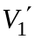 (passing through point M) is higher than V_{l}. Households with a high valuation of insurance will retain their private insurance at point D. As the value of the public insurance (point M) rises (say to M′), the households are more likely to drop private insurance and enroll in Medicaid.
To the extent that the Medicaid coverage provides insurance where none has been available, one observes take-up; to the extent that it replaces existing insurance, one observes crowd-out. One may even see a household choosing less coverage (point M provides less generous coverage than existing point E) because it is free. Opponents of the Affordable Care Act have jumped on this possibility as a failure of the ACA, when in fact it is a feature of all programs that give recipients choices to purchase less of the specified good (for example, housing vouchers), for much less money, freeing up money for them to buy other items that they value more. The expansion of Medicaid through the Affordable Care Act has stimulated numerous analyses of the magnitudes of these effects, and we address them in more detail in Chapter 22.
Observers would expect increased coverage to affect health care utilization. Analysts have found that this impact depends on access to the health care, which may relate to the availability of providers and the distance, cost, or convenience of dealing with the providers. Increased utilization increases costs and presumably improves outcomes, which are typically measured in terms of reduced morbidity (illness) or mortality (death).The incremental cost per unit of outcome is often summarized in terms of costs per illness day prevented, or costs per death prevented—measures of the program’s cost efficiency.
The impact of children’s health programs has been substantial. While the percentage of children above 200 percent of the poverty level (the “not poor”) stayed roughly constant from 1997 to 2010, the percentage of those below 200 percent, and particularly those below the poverty line, fell from well over 20 percent to less than 12 percent over the 13-year period. This is particularly notable given the increase in poverty that accompanied the hard economic times in the U.S. toward the end of the first decade of the twenty-first century.
The Effects of Medicare and Medicaid
Though we can be certain about the provisions of Medicare and Medicaid, we are necessarily less certain about their effects. We consider here a selection of findings on the effects of Medicare and Medicaid on:
• Health care costs
• Access to health care
• Health status
Costs and Inflation
The implementation of Medicare and Medicaid coincided with a considerable increase in health care costs in the United States. While health care costs had been rising before 1965, both in simple percentage terms and in comparison to the general rate of inflation, the hospital care inflation rate increased somewhat after the implementation of Medicare and Medicaid.
(Figure 20-7 Total Expenditures for Medicare and Medicaid, 1987–2014)
The expenditure levels of the two programs increased much more rapidly than most had expected. Figure 20-7 shows the pattern of expenditures over time. In monetary terms, percentage increases in expenditures on both programs were in double digits for many years in the 1990s, and the 2014 total of $1,127 billion is 8.4 times as great as the 1987 figure of $133 billion.
(Figure 20-8 Enrollment for Medicare and Medicaid, 1987–2014)
A large portion of the increase comes from enrollment, as noted in Figure 20-8. Medicare enrollment is largely predictable, and as the older population as increased, so has the enrollment, from 31.7 million in 1987 to 52.8 in 2014. Medicaid and CHIP have been more policy-driven. As Medicaid is one of the foundation blocks of the ACA, its enrollment has dramatically increased by a factor of more than 3, from 20.0 million in 1987 to 65.9 million in 2014.
(Figure 20-9 Real Expenditures per Enrollee, 1987–2014)
The inflation-adjusted expenditures per enrollee increased dramatically from 1987 through 2008, as noted in Figure 20-9. They have leveled off and even declined slightly over the last half dozen years, verifying that aggregate expenditure increases came almost entirely from enrollment increases. Policy analysts continue to debate whether this leveling off can be traced to the passage of the ACA in 2010, and whether it can be expected to continue.
Why Spending Has Risen: Increased Coverage, Technological Improvement, and Increased Inefficiency The increase in the eligible population covered by Medicare and Medicaid clearly helps explain why program expenditures have risen, but it does not fully account for the inflationary effects. Newhouse (1978a) suggested three ways through which insurance programs, such as these, could affect prices and costs, even without growth in the population served.
First, Medicare and Medicaid both tended to increase the insurance coverage of the populations eligible. An increase in insurance expands the demand for care. Second, insurance coverage may induce technological improvements. If so, then the cost per unit of care may rise.
Finally, Newhouse proposed a third theory for the effect of insurance on costs and quantity used. This may be called the “increased inefficiency” theory. The idea is that when insurance covers a substantial portion of the health care bill, institutions, such as hospitals, have less incentive to control costs. It is not clear from this theory that the advent of Medicare and Medicaid, for example, would cause the level of inefficiency in hospitals to increase over time, but such a pattern is at least consistent with the theory.
The Evidence What do we know about the patterns of health expenditure inflation subsequent to the adoption of Medicare and Medicaid, and what do we know about the sources of this inflation? One approach partitions the observed rise in expenditures into its logical components: changes in population, in quantity per capita, and in the nature of services provided per visit or per admission.
Cutler and Meara (1997) find a dramatic change in medical spending over time, and disproportionately so for the very young (those younger than 1 year old) and the old (those age 65 or over). From 1963 through 1987, per-person spending on infants increased by 9.8 percent per year, and per-person spending on the elderly increased by 8.0 percent per year (compared to 4.7 percent per year for the others).
Moreover, they find that essentially all of the disproportionate growth of spending for the very young and the old was accounted for by high-cost users within those groups, and that a substantial amount of high-cost medical use is associated with the increasing technological capabilities of medicine. Among infants, high-cost users are premature babies with substantial respiratory or other acute conditions. For the elderly, high-cost users are generally patients with severe cardiovascular problems or cancer.
Finkelstein (2007) suggests that the impact of Medicare on hospital spending is substantially larger than what the existing evidence from individual-level changes in health insurance would have predicted. She argues that the introduction of Medicare was associated with an increase in the rate of adoption of then new medical technologies. A back of the envelope calculation based on the estimated impact of Medicare suggests that the overall spread of health insurance between 1950 and 1990 may explain at least 40 percent of the increase in real per capita health spending over this period.
Irrespective of the considerable costs, the predominant evidence seems to suggest that both Medicare and Medicaid have succeeded in addressing problems of access. That there was a change in health care use rates among the lower-income groups and the elderly following the beginning of Medicare and Medicaid is evident from the data.
Table 20-1 investigates two dimensions of health care access and utilization: the interval since the last physician contact and the number of hospital discharges per 1,000 people. In 1964, just before the passage of Medicare and Medicaid, 69.7 percent of those aged 65 and older had seen a physician within the past year. This was 4.2 percent higher than the general population and 8.1 percent higher than those aged 45 to 64. By 1990, those aged 65 and older were 11.4 and 12.7 percent more likely to have seen a physician within a year than the respective comparison groups.
Table 20-1 Indirect Impacts of Medicare and Medicaid
A. Age Comparisons
Interval since last physician contact
 | Percent Less Than One Year
 | 1964 | 1990 | 1995
Total | 66.9 | 78.2 | 79.5
Age 45–64 | 64.5 | 77.3 | 79.9
Age 65+ | 69.7 | 87.1 | 90.0
Hospital discharges per 1,000
 | 1964 | 1990 | 1995
Total | 109.1 | 91.0 | 86.2
Age 45–64 | 146.2 | 135.7 | 122.4
Age 65+ | 190.0 | 248.8 | 266.9
B. Income Comparisons
Interval since last physician contact
 | Percent Less Than One Year
 | 1964 | 1990 | 1995
Total | 66.9 | 78.2 | 79.5
Income < $15,000 | 58.6 | 77.3 | 78.2
Income > $50,000 | 73.6 | 81.7 | 83.5
Hospital discharges per 1,000
 | 1964 | 1990 | 1995
Total | 109.1 | 91.0 | 86.2
Income < $15,000 | 102.4 | 142.2 | 140.7
Income > $50,000 | 110.7 | 72.5 | 61.6
Source: Derived from Health United States (1998), Tables 77 and 87.

Another measure of elderly access involves hospital discharges per 1,000. In 1964, those 65 and older had 190.0 discharges compared with 146.2 for those aged 45 to 64, a 30 percent differential. By 1990, the differential had grown to 83.3 percent, and by 1995 to 118.1 percent.
Comparing the less affluent to the more affluent in 1964, those with incomes less than $15,000 were 79.6 percent as likely to have seen a physician in the past year as those with incomes higher than $50,000. By 1990, they were 94.6 percent as likely.
In 1964, those with incomes less than $15,000 had 102.4 hospital discharges per 1,000, compared with 110.7 discharges for those with incomes higher than $50,000, or only 92.5 percent as many. By 1990, the lower-income people had 96.1 percent more discharges per 1,000 people, and by 1995 they had 128.4 percent as many.
Health Status
Card, Dobkin, and Maestas (2009) look at the impact of Medicare by examining over 400,000 hospital admissions to the emergency room for “non-deferrable” conditions— diagnoses with the same daily admission rates on weekends and weekdays. There is no discernible rise in the number of admissions at age 65, suggesting that the severity of illness is similar for patients on either side of the Medicare threshold. The insurance characteristics of the two groups differ, however, with a large jump at 65 in the fraction who have Medicare as their primary insurer, and a reduction in the fraction with no coverage. These changes are associated with significant increases in hospital list chargers, in the number of procedures performed in hospital, and in the rate that patients transfer to other care units in the hospital. The authors estimate a nearly 1 percentage point drop in 7-day mortality for patients at age 65, implying that Medicare eligibility reduces the death rate of this severely ill patient group by 20 percent. The mortality gap persists for at least two years following the initial hospital admission.

Finkelstein and McKnight (2008) remind us that Medicare is a form of insurance against risk. They calculate that the welfare gains from reductions in risk exposure alone may be sufficient to cover between half and three-quarters of the costs of the Medicare program. They view these findings as underscoring the importance of considering the direct insurance benefits from public health insurance programs, in addition to any indirect benefits from an effect on health.
Favorable impacts come with incremental costs. Currie and Gruber (1996) measure the impacts of increased Medicaid eligibility (throughout the United States) for pregnant women between 1979 and 1992. Certain groups saw substantial improvements. For example, a 30 percentage point increase in eligibility among 15- to 44-year-old women was associated with a decrease in infant mortality of 8.5 percent. However, even the most carefully targeted changes in Medicaid eligibility cost the Medicaid program $840,000 per infant life saved, raising important questions of cost effectiveness. In a similar study, Joyce (1999) finds reductions in newborn costs associated with Medicaid participation (this time in New York) to be between $100 and $300 per recipient, insufficient to offset program expenditures.
Medicare: Recent Changes and Future Prospects
Recent Changes In 1996, trustees of the Hospital Insurance (Part A) Fund predicted that the Part A Trust Fund would have a zero balance by 2001. Uncomfortable with raising payroll taxes, the U.S. Congress chose to make major changes in how Medicare paid health care providers through the Balanced Budget Act (BBA) of 1997.
The BBA increased the incentives for efficient production by mandating the development of prospective reimbursement systems for post-acute care. For hospital outpatient departments, it ended cost-based reimbursement. These two changes virtually ended cost-based reimbursement throughout the Medicare system. Payment formulas for new entrants and for home health services were adjusted downward, and the BBA reduced physician payments.
Future Prospects Despite the major changes in the 1997 BBA it is clear that the U.S. Medicare system will become much larger over the next quarter century. Figure 20-10 displays projections of the Medicare-eligible population, starting in 2015. Projections into the future can be risky, but this one is a safe bet. All those who will be 65 years of age in 2040 are already over 40 years old. To project future populations, demographers statistically “age” the various population cohorts by predicting deaths between now and then. Immigration and emigration generally provide only small adjustments at the national level.
(Figure 20-10 – Projected Medicare Enrollment and Workers per Enrollee)
Any way that one looks at things, Medicare will grow. Figure 20-10 shows that the number of Medicare beneficiaries, largely those ages 65 and over, will increase to about 85 million, the result of the baby boom starting in the late 1940s and extending through the early 1960s. In addition, the number of workers (who are also paying into the fund) per beneficiary is projected to fall, from 3.4 in 2010 to 2.3 in 2040. This decrease in workers per beneficiary (occurring in all advanced countries) suggests that there will be more financial pressure on providers to cut costs, and on payers to pay for services.
We must treat projections of future spending with caution, and with the uncertainty surrounding the implementation of ACA, this caution must be re-emphasized. The aging population and expected increases in health care costs suggest a major increase in the Medicare share of the GDP.
These projections are based on projected annual growth of GDP of close to 5 percent until 2020, and 4.6 percent thereafter (Medicare Trustees, P. 55-UPDATE), increasing the denominator of the fraction relating to the percentage of GDP (Percentage = 100 × Expenditures/GDP). Many economists, irrespective of political stripe, would find such projections to be optimistic based on historical perspective. Changing the projected GDP growth rate from 4.6 percent to even a 4.0 percent growth rate, high by historical standards, would raise the 2050 projected share from 5.94% to 7.06%.
Victor Fuchs (2000) considered three major economic approaches to the crisis implicit in elderly health spending projections. Almost two decades later, his reasoning remains valid.
1. Slow the growth rate of health expenditures. This may be undesirable because many medical advances have improved quality of life for the elderly, and infeasible because the elderly want all of the care that might do them some good.
2. Impose higher taxes on the young to pay for the care for the old. Such tax hikes are not likely, as they will add to an already high burden of support that the young are asked to pay in support of the elderly.
3. Provide more of their own income by increases in work and saving. In earlier work, Fuchs (1999) examined elderly retirement savings, concluding that, “most low-income elderly could have saved more [emphasis added] prior to age 65.”
Conclusions
In this chapter, we have discussed social insurance and its application to the health care sector. Almost all modern industrialized countries provide fairly comprehensive health care social insurance; we have reviewed the history of these developments and the pattern in the United States.
The major health care social insurance programs in the United States are Medicare, Medicaid, and CHIP. These programs increase health care costs in theory and have been increasingly costly in practice. It is clear that they have had a beneficial effect on access to care among the elderly and low-income groups, and recent studies suggest that they have a beneficial effect on health status. They leave, however, a substantial number of the poor or uninsured without health care coverage.
The United States has moved toward a national health insurance program with the 2010 passage of the Affordable Care Act. Comprehensive social insurance for health care in the United States would directly address and presumably solve the widely perceived problem of providing for the uninsured, a group that often includes people in the poverty, near-poverty, and other lower-income groups. The ACA has provided a partial step in that direction and we discuss it in detail in Chapter 22.
It is also useful to look at health reform beyond the borders of the United States. We begin by comparing the features of health systems across countries in the next chapter.
Summary
1. Several types of social insurance policies and social programs exist, usefully grouped into poverty programs, old-age assistance, disability, health, and unemployment.
2. Social program features include contributions, benefits, length of coverage, means of reimbursement to providers, and methods of determining payment levels to providers.
3. Social insurance originated in nineteenth-century Europe. Social insurance in the United States began with Social Security in 1935 and the adoption of Medicare and Medicaid in 1965. Until 2010, with the passage of the Affordable Care Act (ACA) the United States remained one of the few developed countries that had not adopted a comprehensive health care social insurance program.
4. Medicare is a national program that provides hospital insurance to the elderly, along with optional supplemental physician care insurance. The Balanced Budget Act of 1997 established several new categories of Medicare options, and prescription drug coverage (Part D) passed 2003, and started in 2006.
5. Medicare Part D, starting in 2006, has led to much increased prescription drug coverage. In 2014, Part D provided $86.4 billion in benefits to 39.2 million enrollees. The average benefit per enrollee exceeded $2,200.
6. Medicaid programs are funded through matching state and federal funds and run by the states. They provide health care to certain categories of the needy and are the primary providers of nursing home aid.
7. Expansion of Medicaid programs serves as one of the the two primary enrollment increasing instruments of the Affordable Care Act.
8. Medicare and Medicaid expenditures have increased rapidly since the programs began, due to increased medical care prices, population covered, and quantity of care per capita consumed by the population, as well as due to changes in the nature of the services provided.
9. Medicare and Medicaid accompanied clear improvement in access to care by the lower income population, as evidenced by increased utilization rates by lower-income groups, both absolutely and relatively, to the higher-income groups.
10. With the aging of the baby boom cohort and the improvements in health care technologies in this second decade of twenty-first century, Medicare must determine how best to structure, provide, and finance the benefits that it is providing to this growing segment of the population.
Discussion Questions
1. In what ways does social insurance differ from private insurance?
2. Of the five types of social insurance programs described, which types characterize Medicare? Which types describe Medicaid?
3. What are the similarities between Medicare and Medicaid? What are the differences?
4. What factors contributed to the historical growth in Medicare spending?
5. Describe how Medicare has affected access to care for the elderly.
6. Does access to health care provided through social insurance programs affect health status? Discuss the evidence.
7. What are some possible reasons that other industrially advanced countries have far more comprehensive social insurance programs for health care than does the United States?
8. Historically in the United States, what groups have supported social insurance for health care, and what groups have opposed it? Why do you think this is the case?
9. For students in the United States, compare Medicaid coverage in your state, with coverage afforded to recipients in a neighboring state. Are they the same? If not, why do you think that they differ?
10. The Affordable Care Act of 2010 has engendered particular debate between proponents and opponents. Why do you think this is the case?
11. Reductions in federal stimulus plans and decreasing state resources have affected the Medicaid program. Discuss the impact on Medicaid and state responses in the state where you live or go to school.
12. Are elderly people provided the right amount of health care under current US policies? Contrast your answer for the United State to other countries with which you are familiar.
Exercises
1. Calculate the average tax rate for Social Security at incomes of $25,000, $50,000, $75,000, $100,000, and $125,000. Do the same for Medicare. (Hint: You may choose to do each graphically.) Characterize each tax as being progressive, regressive, or neutral.
2. Figure 20-3 describes the Medicare Part D prescription drug benefit. Look at the Web page http://www.partd-medicare.com/ in your area and determine the marginal coinsurance rates, applicable in each segment. Then calculate the average amount spent at the following levels of charges: $2,000, $4,000, $6,000, and $8,000. Discuss the “burden” of payments under this schedule.
3. Consider Currie’s discussion of take-up of social programs, where the x-axis is program enrollment and the y-axis refers to monetary costs and benefits.
(a) If we measure the number of people enrolling in a program on the x-axis, why would the “demand” for these programs be downward sloping? Draw a demand curve.
(b) Why would the costs of establishing a program be upward sloping? Draw a supply curve.
(c) What is meant by the equilibrium where supply equals demand?
(d) How can one model program “stigma,” and what does it do to equilibrium enrollment? Why?
4. Consider a population of 1,000 families: 200 had Medicaid insurance, 700 had some other type of insurance, and 100 were uninsured. Suppose now that Medicaid broadens eligibility rules that would allow an additional 100 families to get coverage. After one year, 250 families now have Medicaid, 675 now have some other type of insurance, and 75 are uninsured.
(a) Calculate the average take-up and crowd-out both in numbers of families and in rates.
(b) Calculate the marginal take-up rates occurring due to the eligibility change.
(c) Has insurance coverage for the population increased? Why or why not?
(d) Has insurance coverage for all families increased? Why or why not?
5. Consider the analysis described in Figure 20-6. Tom and Dick each earn $25,000 per year. Tom has a spouse and two children, and Dick is unmarried. Health insurance and other goods trade off dollar for dollar (there is no tax advantage to health insurance).
(a) Where would each of the two be located on the budget constraint, and why?
(b) Which of the two would more likely take up a health insurance program, such as Medicaid?
(c) How would your answers to the first two parts change if health insurance were subsidized (as it is) relative to all other goods?

Add/Delete
Add
Sebastian Schneeweiss, Amanda R. Patrick, Alex Pedan, Laleh Varasteh, Raisa Levin, Nan Liu, and William H. Shrank, “The Effect Of Medicare Part D Coverage On Drug Use And Cost Sharing Among Seniors Without Prior Drug Benefits,” Health Affairs, 28, no.2 (2009):w305-w316 (published online February 3, 2009; 10.1377/hlthaff.28.2.w305)

Schneeweiss, Sebastian et al. “The Effect Of Medicare Part D Coverage On Drug Use And Cost Sharing Among Seniors Without Prior Drug Benefits,” Health Affairs, 28, no.2 (2009):w305-w316 (published online February 3, 2009; 10.1377/hlthaff.28.2.w305)

Kaestner, Robert, Cuiping Long, and G. Caleb Alexander, “Effects of Prescription Drug Insurance on Hospitalization and Mortality: Evidence from Medicare Part D,” September 2014
NBER Working Paper 19948

Kaestner, Robert, and Nasreen Kahn, “Medicare Part D and Its Effect on the Use of Prescription Drugs and Use of Other Health Care Services of the Elderly,” Journal of Policy Analysis and Management, Vol. 31, No. 2, 253–279 (2012)

Jung, Hye-Young et al. “Integrated Medicare and Medicaid Managed Care and Rehospitalization of Dual Eligibles,” American Journal of Managed Care 21 (2015):711 - 719

[Hye-Young Jung, PhD; Amal N. Trivedi, MD, MPH; David C. Grabowski, PhD; and Vincent Mor, PhD VOL. 21, NO. 10]

Bosworth, Barry, Gary Burtless, and Kan Zhang, Later Retirement, Inequality in Old Age, and the Growing Gap in Longevity between Rich and Poor, Washington, Brookings Institution, 2016 http://www.brookings.edu/~/media/Research/Files/Reports/2016/01/life-expectancy-gaps-promise-social-security/BosworthBurtlessZhang_retirementinequalitylongevity_012815.pdf

Irwin, Neil, “Rich People Are Living Longer. That’s Tilting Social Security in Their Favor,” New York Times, April 22, 2016. http://www.nytimes.com/2016/04/24/upshot/rich-people-are-living-longer-thats-tilting-social-security-in-their-favor.html?_r=0

DELETE

Davis and Reynolds

Sources: National Partnership for Women and Families, January 31, 2011; http://www.nationalpartnership.org/site/News2?page=NewsArticle&id=27551&news_iv_ctrl=0&abbr=daily2_; Sack, Kevin, “For Governors, Medicaid Looks Ripe for Slashing,” http://www.nytimes.com/2011/01/29/us/politics/29medicaid.html?_r=1, both accessed June 17, 2011.
Holahan, Wiener, and Wallin (1998, p. 58)
Paul Starr (1983)
Skocpol (1995)
Truffer et al (2010)

Holahan and Liska (1997)
Holahan and Ghosh (2005)
Dorn, Garrett, Holahan, and Williams (2008)

Figure 20-1 Medicare Enrollment by Year, 1966–2014
Source: Graph developed by authors through data from Centers for Medicare and Medicaid Services data compendium.
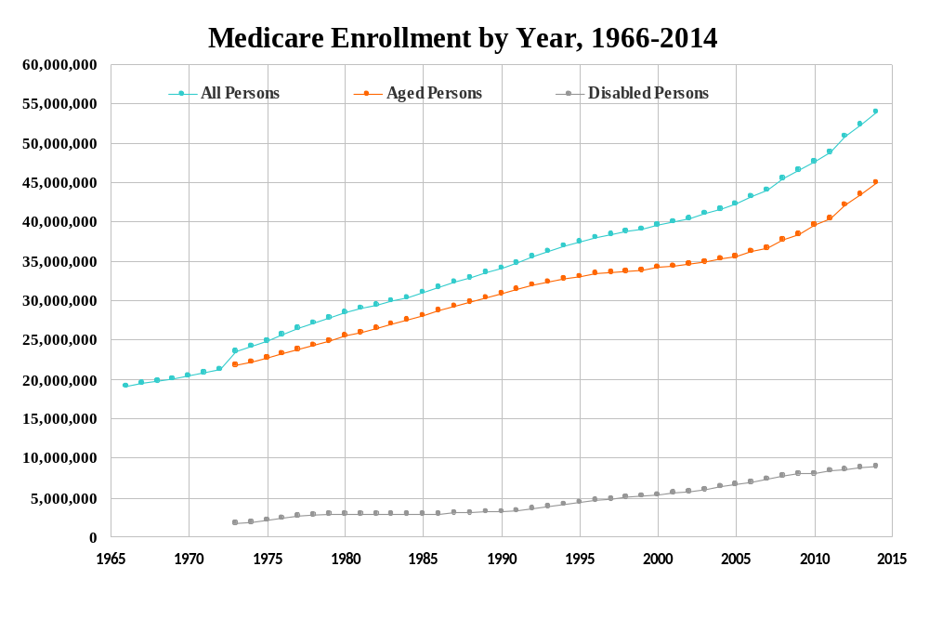
Figure 20-2 Share of Medicare Beneficiaries Enrolled in Medicare Advantage Plans, by State, 2015
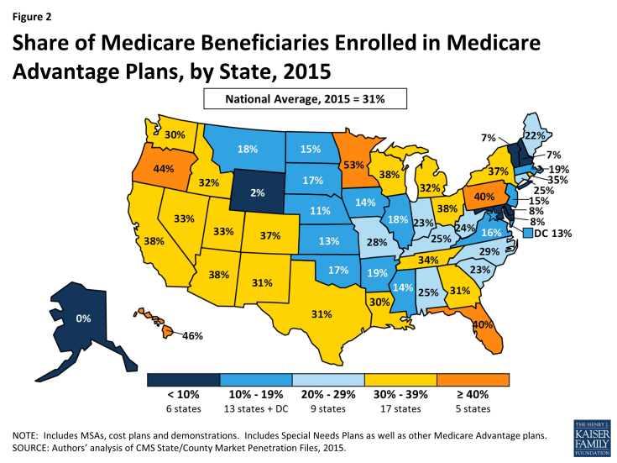
Source: Jacobson et al. (2015). This information was reprinted with permission from the Henry J. Kaiser Family Foundation. The Kaiser Family Foundation is a non-profit private operating foundation, based in Menlo Park, California, dedicated to producing and communicating the best possible information, research, and analysis on health issues.

Figure 20-3 Medicare Part D Prescription Drug Benefit - 2016
Payments vs. Drug Charges
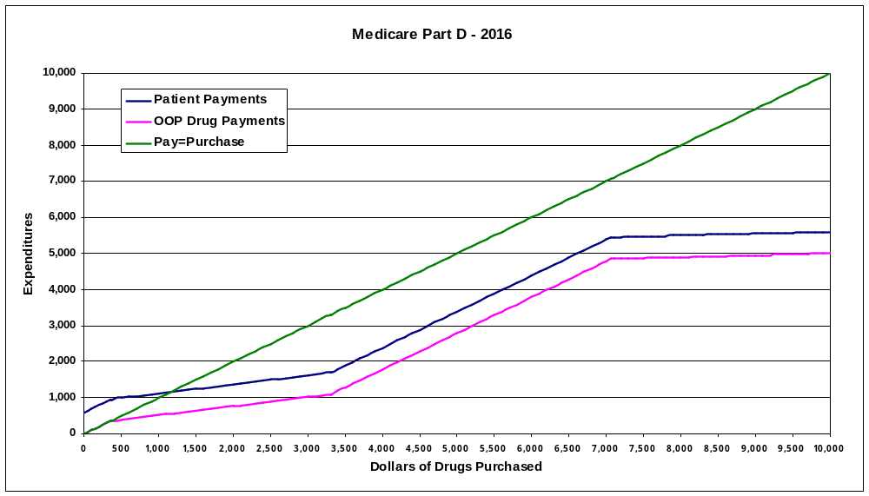
Deductible
Break-Even

“Doughnut Hole”
Catastrophic Range

Figure 20-4 The Impact of Medicaid Cost Sharing on State Expenditures

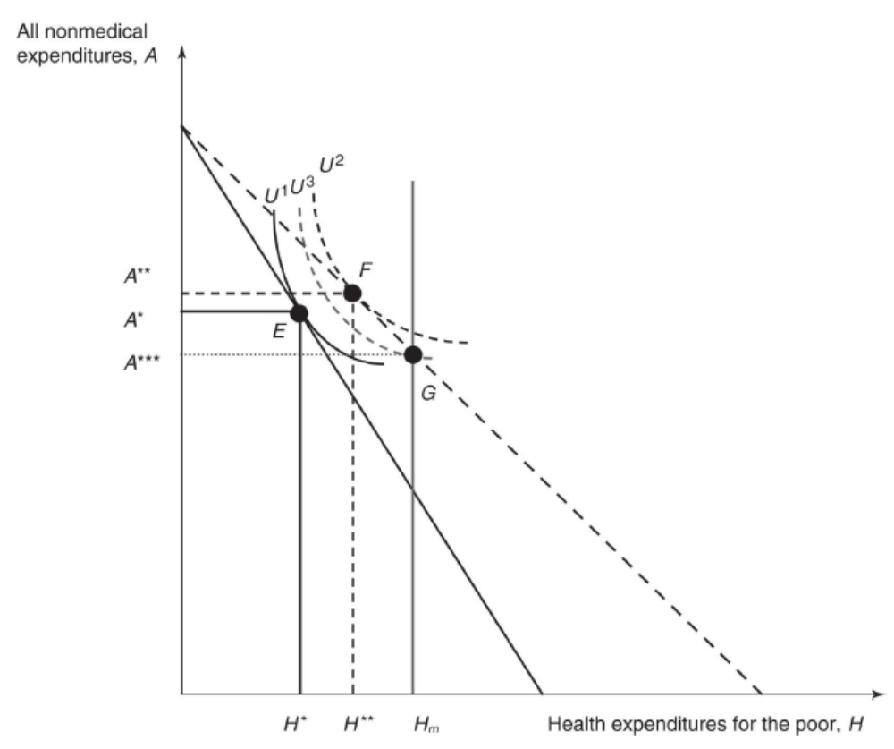
Figure 20-5 Analyzing the Impacts of Improved Medicaid Coverage
Source: Adopted from Gruber (2002).
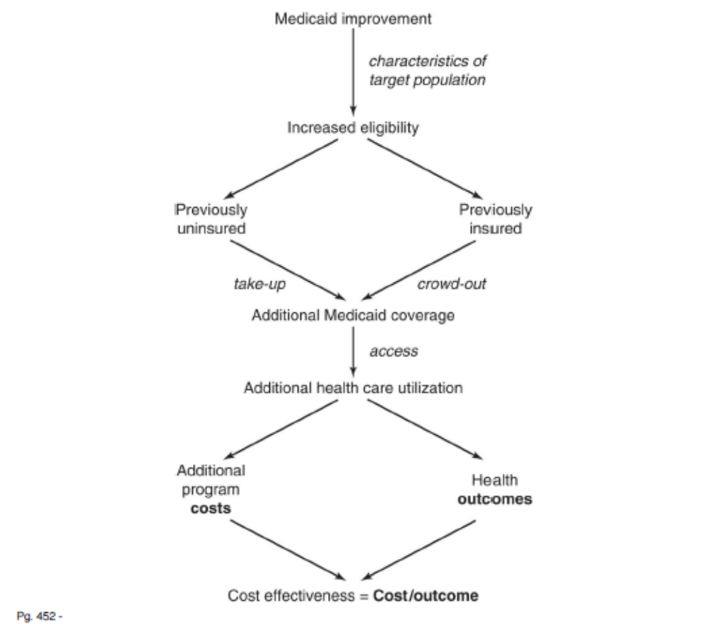
Figure 20-6 Analyzing the Economics of Take-up and Crowd-Out
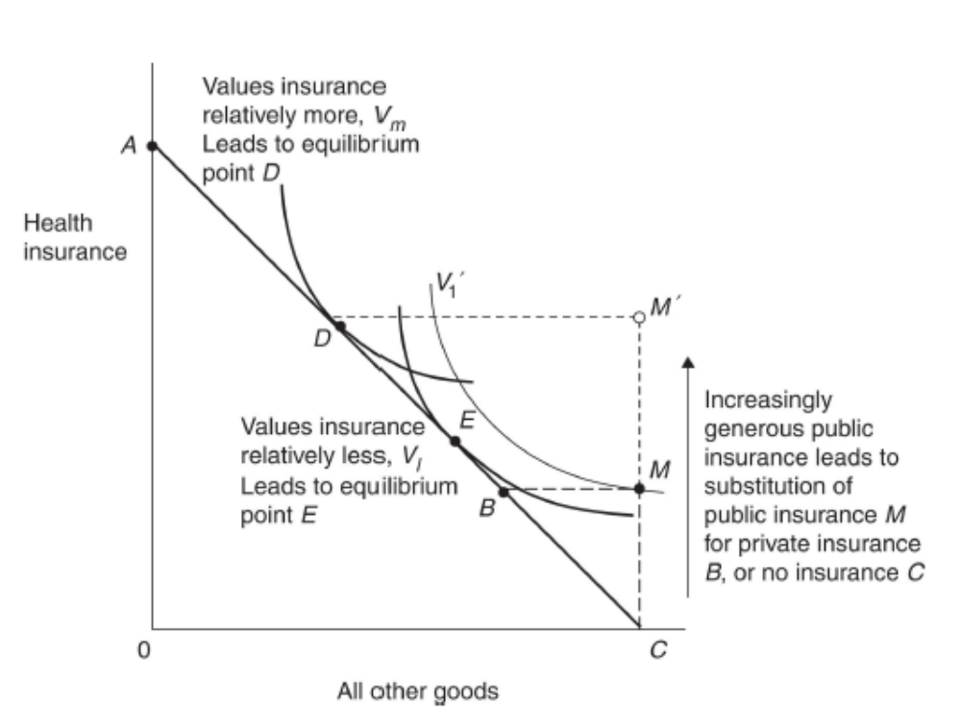
Increasingly generous public insurance leads to substitution of public insurance M for private insurance B (crowd-out), or no insurance C (take-up).
Figure 20-7 Total Expenditures for Medicare and Medicaid, 1987–2014

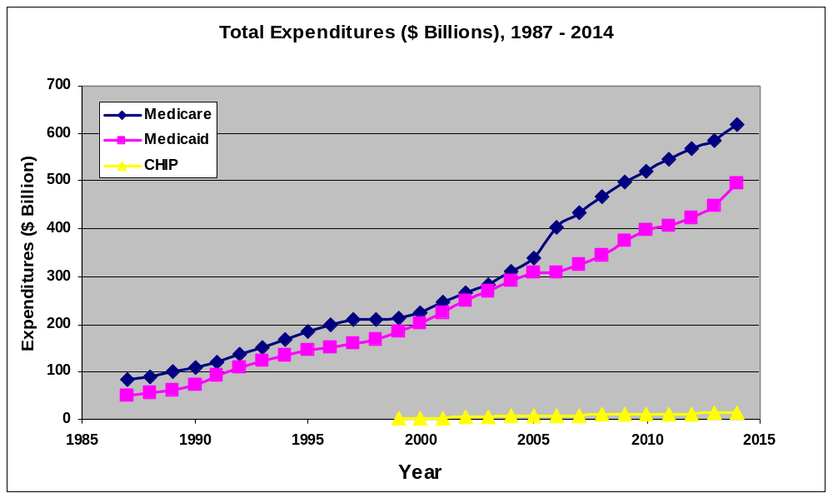
Figure 20-8 Enrollment for Medicare and Medicaid, 1987–2014

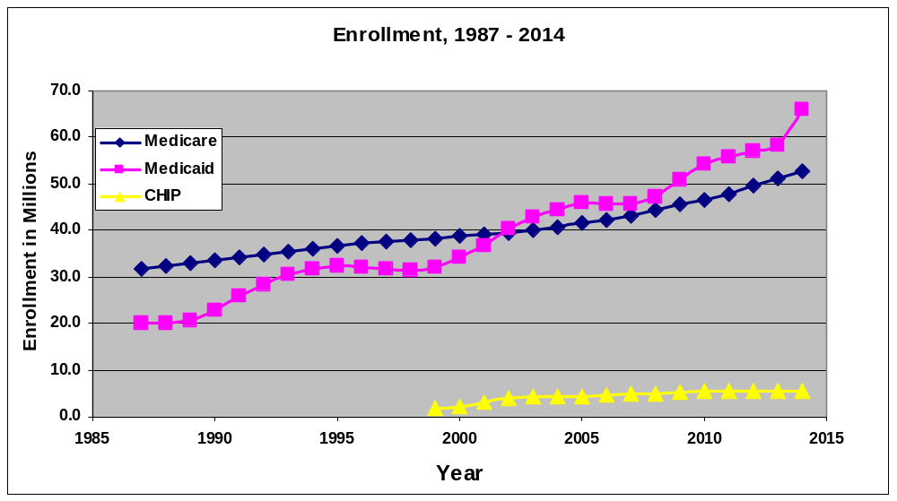

Figure 20-9 Real Expenditures per Enrollee, 1987–2014

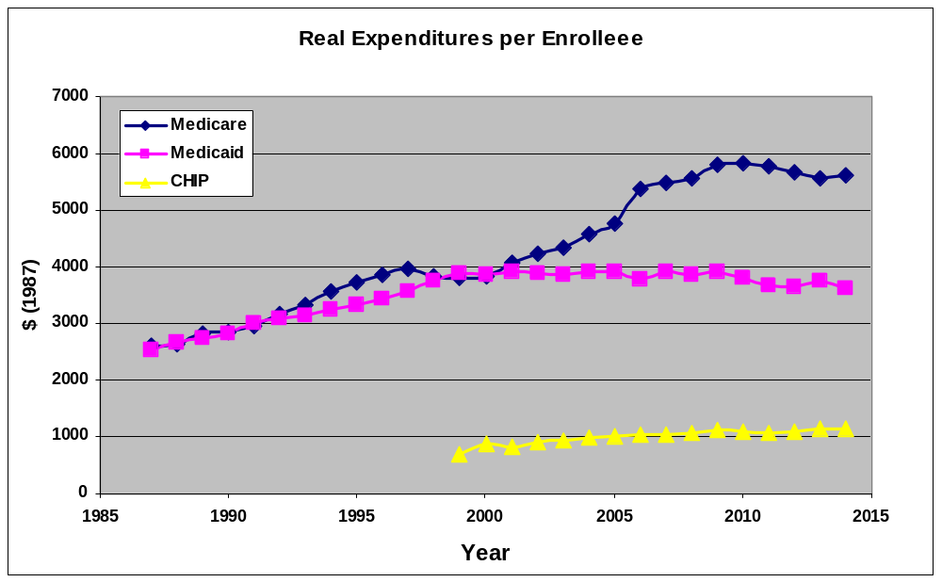

Figure 20-10 – Projected Medicare Enrollment and Workers per Enrollee
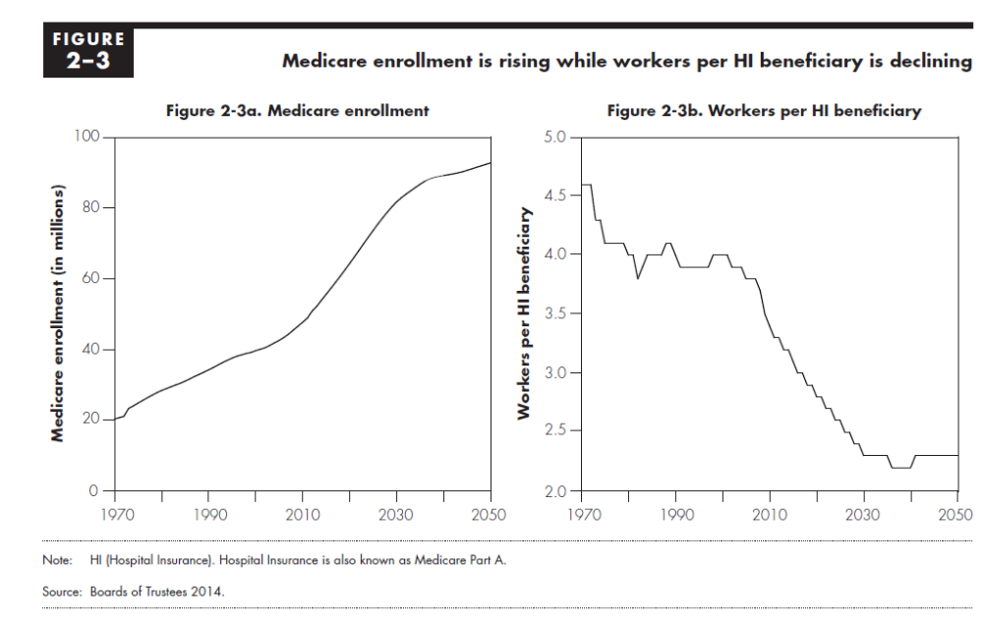
Projected
Projected
Source: MEDPAC Report, Chapter 2June 2015,

From 1937 to 1949, the tax rate was 1% of payroll incomes up to $3,000, a maximum tax of $30 per year!
The most current information on these programs are: (1) Medicare Program - General Information, https://www.cms.gov/Medicare/Medicare-General-Information/MedicareGenInfo/index.html, accessed February 11, 2016; (2) National Medicaid & CHIP Program Information, https://www.medicaid.gov/medicaid-chip-program-information/ program-information/medicaid-and-chip-program-information.html, accessed February 11, 2016.
The Affordable Care Act plans to eliminate the doughnut hole by 2020 by reducing expenses for those whose expenditures are in that interval. Until then, Plan D participants will have relatively large coinsurance rates.
With the parameters in the example above, the break-even point is about $1,160.
These classes were (1) hypertension drugs Angiotensin-Converting Enzyme (ACE) Inhibitors; (2) Alzheimer’s disease treatments; (3) Anti-Depressants; (4) Angiotensin Receptor Blockers (ARBs), also used to treat hypertension; (5) Oral Anti-Diabetics; (6) Osteoporosis treatments; (7) Proton Pump Inhibitors (PPIs) for heartburn, gastroesophageal reflux disease (GERD), and ulcers; and (8) cholesterol drugs HMG-CoA Reductase Inhibitors (Statins).
Material gathered from http://kff.org/medicaid/report/medicaid-and-long-term-services-and-supports-a-primer/, accessed March 18, 2016).
Data are from https://www.cms.gov/Medicare-Medicaid-Coordination/Medicare-and-Medicaid- Coordination/Medicare-Medicaid-Coordination-Office/Downloads/MMCO_2015_RTC.pdf, accessed March 24, 2016)
Tabulations of the unemployed or uninsured often confuse “ever” with “point-in-time.” An annual count of children ever-enrolled will always exceed the number enrolled at any point-in-time, if new enrollments and departures occur during the year. The greater the number of new enrollments and departures, the greater will be the difference between the point-in-time and annual ever-enrolled counts. Over the first decade of the 21st century, over one-third of CHIP enrollees enrolled at any time during the year were not enrolled at the end of the year.

