Chapter 3
Statistical Tools for Health Economics
 Hypothesis Testing
 Difference of Means
 Regression Analysis
 Multiple Regression Analysis
 Statistical Inference in the Sciences and Social Sciences
 Conclusions
The ideas from economic theory must be tested and measured according to the standards of real-world data. Statistical techniques applied to economics are collectively called econometrics. In Chapter 2, we discussed supply and demand, as well as the importance of price and income elasticities. Economic theory predicts that demand curves will slope downward, but it does not predict the degree of responsiveness of demand to price and other variables; it is the task of statistical analysis to estimate these magnitudes. When close substitutes are available for a good, theory predicts that demand will be more sensitive to price than if no close substitutes are available. Yet it is hard to know whether a 1 percent increase in price will decrease the quantity demanded by 10 percent, 1 percent, or 1/10 of a percent, yielding elasticities of –10.0, –1.0, or -0.1, respectively. Measurements of the economic parameters may prove crucial in analyzing whether drug companies raise drug prices, whether higher insurance copayments will lead people to use less treatment, or whether mandated levels of health care are economically efficient.
This chapter considers statistical methods that econometricians use to draw inferences from data that are collected. Many students with natural science backgrounds are familiar with laboratory experiments which seek to hold the environment constant and administer treatments to experimental groups. Researchers then compare the results to those of untreated control groups. One form of this design is the dose-response model in which researchers relate the results or responses to the experimental treatment, or the dose. If statisticians determine that the resulting differences are significant, a term we will discuss in this chapter, they consider the dose to be effective.
Social science analysts of human behavior rarely find an experimental group to match with a convenient control group. Instead, they must usually collect information from people doing day-to-day activities. Using statistical methods, they try to control for the confounding differences among the people that they are analyzing. The more successful they are in controlling for such differences, the more reliable the analysis will be.
This chapter begins with discussions on how we form hypotheses. It then considers difference of means analysis as a way of introducing statistical inference. Most of the rest of the chapter concentrates on the simple and multiple regression analyses that economists most often use.
Hypothesis Testing
Economists studying health care often face statements that, while plausible, demand some validation:
“Men and women don’t smoke the same numbers of cigarettes.”
“Rich people spend more on health care than do poor people.”
“The United States spends more on health care than does the United Kingdom.”
Either logic or casual observation would suggest that these statements are true. It would be useful, however, to have a rigorous method of determining whether the assertions are correct. Statistical methods suggest formulating these statements as hypotheses and collecting data to determine whether they are correct.
Take, for example, the first assertion about smoking levels. We state clearly both the hypothesis we wish to disprove (called the null hypothesis), as well as the hypothesis the theory suggests to be the case (the alternative hypothesis).The null hypothesis here, H₀, is that men’s levels (c_{m}) equal women’s levels (c_{w}), or
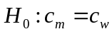 (3.1)
The alternative hypothesis H₁, is that c_{m} does not equal c_{w}:
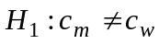 (3.2)
We seek convincing evidence that c_{m} differs from c_{w}. Hypotheses that are designed to test for equality among two or more items are sometimes called simple hypotheses.
Consider the second hypothesis, which asserts that rich people spend more on health care than do poor people. If we define health care expenditures of the rich as E_{r} and the poor as E_{p}, then the null hypothesis is:
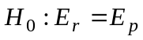 (3.3)
The alternative is:
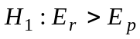 (3.4)
In this analysis, it may not be enough just to show that E_{r} differs from E_{p.} Even convincing evidence that the poor spend more, or E_{p} > E_{r} would not validate the hypothesis. Hypotheses that test whether two or more items are greater (or less) than each other, are composite hypotheses. Having seen how one might construct the hypotheses in question, we now discuss how to test them.

Difference of Means

In the past decade, health professionals have turned their attention, often with some alarm, to the increased level of population obesity. According to the Centers for Disease Control, obesity is “common, serious and costly” with:
- More than one-third of U.S. adults (35.7%) obese.
- Obesity-related conditions including heart disease, stroke, type 2 diabetes and certain types of cancer, some of the leading causes of preventable death.
- An estimated annual medical cost of obesity in the U.S. of $147 billion in 2008 U.S. dollars; the medical costs for people who are obese were $1,429 higher than those of normal weight.
(Source: Adult Obesity Facts, http://www.cdc.gov/obesity/data/adult.html, accessed February 14, 2014)
Although we will look more explicitly at obesity in Chapter 7, measuring its incidence is an important and useful topic in the use of quantitative methods.
The body-mass index or BMI is probably the most common (although far from the only) measure of obesity. Researchers calculate the BMI by dividing the subject’s weight in kilograms by height in meters squared. The formula then is:
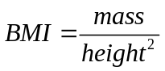
So Pat, a research subject with a weight of 170 pounds (77.1 kilograms) and a height of 66 inches (1.67 meters) will have a BMI of 27.6. Medical and public health experts consider a BMI over 25 as “overweight”, and one over 30 as “obese”. According to the BMI, Pat is overweight.
Suppose we wish to compare the BMI of men with that of women. We can weigh and measure one man and one woman, and find the man’s BMI of (B_{M}) 27 and the woman’s BMI (B_{W}) of 25. This provides evidence that men have higher BMIs than women, because B_{M} > B_{W}, or 27 > 25. It is not very convincing evidence, however. The man or woman, or either, may not be typical of the entire group. What if a different man and/or woman had been selected? Would the answer have been different?
It seems logical to test several men and to compute the mean or average level by summing the measurements and dividing them by the total number of men tested. The National Institutes of Health (in 2001 and 2002) collected a database of over 43,000 people ages 18 and over, called the National Epidemiologic Survey on Alcohol and Related Conditions, or NESARC. Although this sample focused on potentially substance abusive activities including smoking, drinking of alcoholic beverages, and the taking of recreational (and harder) drugs, it also measured height and weight. The textbook authors found that
For 18,159 men, the mean, or average level, 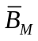was 27.19, with a minimum of
For 23,495 women, the average level, 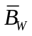, was 26.33.
The difference, 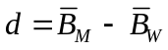 then, is 0.85, evidence that men have higher BMIs which indicate the problem of obesity.
The Variance of a Distribution
Although a difference of the two means is improved evidence, the econometrician desires a more rigorous criterion. Suppose the true BMI for both men and women is 27.00 but our sample randomly drew a higher average level for men (27.19) than for women (26.33). Figure 3-1 plots the distributions in percentage terms. The women have higher percentages in the lower categories and the higher categories. For example, 39.45 percent of the women have BMI between 20 and 25, in contrast to only 31.07 percent of the men. However, men are far more likely to be overweight (BMI between 25 and 30); 43.48 percent of the men have BMI between 25 and 30, compared with 27.95 percent of the women.
Statisticians have found the variance of a distribution to be a useful way to summarize its dispersion. To calculate the variance of women’s levels, we subtract each observation from the mean (26.33), square that term, sum the total, and divide that total by the number of observations, N. Hence, for the 23,495 women in the sample, variance, V_{w}, equals:
(3.5)
Here N_{min} is the number of women with the minimum calculated BMI, N₂ is the number with the next level of BMI, and so on (and yes, there was a woman with a BMI of 10.98 and another with a BMI of 78.12!).
V_{w} reflects the variance of any individual term in the distribution. If V is large, then the dispersion around the mean is wide and another woman tested might be far from our mean. If V is small, then the dispersion around the mean is narrow and another observation might be close to the mean.
Standard Error of the Mean
The variance is often deflated by taking the square root to get the standard deviation, s, yielding:
(3.6)

As with V, a large (small) value of s indicates a large (small) dispersion around the mean. Statisticians have shown that we can calculate the standard error of the mean itself by dividing s by the square root of the number of observations, and because the data come from a population weighted sample (the 23,495 women were statistically chosen to represent all women over the age of 18), the denominator is over 100 million (women). In this sample, the standard deviation of the distribution for women equals 403.07 – the average woman may vary greatly from the mean. The standard error of the mean of the women’s distribution would then equal s_{w} divided by the square root of 103,444,772, or (403.07 ÷ 10,171), which equals 0.04.
A powerful theorem in statistics, the Central Limit Theorem, states that no matter what the underlying distribution, the means of that distribution are distributed like a normal, or bell-shaped, curve. Hence, we can plot the normal distribution of means of women’s levels with a mean of 26.33 and a standard error of 0.04.
Statisticians have also shown that a little more than 68 percent of the area under the curve would be within one standard error, or between levels of 26.29 (that is, 13.47 – 0.04), and 26.37 (i.e., 13.47 + 0.04). About 95.4 percent would be within two standard errors. This means that we could be about 95 percent sure that the true BMI for the women over the age of 18 is between 26.25 and 26.41. A similar calculation can be done for men, yielding a similar measurement. Intuitively, the further apart the means and the smaller the dispersions (standard errors), the more likely we are to determine that the average level for men is smaller than that for women. To test the hypothesis formally, we then construct a “difference of means” test. We wish to compare measurement 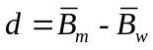, to zero, which was the original hypothesis.
Here d = 0.8527. The variance of the difference is defined as the sum of the variances of the standard errors. The standard error for women was 0.0396 as we calculated it, and the standard error for men was 0.0362, so the standard error of the difference would be:
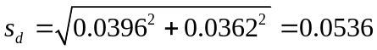 (3.7)
We plot the difference and its distribution in Figure 3 – 2.
The most probable value of the difference, as noted in Figure 3-2, is 0.8527. About 68 percent of the distribution lies between 0.7991 (i.e., 0.8527 – 1 × 0.0536) and 0.9064 (similarly, 0.8527 + 1 × 0.0536). About 95.4 percent of the distribution lies within two standard deviations, between 0.7454 and 0.9600. This experiment would find very good evidence that women have a lower BMI than do men. The probability is well over 99 percent that this difference is statistically significant, that is not equal to 0.
Alternatively, the t-statistic, comparing the numbers 0.8527 and 0.0, equals 0.8527 ÷ 0.0536, or approximately 15.90. Statisticians calculate tables of t-statistics, whose critical values are related to the size of the sample. With an effective sample over 200,000,000, a t-statistic of nearly 16 is statistically significant at well over the 99 percent level. In other words, we can be 99+ percent certain that men have a higher BMI than do women.
Hypotheses and Inferences
This process illustrates the steps that are necessary to test hypotheses appropriately. The econometrician must:
1. State the hypotheses clearly
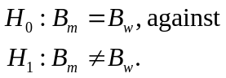
2. Choose a sample that is suitable to the task of testing.
3. Calculate the appropriate measures of central tendency and dispersion: the mean and the standard error of the mean for both men and women, leading to the difference of the two means.
4. Draw the appropriate inferences: men smoke more than women.
No matter how sophisticated the method used, good statistical analysis depends on the ability to address these four criteria and stands (or falls) on the success in fulfilling them. Box 3-1 provides an interesting example of how analysts have examined the potentially cancer-causing properties of cellular phones.
There are, of course, measures of central tendency other than the mean (or average). Someone with a BMI of 50 may unduly influence the mean. A different measure, the median, calculates a statistic such that half of the observations are greater than the median and half are less. Thus, a median BMI of 26 would imply that half of the people had a BMI of less than 26, and half more. The median is less sensitive to extreme values in the data (e.g., someone with a BMI of 50 has no more impact on the median than someone with a BMI of 30). However, the median can present mathematical problems in hypothesis testing. Simple formulas for standard errors of medians have not been available, although popular numerical “bootstrapping” methods now provide intuitive and accurate standard errors. For a good discussion of bootstrapping, see Efron and Tibshirani (1993).
New Box 3 – 1
Do Cell Phones Cause Cancer? – Positive Reports but Inconsistent Data
In 2011 the International Agency for Research on Cancer (IARC) publicized its Monograph on the Evaluation of Carcinogenic Risks to Humans. The monograph classified exposure to mobile phones as category 2B, “possibly carcinogenic to humans.” In a National Cancer Conversation Series, Dr. Martha Linet, a long-time researcher at the National Cancer Institute spoke about this classification.
Is there evidence of an increased risk of cancer from mobile phone use?
[Dr. Linet responded] that while most studies to date have not found an association between cell phone use overall and the development of tumors, “a handful of studies” have shown an association with increased risk for glioma (a type of brain cancer) among the small number of cell phone users who reported the highest level of call time. Among the positive studies there were conflicting results, and they did not show increasing incidence as the exposure (to cell phones) increased. She also said there was “no biologically plausible mechanism or animal evidence for how cell phones might cause cancer.”
Why were there inconsistencies among the studies?
Most of the studies were interview-based from brain tumor patients and control subjects. Cell phone technology has changed over the years as has the way people use cell phones. Both of these could make accurate recall difficult. Further, none of the epidemiologic studies measured actual radiofrequency exposure to the brain.
Readers should note that other substances having classification 2B include lead, coffee, and pickled vegetables (a traditional Asian dish). The “takeaway” said Dr. Linet, is that the term possible carcinogen (emphasis added) is appropriate if “one keeps in mind that possible means ‘maybe,’” relating to “positive reports but overall inconsistent data.”
Sources: IARC (2013). Dr. Martha Linet on Cell Phone Use and Cancer Risk – NCI Cancer Bulletin for June 28, 2011 – National Cancer Institute, http://elbiruniblogspotcom.blogspot.com/ 2011/06/dr-martha-linet-on-cell-phone-use-and.html, accessed July 1, 2016.
Regression Analysis
The difference of means analysis is extremely useful in treating continuous data that can be broken up by categories, such as gender, race, or location. Yet many interesting economic variables occur naturally as continuous variables. Health care expenses, physician visits, firm profits, as well as prices and/or incomes could take large numbers of values naturally, and if we group them into categories we lose considerable information. If we have information on income, in terms of dollars per year, we can distinguish among households with incomes of $10,000, $20,000, $30,000, and so on. If we defined high income as greater than $100,000, for example, separating all of the different incomes into two categories, we would then have no way of distinguishing between households with incomes of $10,000 and $20,000 (or, for that matter, between households with incomes of $125,000 and $250,000).
Regression analysis allows the econometrician to fit a straight line through a set of data points. How might we use this for analyses? We have seen that men seem to have higher BMIs than women. Older people may have different BMIs than do younger people. African-Americans may differ from whites or Hispanics either due to their incomes or their tastes for different kinds of foods. Smokers or drinkers may have higher (or lower) BMIs. High income people may eat more (raising the BMI), but they may eat healthier foods (lowering the BMI).
Ordinary Least Squares (OLS) Regressions
Econometricians use two rules to determine this line. The first rule is that the deviations (unless the line fits perfectly) from the line must sum to zero. Positive deviations must be offset by negative deviations. Many lines, however (see Figure 3-3), have this characteristic (for example, dashed lines R₁ and R₂). It is necessary to have a second criterion by which to distinguish among the large number of lines where the sum of the deviations equals zero.
The second criterion minimizes the sum of the squared deviations of the actual data points from the fitted line. Even though the sum of the deviations equals zero, the sum of the squared deviations must be positive (any number multiplied by itself is either zero or positive). Hence, one can choose among the many lines with sums of zero deviations by picking the single line with the minimum or least sum of the squared deviations. Such analyses are ordinary least squares (OLS) analyses.
Suppose, for example, we wish to relate people’s BMI, for example, to their incomes. The resulting equation would have the following form:
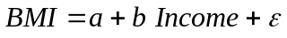 (3.8)
where a and b are the parameters to be estimated. Parameter a is sometimes referred to as the constant, or the intercept.
Parameter b refers to the slope of the line and shows the direction and magnitude of the impact of a change in income, for example, on the BMI. If a higher income level has a positive value of b, it implies that more affluent people are eating more, and getting fatter. If b is negative, it implies that affluent people are eating better food that lowers their BMI.
The last parameter is the error term ε. No regression analysis will fit the data exactly. Errors are likely and may reflect several causes. We may have omitted a variable, such education (more educated people may be more aware of the dangers of obesity and eat less). We may have measured one or more of the explanatory variables, or the dependent variable (the BMI itself – this could happen if the data are self-reported, and people overestimate their heights and underestimate their weights), inaccurately. All of these may stand in the way of our predicting the amount demanded exactly. In advanced econometric work, understanding ε is crucial for ensuring that the estimated parameters are accurate. Our exposition here will assume that ε obeys the rules to allow us to make appropriate inferences with OLS analyses. We will examine some exceptions later in the chapter.
A Simple Regression
Table 3-1a shows a simple regression of BMI on income in thousands of dollars.
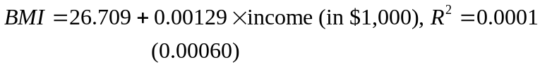 (3.9)
This equation indicates that a $1,000 increase in income is correlated with a very small (0.00129) increase in BMI. The standard error of estimate for the coefficient of income is 0.00060. This term is similar to the standard error of the estimated mean in the example of BMI for men and women earlier in the chapter. As before, the smaller the standard error, relative to the estimated value of b (in this case, 0.00129), the better the estimate. In this regression, the standard error of 0.00060 is relatively small compared to the coefficient, 0.00129; hence, the coefficient is significantly different from zero. The expression R² measures the fraction of the variation of the quantity of cigarettes explained by the price alone. An R² of 0.0001 implies that variation in income explained one-hundredth of one percent of the variation in BMI. In short, income alone explains some, but not very much of the variation in obesity, and its incremental impact is tiny.
It is useful to examine this simple regression in detail because it has many features that occur in more complex analyses. Consider the following hypothesis:
H₀: Income doesn’t matter; that is, b = 0 against the alternative hypothesis, which is:
H₁: Income is positively related to BMI; that is, b > 0. The test of the hypothesis is similar to a difference of means test. In particular, we are testing the difference between 0.00129 (estimated with standard error 0.00060) and 0.
The t-statistic here is 2.15; that is, the value of the coefficient, 0.00129, divided by the standard error of 0.00060. The value of 2.15 suggests that we can be more than 95 percent sure that the income has an increasing impact on BMI. This term is statistically different from zero.
If we have explained less than 1 percent of the variation of the BMI, then well over 99 percent is unexplained. In part, this occurs because the regression does not include some variables that are likely to be important. We noted earlier that several other variables might help explain more of the variation in BMI. The inclusion of more variables in a multiple regression is explained later.
This example also illustrates cross-sectional analysis, which provides snapshots of a slice of the population at one period in time. Because 2001–2002 was the first time that the NESARC was collected, it could not yet follow the people in the sample over time, and researchers could not be aware of continuing health problems, changes in wealth or income, or systematic differences in health or ability (that cannot be measured), that cross-sectional models treat as “random noise.” As a result, cross-sectional regressions often explain less variance than panel data, which follow units of observation (individuals or households) over time, or time-series data, which calculate aggregates over time.
Estimating Elasticities
Analysts also use regressions to estimate elasticities. The definition of the income elasticity of demand (E_{y}) is the percentage change in quantity demanded, elicited by a 1 percent change in income and written as:
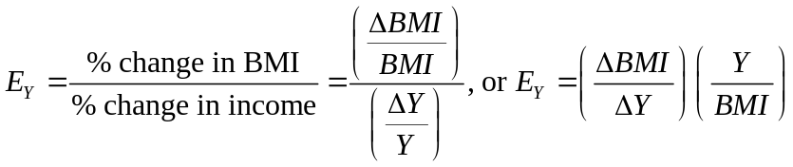
ΔY stands for a one-unit (here $1,000) change in the income, while ΔBMI represents the resulting change in the BMI. It follows that ΔBMI/BMI is a measure of the percentage change in quantity, whereas ΔY/Y is a measure of the percentage change in income. In rearranging terms at the right, the term ΔBMI/ΔY represents the ratio of changes. With the linear function here, this is 0.00129.
In calculating an elasticity from coefficients estimated in a regression, we could find a different elasticity at any given income. Therefore, we want reference values for BMI and Y, and the mean (or average) values are often used. In our sample, the mean BMI is 26.75, and the mean income (in dollars x 1,000) is 29.86.
Hence, calculated at the mean,
(3.10)
This says that a 10 percent increase in the income relates to (and possibly causes) a 0.14 percent increase in BMI. Does this make sense? Certainly at lower income levels (close to starvation, perhaps), increased income allows people to buy food to live on and fight malnutrition. However, at higher income levels, it is possible that the relationship could change.
Multiple Regression Analysis
Real-world relationships are seldom two-dimensional, as useful as this situation would be in drawing graphs. BMI may differ by gender, race, and ethnicity, and it may also relate to age and life-style variables. Some variables which are crucially important to determining BMI such as basal metabolic rate (the rate at which the body metabolizes nutrition), may not be available outside of a clinical setting. Indeed, the omission of important variables may lead to particular behavior in the error term ε.
If we could graph each relationship, assuming that nothing else was changing, then simple regression would work fine. Fortunately, however, the mathematics necessary to estimate the appropriate relationship can easily accommodate more than two dimensions. We write the following multiple regression:
(3.11)
where:
Y = income;
G = gender (male or female)
A = age
E = ethnicity
O = all other variables, including health and life-style variables

Although the example presented in Table 3-1 will now summarize numerous dimensions rather than original two dimensions, we use exactly the same least-squares criteria as before. The interpretation of the coefficients is similar to before but we can do it with more confidence. With the simple regression, relating BMI only to Y, the econometrician would not know whether gender, or age, or life-style, was varying as well. Including them in this regression allows us to “hold constant” these other variables and reduce the error. As a result, effects can now be calculated under the condition that “all else is equal.” The R² measure of variation explained earlier also is available here.
R² will always rise with more variables. (Adding additional variables cannot explain less of the variation!) Several methods can be used to interpret R², and some statisticians wish to maximize R²; that is, to explain as much variation as possible. While this may be desirable, most econometricians are at least as interested in the values of the parameters estimated.
Interpreting Regression Coefficients
Table 3-1a shows the result of a multivariate regression of BMI against a number of factors that might affect it.
(3.9)
This equation verifies the earlier finding from the simple comparisons, that men are more likely to be obese, but it also indicates that African-Americans, people with spouses, and Hispanics are all likely to have higher BMIs. Health is an index (where 1 is good, and 5 is bad), so bad health is correlated with a higher BMI. The affect of age is non-linear. Evaluating the coefficients, people tend to have increasing BMIs up to age 50, but they fall off slightly after that. Income, which showed a slight positive impact in the simple regression, now shows a slight negative, but insignificant, impact here. All in all, the regression explains about 8.6 percent of the BMI.
Regression (b) adds some interesting covariates relating to “life-style” behaviors. It turns out that both lifetime alcohol abstainers, as well as those who drink monthly, have BMI values about 0.6 less than others. Current users of addictive drugs have BMIs that are about -0.25 points lower than others. Current smokers have BMIs about -0.88 points less (smoking apparently does keep the weight down), while ex-smokers have BMI values about 0.2 points higher. Income, which had seemed to be slightly positive in its impact in earlier regressions, has a slightly negative and statistically insignificant impact, in the full regression.
Most often, econometricians are interested in whether coefficients are positive or negative and whether they differ significantly from zero. In a now famous example, Box 3-2 presents the surprising results of a detailed multivariate analysis looking at the impacts of hormone replacement therapy on postmenopausal women.

Box 3-2
Hormone Replacement Therapy—Rigorous Statistics Reveal Surprising Results
As of July 2002, approximately 38 percent of postmenopausal women in the United States used hormone replacement therapy (HRT). While the U.S. Food and Drug Administration-approved indications for HRT included relief of menopausal symptoms (hot flashes, night sweats, and vaginal dryness) and prevention of osteoporosis, long-term use had been common to prevent a range of chronic conditions, especially heart disease. Advertisements by drug companies urged women to take HRT so they would stay “forever feminine.”
Many scientists had expressed concern that studies finding benefits of HRT were based on nonrandom samples of women who sought out the hormone therapy. Users of HRT were better educated and healthier than postmenopausal women who did not take HRT. Thus, some researchers felt that “selection bias” could account for the effectiveness of HRT because those women for whom it was not effective and those who found the side effects bothersome or harmful, as well as less educated and sicker women, were not included in the studies.
Between 1993 and 1998, a randomized clinical trial called the Women’s Health Initiative (WHI) studied 16,608 postmenopausal women aged 50 to 79. The study randomly assigned roughly half of the participants to the experimental group receiving HRT, a daily tablet containing conjugated equine estrogen and medroxy progesterone acetate (progestin). It assigned the other half to the control group receiving a placebo (an inert pill with no medical properties). Study participants were contacted by telephone six weeks after randomization to assess symptoms and reinforce adherence. Follow-up for clinical events occurred every six months with annual in-clinic visits required.
Researchers measured a multitude of health outcomes related to cardiovascular disease, stroke, cancer, fractures, and death. The complex statistical analysis compared health outcomes for the experimental group who took the estrogen/progestin tablet to the control group who took the placebo. Formal monitoring began in the fall of 1997, with the expectation of final analysis in 2005 after an average of approximately 8.5 years of follow-up. An independent data and safety monitoring board (DSMB) examined interim results to determine whether the trial should be stopped early, if the treatment proved either significantly beneficial or harmful to the experimental group relative to the control group (a practice known as a “stop rule”).
By May 2002, an average of 5.2 years into the analysis (recall that women had entered the study over a 5-year period), the DSMB found significantly higher risks of breast cancer, coronary heart disease, stroke, and pulmonary embolism in the experimental group, and that these increased probabilities outweighed some evidence of reduced risk of fractures and colon cancer. Therefore, the DSMB invoked the stop rule for the estrogen plus progestin component of the trial because it would be unethical to put more women at risk for adverse events by continuing HRT. Study results appeared in the Journal of the American Medical Association, and due to the results received wide publicity. A treatment that the medical profession had taken for granted as beneficial in reducing menopausal symptoms and preventing heart disease had faced a carefully designed randomized clinical trial. The results sent shock waves that continue to reverberate through the medical system years later. Further studies have repeatedly verified the original findings that women and their providers must balance any hormone replacement benefits against its demonstrable risks.
Sources: Writing Group for the Women’s Health Initiative Investigators (2002); Fletcher and Colditz (2002).
Dummy Variables
Health care researchers often seek to find whether particular groups of patients or subjects differ from others. For example, Table 3-1 denoted men, African Americans, and Hispanics, using 1 if the person was a member of such a group and zero otherwise. These groups were indicated by using binary, or dummy, variables. Econometricians may also wish to indicate whether research subjects are white (white = 1), or not (white = 0), or whether the subject is a woman (female = 1) or not (female = 0).
Regression 3.b shows an important interaction between race and gender. In Regression 3.a, if we compare African-American men to white women, we add the coefficients 0.8967 (for male) + 1.6142 (for African-American) or find that on average the BMIs of the African-American men are about 2.50 points higher. Several government findings indicate, however, that many African-American women have high BMIs, due perhaps to diet or life-style preferences. In regression b, we add an additional variable if the person is both African-American and male. It is statistically significant, and it gives an interesting finding. Relative to white women:
White men – BMI = + 1.2776
African-American women – BMI = +2.5127
African-American Men – BMI = 1.2776 (men)+ 2.5127 (Afr-Am) – 2.1862 (Interaction)
= +1.6041
White men (+1.2776) and African-American men (+1.6041) have higher BMIs than white women. African-American women’s BMIs (+2.5127) are close to another point higher.
Statistical Inference in the Sciences and Social Sciences
Natural scientists attempt to control experimentally, and not always successfully, for all of the other possible sorts of variation. By contrast, econometricians are seldom so fortunate. Experimental economic studies have been rare and expensive. One such study was the multimillion-dollar health insurance experiment conducted by the RAND Corporation in the late 1970s and early 1980s, funded by the federal government, and we discuss parts of that study in several later sections of the book. (Newhouse and collaborators, 1993.) Even with the careful planning that went into this study’s experimental design, it could not avoid some major analytical issues.
Other fields have similar problems. A 1988 report from the Panel of the Institute of Mathematical Statistics referred to analytical problems in chemistry:
The data are frequently complex with a large number of dimensions, may sometimes have a time element, and can be further complicated because of missing values. In some instances, standard multivariate or time-series methods may suffice for analysis, but, more commonly, novel developments are required, for example, to handle the problem of multivariate calibration (Olkin and Sacks, 1988, p. II-1).
Econometricians must most often use natural experiments and must seek ways to account for the other variations. Because many policies, such as the provision of public health services or the regulation of the prescription drug industry, depend on accurate measurement of economic phenomena, it is essential that the measurements be accomplished carefully and scientifically.
A 2011 report from the Center for Turbulence Research at Stanford University examines experimental uncertainties in determining chemical reaction rates, tracing them to problems in measuring activation energy and collision frequency. They note:
…very seldom can a reaction rate be measured in experiments without making use of another [sic] chemical reactions for its determination … This suggests that all uncertainties in chemical mechanisms are interwoven in a very experiment-specific manner, and that some of the regions predicted by independent random-variable models of uncertainties in multiple-reaction mechanisms are likely not physically accessible. Further research is needed to clarify these points. (Kseib, Urzay, and Iaccarino, 2011)

Econometricians must most often use natural experiments and must seek ways to account for the other variations. Because many policies, such as the provision of public health services or the regulation of the prescription drug industry, depend on accurate measurement of economic phenomena, it is essential that the measurements be accomplished carefully and scientifically.
Conclusions
This chapter has provided a “taste” of the statistical methods necessary to address questions that occur in health economics and to clarify the analyses where statistical material is presented later in the text. Students should be able to formulate questions in terms of hypotheses, read statistical test results to determine significance of results, understand statistical significance, and interpret reported regression results. Emphasizing problems to watch for in statistical analysis does not mean that researchers should be unduly skeptical over the statistical data. On the contrary, we seek to distinguish the best studies in which to place our confidence.
Summary
1. Economists usually must collect information from people doing day-to-day activities and use statistical methods to control for the confounding differences among the people that they are analyzing. The more successful they are in controlling for such differences, the more reliable the analysis will be.
2. Statistical methods suggest formulating economic assertions as hypotheses, and collecting data to determine whether the hypotheses are correct.
3. Hypotheses that test for equality among two or more items are called simple hypotheses. Hypotheses that test whether two or more items are greater (or less) than each other, are called composite hypotheses.
4. To test hypotheses appropriately, the econometrician must:
• state the hypothesis clearly,
• choose a sample that is suitable to the task of testing,
• calculate the appropriate measures of central tendency and dispersion, and
• draw the appropriate inferences.
5. Regression analysis allows the econometrician to fit a straight line through a set of data points. In ordinary least-squares regression, the sum of the squared deviations of the actual data points from the line is minimized.
6. R² measures the proportion of the total variation explained by the regression model. While it may be desirable to maximize R², most econometricians are at least as interested in the values of the estimated parameters.
7. Important skills in statistical analysis include:
• understanding statistical significance,
• interpreting reported statistical results, and
• detecting problems in reported statistical findings.
Discussion Questions
1. List at least three ways in which natural experiments differ from laboratory experiments.
2. What is the difference between a simple hypothesis and a composite hypothesis? Why might economists choose one over another?
3. In considering the difference in smoking between men and women, what is the null hypothesis? What is the alternative hypothesis? Is the alternative hypothesis simple or composite?
4. Suppose that we wish to compare the health status of two groups of people. What variable might we use to measure the status? What variables might we wish to control in order to draw the appropriate inferences?
5. If someone reports that the mean weight for fourth-grade boys is 80 pounds and for fourth-grade girls is 78 pounds, what must you know to test hypotheses using the difference of means?
6. If we are trying to relate output to labor inputs and capital inputs using regression analysis, would we expect the coefficients of the regressions to be positive or negative? Why?
7. What are dummy variables? How are they useful in identifying differences among groups?
8. Suppose that you used regression methods to estimate the demand curve for physician visits and found a positive relationship; that is, you found that the higher the price is, the more visits are demanded. What problem has likely arisen? Explain the problem in words. Why might it make statistical inference difficult?
9. Rich people consume more health care services than poor people. Explain two ways one might test this hypothesis.
Exercises
(For students with access to statistical software or spreadsheet programs) Consider the following data for a cross section of individuals in the population, in which
Q = Quantity (in 100s) of aspirin purchased in a year
P = Average price of aspirin in that year
Y = Annual income
A = Age of buyer
Observation | Q | P | Y | A
1 | 1 | 1.5 | 20 | 25
2 | 2 | 1.5 | 40 | 20
3 | 4 | 1 | 12 | 25
4 | 2 | 1 | 10 | 30
5 | 2 | 1 | 8 | 30
6 | 3 | 2 | 30 | 35
7 | 3.5 | 1.5 | 30 | 40
8 | 4 | 2 | 20 | 40
9 | 7 | 1 | 20 | 45
10 | 1 | 3 | 15 | 40
11 | 2 | 2 | 18 | 30
12 | 3 | 2 | 20 | 32
13 | 3.5 | 2 | 15 | 36
14 | 4 | 2 | 10 | 30
15 | 2 | 3 | 25 | 20
16 | 1 | 4 | 15 | 25
17 | 8 | 2 | 15 | 55
18 | 9 | 1 | 40 | 50
19 | 1 | 4 | 10 | 45
20 | 10 | 1.5 | 30 | 55
21 | 6 | 1.5 | 35 | 60
22 | 2 | 1 | 30 | 40
23 | 3 | 1 | 25 | 40
24 | 3 | 2 | 20 | 35
25 | 3 | 2 | 15 | 35
26 | 4 | 3 | 20 | 35
27 | 1 | 4 | 20 | 25
28 | 1 | 4 | 25 | 30
29 | 2 | 5 | 28 | 30
30 | 3 | 1 | 30 | 32
Now consider questions 1 to 4:
1. If we divide the population into two groups, up to age 35 and over age 35, which group purchases more aspirin?
2. Divide the population into three groups—up to age 30, over 30 and up to 45, and over 45. Do the purchases vary by age?
3. What is the relationship in a regression analysis between Q and P? Between Q and Y? Between Q and A?
4. Calculate the multiple regression that relates Q with P, Y, and A. Which variables are statistically significant? What is the elasticity of Q with respect to P, to Y, and/or to A?
5. From Table 3-1, column b, suppose income is $20,000, the excise tax on cigarettes is $1, and the person is a 40-year-old white, non-Hispanic male who completed high school (education level = 9). Calculate the elasticities of demand for aspirin with respect to excise tax, income, and age.
6. Consider demand curves for aspirin, estimated for two different sets of consumers:
(a) Q = 20 – 5P + 0.2Y
(b) Q = 30 – 5P + 0.2Y
If Y = $20 and P = $1, calculate the price and income elasticities for group (a) and group (b). Whose elasticities will be higher? Why?
7. Given the regression estimate of the demand equation of
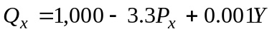
where Y is income, what is the change in demand if price rises by $1, holding income constant? What is the percentage change in demand if price rises by $1 from an initial price of P_{x} = $200 given Y = 10,000? What is the effect on demand of a $1 increase in income, holding price constant?
8. Consider the estimate demand equation of
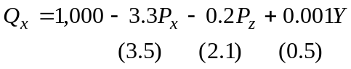
with t values in parentheses, where P_{z} is the price of another good Z, and Y is income. Is good Z a substitute or a complement? Can we say confidently whether good X is a normal good or an inferior good?
9. Look at Regression (b) in Table 3-1, and consider the following questions:
(a) Does BMI increase as income rises?
(b) Using the variables Age and Age-squared, calculate the changes in BMI between the ages of 25 and 35; 35 and 45; 45 and 55; 55 and 65. Are these changes constant? Why or why not?
10. Table 21-1 shows GDP/capita and total health care spending per capita for 42 countries (the first two columns of numbers).
(a) Calculate the means of both variables.
(b) Calculate a regression relating health care spending to GDP/capita.
(c) Using the method discussed in equation (3.10) calculate the income elasticity of health expenditures.
(d) What does your answer to part c indicate about the “share” of GDP/capita going to health? Why?

Figure 3-1 BMI by Gender, 2001–2002

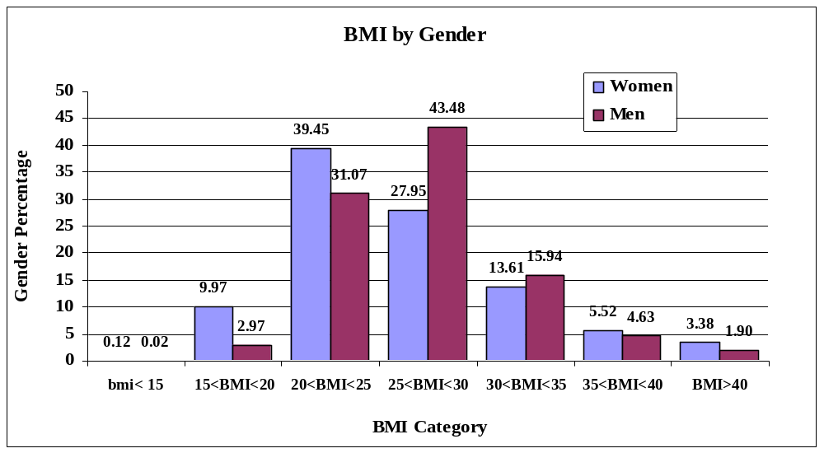
Overweight
Obese
Table 3-1 – Economic Determinants of BMI
 |  | (a) |  |  |  |  |  | (b)*
Determinants of BMI |  | Coeff | Std.Error | t-test |  |  |  | Coeff | Std.Error | t-test
Intercept |  | 17.50638 | 0.18327 | 95.52 |  |  |  | 18.02081 | 0.22234 | 81.05
(0 if female; 1 if male) |  | 0.89674 | 0.05311 | 16.88 |  |  |  | 1.27763 | 0.05721 | 22.33
(1 if African-Am; 0 otherwise) |  | 1.61420 | 0.08288 | 19.48 |  |  |  | 2.51273 | 0.11202 | 22.43
age |  | 0.29164 | 0.00811 | 35.96 |  |  |  | 0.28948 | 0.00817 | 35.42
age*age |  | -0.00290 | 8.02E-05 | -36.20 |  |  |  | -0.00295 | 8.09E-05 | -36.44
Health status (1 = excellent – 5 = poor) |  | 0.93704 | 0.02464 | 38.03 |  |  |  | 0.94584 | 0.02513 | 37.64
(1 if spouse; 0 otherwise) |  | 0.14897 | 0.05566 | 2.68 |  |  |  | 0.08652 | 0.05559 | 1.56
(1 if Hispanic; 0 otherwise) |  | 0.59101 | 0.08263 | 7.15 |  |  |  | 0.60297 | 0.08515 | 7.08
(1 if African-Am+male; 0 otherwise) |  |  |  |  |  |  |  | -2.18621 | 0.16274 | -13.43
Income x 1,000 |  | -0.000552 | 0.00061 | -0.91 |  |  |  | -0.000557 | 0.00061 | -0.92
1 if lifetime alcohol abstainer |  |  |  |  |  |  |  | -0.61792 | 0.08068 | -7.66
1 if monthly drinker |  |  |  |  |  |  |  | -0.59014 | 0.05964 | -9.89
1 if binge drinker |  |  |  |  |  |  |  | -0.01183 | 0.01516 | -0.78
1 if uses addictive drugs |  |  |  |  |  |  |  | -0.25827 | 0.11421 | -2.26
1 if previously used addictive drugs |  |  |  |  |  |  |  | -0.01750 | 0.07381 | -0.24
1 if “ever smoked” |  |  |  |  |  |  |  | 0.19791 | 0.07077 | 2.80
1 if “currently smokes |  |  |  |  |  |  |  | -0.88209 | 0.07724 | -11.42
R² |  | 0.0864 |  |  |  |  |  | 0.0986
* Regression contains geographic regions, which are statistically significant.
Source: Computations from National Epidemiologic Survey on Alcohol and Related Conditions (NESARC) by A. Goodman, 2014.

Figure 3 – 2 Difference of Means Test for BMI

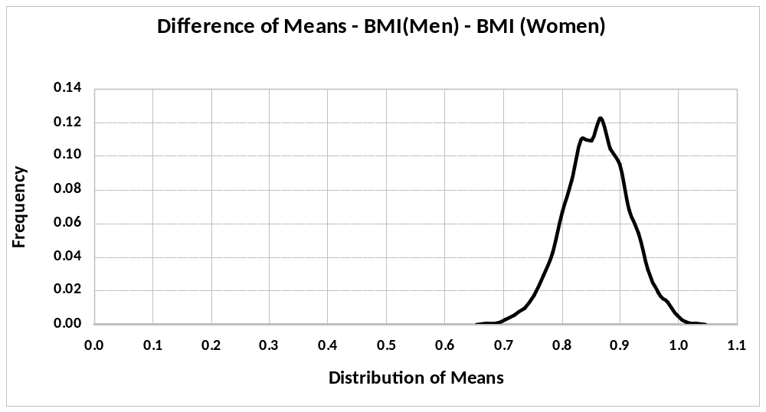
Mean = 0.8527
Std. error = 0.0536

If we were working with a sample (as opposed to the entire population), we calculate the standard error by dividing by n - 1. All calculations are rounded to the nearest hundredth.
Although difference of means considers only two categories, analysis of variance methods allow the consideration of three or more categories in a more general way (difference of means is actually a restricted version of analysis of variance). Newbold, Carlson, and Thorne (2007) present good discussions on this and other statistical topics.
R² is often adjusted for number of explanatory variables k and number of observations n: 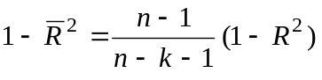 Adding more variables k will always raise R² but may not raise 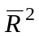, the “adjusted R²”.
See, for example, U. S, Dept of HHS, Office on Women’s Health (2010), which indicates that about 4 in 5 African American women are overweight or obese.

