Chapter 8
Demand and Supply of Health Insurance
 What Is Insurance?
 Risk and Insurance
 The Demand for Insurance
 The Supply of Insurance
 The Case of Moral Hazard
 Health Insurance and the Efficient Allocation of Resources
 Income Transfer Effects of Insurance
 Conclusions
Health insurance underlies any discussion of the health economy. Most Americans, and indeed most citizens of other countries, do not pay directly for their health care. Rather, private or public insurers pay for much of the care, with the consumer paying only a portion of the bill directly. This portion is sometimes called coinsurance. Insurance coverage is provided through the payment of premiums (in privately financed systems) or taxes (when insurance is provided publicly). In the United States, the premiums have often, although not always, been purchased and paid for through the consumer’s participation in the labor force.
Health care expenses are uncertain because many illnesses occur rarely and seemingly at random. When they do, they may cost a great deal, and they can be financially troublesome if not ruinous to households. Costs could be so high that without financial help, treatment might not be available.
Because insurance is so important to the demand and supply of health care, as well as the government’s role in allocating health resources, we spend this entire chapter on the demand and supply of insurance in general, and health insurance in particular. This provides a set of tools for addressing issues such as the demand for and supply of health care, the role of information in health care markets, and the variation of health care among various markets. We return to insurance issues in Chapter 11, which will look at the operation of insurance markets.
What is Insurance?
Consider the demand for insurance without all of the detailed trappings (deductibles, premiums, coinsurance, etc.) that accompany modern insurance plans. Start with a club with 100 members. The members are about the same age, and they have about the same interests and lifestyles. About once a year one of the 100 members gets sick and incurs health care costs of $5,000. The incidence of illness seems to be random, not necessarily striking men, women, the old, or the young in any systematic fashion. Club members, worried about potential financial losses due to illness, decide to collect $50 from each member and put the $5,000 in the bank for safekeeping and to earn a little interest. If a member becomes ill, the fund pays for the treatment. This, in a nutshell, is insurance. The members have paid $50 in advance to avoid the risk or uncertainty, however small, of having to pay $5,000. The “insurer” collects the money, tries to maintain and/or increase its value through investment, and pays claims when asked.
This example illustrates several desirable characteristics of an insurance arrangement.
1. The number of insured should be large, and they should be independently exposed to the potential loss.
2. The losses covered should be definite in time, place, and amount.
3. The chance of loss should be measurable.
4. The loss should be accidental from the viewpoint of the person who is insured.
Insurance generally reduces the variability of the incomes of those insured by pooling a large number of people and operating on the principle of the law of large numbers. That is, although outlays for a health event may be highly variable for any given person in the insurance pool, insurers can predict the average outlays for the group. The law of large numbers shows that for a given probability of illness, the distribution of the average rate of illness in the group will collapse around the probability of illness as the group size increases.
This chapter considers the theory and practice of health care insurance. It shows the necessity of quantifying risk, as well as attitudes toward risk. With those ideas, we consider the structure of insurance policies and how markets evolve to provide them.
Insurance Versus Social Insurance
We wish to distinguish between insurance as provided through the pooling of risk, and government programs (often referred to as social insurance), such as Social Security, Medicare, and Medicaid in the United States. Insurance is provided through markets in which buyers protect themselves against rare events with probabilities that can be estimated statistically. The government programs use the government as insurer and are distinguished by two features:
1. Premiums (the amounts paid by purchasers) are heavily and often completely (as in the case of Medicaid) subsidized.
2. Participation is constrained according to government-set eligibility rules.
In addition, government insurance programs often transfer income from one segment of society to another. Given the importance of such social insurance programs, we devote an entire chapter (Chapter 21) to them later in the text.
Insurance Terminology
Consider some terms that we use to discuss insurance. Although much of the analysis uses the standard economic language of prices and quantities, the insurance industry has developed a particular set of definitions. These include:
Premium, Coverage—When people buy insurance policies, they typically pay premiums for a given amount of coverage should the event occur. For example, an insured person may pay a $50 premium for $1,000 of coverage.
Coinsurance and Copayment—Many insurance policies, particularly in the health insurance industry, require that when events occur, the insured person share the loss through copayments. This percentage paid by the insured person is the coinsurance rate. With a 20 percent coinsurance rate, an insured person, for example, would be liable (out-of-pocket) for a $30 copayment out of a $150 charge. The insurance company would pay the $120 remainder, or 80 percent. Thus, coinsurance refers to the percentage paid by the insured; copayment refers to the amount paid by the insured (such as a fixed payment for a prescription).
Deductible—With many policies, the insured must pay some amount of the health care cost in the form of a deductible, irrespective of coinsurance. In a sense, the insurance does not apply until the consumer pays the deductible. Deductibles may apply toward individual claims. Often in the case of health insurance they apply only to a certain amount of total charges in any given year.
Insurers often use coinsurance and deductibles together. An insurance policy may require that Elizabeth pay the first $250 of her medical expenses out of pocket each year. It may then require that she pay 20 percent of each additional dollar in charges. This policy then has a deductible of $250 and a coinsurance rate of 20 percent.
Many feel that deductibles and coinsurance simply represent ways that insurance companies have found to separate consumers from their money. Economists, in contrast, have explained that deductibles and coinsurance may lead to desirable economic consequences. The copayment requirement makes consumers more alert to differences in the true costs of the treatment they are purchasing. Charging deductibles discourages frivolous claims or visits, and it also makes insured people more aware of the results of their actions. Both deductibles and coinsurance may serve to avoid claims and to reduce costs.
Finally, a few other terms describe various features of insurance:
Exclusions—Services or conditions not covered by the insurance policy, such as cosmetic or experimental treatments.
Limitations—Maximum coverages provided by insurance policies. For example, a policy may provide a maximum of $3 million lifetime coverage.
Pre-existing Conditions—Medical problems not covered if the problems existed prior to issuance of insurance policy. Examples here might include pregnancy, cancer, or HIV/AIDS. The Affordable Care Act (ACA) of 2010 prohibits the denial of insurance coverage due to pre-existing conditions.
Pure Premiums—The actuarial losses associated with the events being insured.
Loading Fees—General costs associated with the insurance company doing business, such as sales, advertising, or profit.
With these in mind, we turn to a more formal analysis of risk and insurance.
Risk and Insurance
To this point we have assumed that all decisions occur under conditions of certainty; that is, consumers know what the prices, incomes, and tastes are and will be. Clearly, however, many decisions are made under conditions in which the outcome is risky or uncertain. Students should know that economists sometimes contrast risk where the probability of an adverse effect is known (like the odds of a roulette wheel), with uncertainty, where the probability is not known (the odds of a nuclear plant meltdown). Our discussion will use the terms interchangeably.
We begin by considering the insurance coverage of an event that occurs with the known probability, p, leading to a predictable loss and/or payment. This assumption will characterize people’s choices under uncertainty. We will then extend the general characterization to health insurance, where the payment may be affected by the insurance. We address this difference once the basic points regarding risk are developed.
Expected Value
Suppose Elizabeth considers playing a “coin flip” game. If the coin comes up heads, Elizabeth will win $1; if it comes up tails, she will win nothing. How much would Elizabeth be willing to pay in order to play this game? Analysts rely on the concept of expected value for the answer. With an honest coin, the probability of heads is one-half (0.5), as is the probability of tails. The expected value, sometimes called the expected return, is:
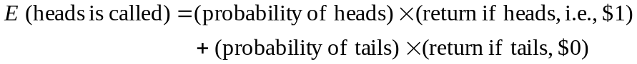 (8.1)
The expected value is $0.50; that is (¹⁄₂ × 1) + (¹⁄₂ × 0). If she uses the decision criterion that she will play the game if the expected return exceeds the expected cost, Elizabeth will play (pass) if it costs her less (more) than $0.50. More generally, with n outcomes, expected value E is written as:
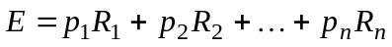
where p_{i} is the probability of outcome i, (that is p₁ or p₂, through p_{n}) and R_{i} is the return if outcome i occurs. The sum of the probabilities p_{i} equals 1.
The special case where the price of the gamble is exactly $0.50 and equals the expected return is analogous to an insurance situation in which the expected benefits paid out by the insurance company equal the premiums taken in. This equality of expected benefit payments and premiums is called an actuarially fair insurance policy. In reality, insurance companies must also cover additional administration and transaction costs to break even (the loading costs discussed earlier), but the definition of an actuarially fair policy provides a benchmark in talking about insurance.
Marginal Utility of Wealth and Risk Aversion
The foregoing example implies that Elizabeth is indifferent to risk. That is, her incremental pleasure of winning $0.50 (the gain of $1 less the $0.50 she paid to play) is exactly balanced by her incremental displeasure of losing $0.50 (the gain of zero less the $0.50 paid to play). Suppose we now increase the bets so that the coin flip now yields $100, or nothing, and that Elizabeth is now asked to bet $50 to play. Actuarially this is the same bet as before, but Elizabeth may now think a little harder. She may now refuse an actuarially fair bet—$50—on the grounds that she cannot afford to risk the $50 loss if the coin lands tails. This suggests that the disutility of losing $50 may exceed the utility of winning $50. This would occur if she felt that the utility of an extra dollar of wealth greater if she has less money than the utility of an extra dollar of wealth when she has more. The utility from an extra dollar is called the marginal utility of wealth.
It is important to incorporate Elizabeth’s utility of wealth function into the analysis. In Chapter 2, we assumed that consumers could rank bundles but could not (and need not) compare magnitudes of satisfaction. Here, however, to understand the utility model of risk behavior, we must further assume that consumers can rank alternatives and compare their magnitudes.
In Figure 8-1 suppose that Elizabeth’s wealth is $10,000. That wealth gives her a utility level of U₁ = 140 and allows her to buy some basic necessities of life. This can be denoted as point A. Suppose her wealth rises to $20,000. Will her utility double?
While it is hard to be certain, most likely the next $10,000 will not bring her the incremental utility that the first $10,000 brought. So, while U₂ is certainly higher than U₁, it (U₂) will likely be less than twice U₁. Suppose, for example, that U₂ = 200. This is denoted as point B. Do all of the points on the utility function between U₁ and U₂ lie on a straight line? If they do, this is equivalent to saying that the utility from the 10,001st dollar is equal to the utility from the 19,999th dollar, and hence the marginal utility is constant. This also is unlikely. Because the marginal utility of earlier dollars is likely to be larger than that of later dollars, the utility curve is likely to be bowed out, or concave, to the x-axis.
The marginal utility of wealth refers to the amount by which utility increases when wealth goes up by $1. This rise in utility, divided by the $1 increase in wealth, is thus the slope of the utility function. The bowed shape of the utility function shows a slope that is getting smaller or flatter as wealth rises; the marginal utility of wealth is diminishing.
Elizabeth begins with wealth of $20,000, but understands that if she falls ill, which may occur with probability 0.10, the expenses will cause her wealth to decline to $10,000. If this occurs, she can calculate her expected wealth, E(W),
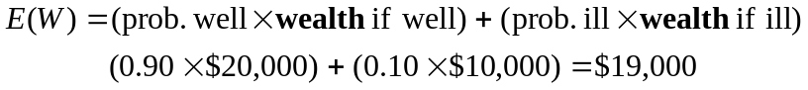 (8.2a)
and expected utility, E(U):
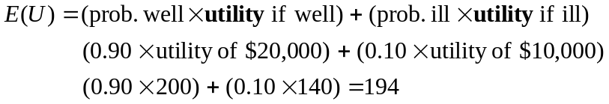 (8.2b)
Thus, the expected utility E(U) is 194 or point C because of the risk of illness. Geometrically, this is the line segment between points A and B, evaluated at wealth level E(W) = $19,000. The expected utility due to risk must be compared to the utility of 198 (point D), corresponding to the utility that she would receive if she could purchase insurance at an actuarially fair rate. As drawn, the risk of loss puts her on the line below the curve indicating certainty, and leads to a loss of 4 units (198 to 194) of utility. To be clear, Elizabeth worries that her wealth may be either $10,000 or $20,000, and this uncertainty costs her utility. She would have higher utility if she could eliminate this uncertainty.

Purchasing Insurance
Suppose that Elizabeth can buy an insurance policy with a premium of $1,000 per year that will maintain her wealth irrespective of her health, thus eliminating the uncertainty. That is, if she stays well, her wealth will be $20,000 less the $1,000 premium. If she falls ill, she is provided $10,000 in benefits, so that her wealth will be $10,000 plus the $10,000 in benefits, less the $1,000 premium. She is certain to have $19,000 at the end of the year.
Is it a good buy? At a net wealth of $19,000, which equals her initial wealth minus the insurance premium, Elizabeth’s certainty utility is 198. She is better off at point D than at point C, as shown by the fact that point D gives the higher utility. If insuring to get a certain wealth rather than facing the risky prospect makes Elizabeth better off, she will insure.
We can, in fact, use Figure 8-1 to calculate the maximum amount that Elizabeth would be willing to pay for the insurance by moving southwest down the utility function to the level of U = 194 and reading the level of wealth (off the x-axis) to which it corresponds, or point F. The distance FC reflects Elizabeth’s aversion to risk. At point F, Elizabeth would be willing to pay up to $4,000 (that is, initial wealth of $20,000, less $16,000 at point F) for insurance and still be as well off as if she had remained uninsured. If, for example, she were able to purchase the insurance for $3,000, she would get $1,000 in consumer surplus.
This analysis illustrates several facts:
1. Consumers will buy insurance only when there is diminishing marginal utility of wealth or income—that is, when the consumer is risk-averse. In Figure 8-1, if marginal utility is constant, a requirement that Elizabeth pay an actuarially fair premium for insurance would leave her no better off than if she were uninsured. If Elizabeth is “risk-loving,” with increasing marginal utility of wealth or income, she will definitely refuse to buy insurance.
2. Expected utility is an average measure; Elizabeth either wins or loses the bet. If exposed to risk, Elizabeth will have wealth and hence utility of either $20,000 (with utility of 200), or $10,000 (with utility of 140), and a risky expected wealth of $19,000. Insurance will guarantee her wealth to be $19,000. If she stays well, her wealth will be $20,000 less the $1,000 insurance premium; if she falls ill, her wealth will be $10,000 plus the $10,000 payment for the loss of health, minus the $1,000 premium—again $19,000.
3. If insurance companies charge more than the actuarially fair premium, people will have less expected wealth from insuring than from not insuring. Even though they will have less wealth as a result of their insurance purchases, the increased well-being comes from the elimination of risk.
4. The willingness to buy insurance is related to the distance between the utility curve and the expected utility line. If Elizabeth is very unlikely to become ill, (near point B), then her expected utility will be almost identical to her certainty utility, and her gains from insurance will be small. If Elizabeth’s probability of illness increases to 0.5 (point C´), her expected wealth will be $15,000 and her expected utility will be 170. She will accrue significant gains by insuring as noted by the distance C´D´. However, if Elizabeth is almost certain to fall ill, (approaching point A), her gains from buying insurance decrease. Why? Here, she is better off “self-insuring,” by putting the (almost) $10,000 away to pay for her almost certain illness rather than incurring the trouble of buying insurance and then filing claims.
The Demand for Insurance
Exactly how much insurance will Elizabeth purchase? The next two sections present a classic model introduced by Mark Pauly in 1968 to consider the fundamental demand and supply decisions regarding insurance.
How Much Insurance?
Recall that Elizabeth’s expected utility involves her wealth when ill, with a probability of 0.10, or when healthy, with a probability of 0.90. If ill, her wealth will fall from $20,000 to $10,000.
We address Elizabeth’s optimal purchase using marginal benefits and marginal costs. Consider first a policy that provides insurance covering losses up to $500. Although Elizabeth might find it hard to justify buying a $500 insurance policy when she will lose $10,000 if she falls ill, it is a useful place to start.
The goal of maximizing total net benefits provides the framework for understanding her health insurance choice. She benefits from health insurance only when she is ill and receives the insurance benefit payments. She still pays the insurance premiums when ill, but gains financially net of those premiums. When well only the premium applies to her, and this is a net cost.
In turn when she is well, the marginal benefits will decline as she purchases additional insurance coverage; we understand this by applying the law of diminishing marginal utility of wealth. In contrast, again due to the diminishing marginal utility of wealth, the marginal costs when well will rise as when she purchases additional insurance. At the end, Elizabeth will buy insurance so that the marginal benefits of the last dollar spent equal the marginal costs.
Suppose she must pay a 20 percent premium ($100) for her insurance, or $2 for every $10 of coverage that she purchases. The following worksheet describes her wealth if she gets sick.
Insurance Worksheet—$500 coverage
Wealth If Ill
 | Original wealth | $20,000
less | Loss | $10,000
 | Remainder | $10,000
plus | Insurance | 500
 | Sum | $10,500
less | Premium | 100
or | New wealth | $10,400
For the initial coverage, Elizabeth’s wealth if well is $20,000 less the $100 premium, or $19,900. Her marginal benefit from the $500 from insurance is the expected marginal utility that the additional $400 ($500 minus the $100 premium) brings. Her marginal cost is the expected marginal utility that the $100 premium costs. We describe these benefits and costs in Figure 8-2. If Elizabeth is averse to risk, the marginal benefit (point A) of this insurance policy exceeds its marginal cost (point A´).
We can also see this in the original Figure 8-1. Point X refers to Elizabeth’s wealth if ill, and point Y to her wealth if healthy. By inspection, we see that the incremental (marginal) utility between points A and X increases much more than it decreases between points B and Y. Expected utility line XY lies above the original expected utility line AB. The first $500 of insurance is a good buy!
Should Elizabeth increase her coverage from $500 to $1,000? She must again compare the marginal benefits of this next $500 increment to its marginal costs. Because Elizabeth is slightly wealthier than before, if ill (starting at $10,400 rather than $10,000) the marginal utility from an additional $400 of wealth (calculated as before) will be slightly smaller than from the first $400. Hence, the marginal benefits from the second $500 insurance increment will be slightly smaller than for the first $500 increment. Her marginal benefit curve, MB₁, is downward sloping, with her new marginal benefit at point B.
Similarly, because if well she is a little less wealthy than before, an additional $100 in premiums will cost a little more in foregone (marginal) utility of wealth than the first increment at point B´. Thus, her marginal cost curve, MC₁, is upward sloping.
Continuing, we see that
Elizabeth will adjust amount of insurance q that she purchases to the point at which the marginal benefits equal the marginal cost. The quantity, q*, at which they are equal (point X) is Elizabeth’s optimum insurance purchase. The x-axis of Figure 8-2 is drawn to scale, and it shows that q* is approximately $3,000.
Changes in Premiums
How will her insurance decision change if premiums change, that is insurers raise the prices for the product they sell? Consider first the impact of a higher premium, say 25 percent rather than the 20 percent used earlier. With the 25 percent premium ($125), Elizabeth faces the following calculation for the starting $500 policy:
Insurance Worksheet—Higher Premium
Wealth If Ill
 | Original wealth | $20,000
less | Loss | $10,000
 | Remainder | $10,000
plus | Insurance | 500
 | Sum | $10,500
less | New premium | 125
or | New wealth | $10,375
If she stays well, her wealth is $20,000 less the $125 premium, or $19,875. Look now at Figure 8-3. Elizabeth’s marginal benefit from the $500 from insurance is now $375 rather than the previous value of $400, so point C lies on curve MB₂ below the previous marginal benefit curve, MB₁. We can fill in additional points on this curve, which reflects the higher premium.
Similarly, Elizabeth’s marginal cost is the expected marginal utility that the (new) $125 premium costs her. This exceeds the previous cost in terms of foregone utility, so point C lies on curve MC₂ above the previous marginal cost curve, MC₁. Again, we can fill in additional points on this curve and find the intersection of MB₂ and MC₂ at point Y. The resulting analysis suggests that consumers react rationally to higher premiums by reducing their optimum coverage from q* to q**. In this example, the purchase falls is from about $3,000 to $2,300.
Changes in Expected Loss
How will changes in expected losses affect the insurance decision be affected? Returning to the original example with a premium of 20 percent, suppose that instead of $10,000, Elizabeth expected to lose $15,000 if ill. Consider again the first $500 of insurance coverage. Her wealth, if healthy, is $19,900, so nothing changes with respect to marginal cost. Elizabeth remains on curve MC₁. The marginal benefit calculation, however, does change:
Insurance Worksheet—Higher Expected Loss
Wealth If Ill
 | Original wealth | $20,000
less | New loss | $15,000
 | Remainder | $ 5,000
plus | Insurance | 500
 | Sum | $ 5,500
less | Premium | 100
or | New wealth | $ 5,400
As before, the insurance gives her a net benefit of $400. However, this net benefit increments a wealth of $5,000 rather than $10,000. If we assume that an additional dollar gives more marginal benefit from a base of $5,000 than from a base of $10,000, then the marginal benefit curve shifts upward because of the increased expected loss. This provides equilibrium point Z on curve MB₃ in Figure 8-3. It follows that in equilibrium, an increase in the expected loss will increase the amount of insurance purchased at point Z, or q***. As drawn, q*** equals approximately $3,500.
Changes in Wealth
Finally, consider a change in initial wealth. Suppose Elizabeth started with a wealth of $25,000 instead of $20,000. Assume once again a premium rate of 20 percent.
Insurance Worksheet—Increased Wealth
Wealth If Ill
 | Increased wealth | $25,000
less | Loss | $10,000
 | Remainder | $15,000
plus | Insurance | 500
 | Sum | $15,500
less | Premium | 100
or | New wealth | $15,400
At the higher level of wealth, the same insurance policy provides a smaller increment in utility, so the marginal benefit curve shifts down from MB₁ to MB₂. However (for the same expected loss), the $100 premium costs less in foregone marginal utility relative to the increased wealth, a downward shift of MC₁ to MC₃. As a result of both downward shifts, the new equilibrium value of q at point W may be higher or lower than the original value of q* (as drawn in Figure 8-3, it is slightly lower, about $2,800). If, however, increased wealth is accompanied by increased losses, then the MB curve may shift down less. If it does shift down by less, the desired amount of insurance may increase because the increased expected losses would make a larger amount of insurance more desirable.
The Supply of Insurance
In the previous example, we assumed a 20 percent premium rate, but to determine the amount of coverage someone will buy, we must know how insurers determine the premium. We started this chapter with the club that insures its members against illness. The officers of the club do not know, nor necessarily care, who will file a claim. To function as an insurer, the club must simply see that that revenues cover costs. In practice, insurers will also incur administrative and other expenses that also must be covered by premiums.
Competition and Normal Profits
Let’s return to Elizabeth’s insurance problem from the previous section. In a competitive market, and under perfect competition, all firms earn zero excess profits. Recall that Elizabeth faced a potential illness with a probability of 0.10 (1 in 10). She sought to buy insurance in blocks of $500, and at the outset, her insurer, Asteroid Insurance, was charging her $100 for each block of coverage, or an insurance premium of 20 percent ($100 as a fraction of $500). Assume also that it costs Asteroid $8 annually to process each insurance policy and (if necessary) write a check to cover a claim. Asteroid’s profits per policy are:
Revenues are $100 per $500 policy. What are Asteroid’s costs? For 90 percent of the policies, costs are $8 because the insured does not get sick and does not collect insurance. The company pays only the $8 processing costs per policy. The costs for the other 10 percent of the policies costs are $508, consisting of the $500 payment to those who are ill plus the $8 processing costs.
Thus, the per policy profits for Asteroid are:
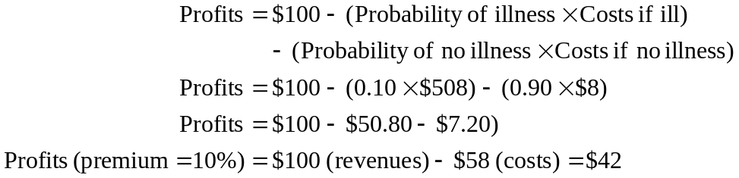 (8.3)
These are positive profits for Asteroid, and they imply that a competing firm, Comet Insurance, (also incurring costs of $8 to process each policy) might enter the market and charge a lower premium, say, 15 percent, to attract clients. The cost side of the equation would remain the same, but the revenues for the 2 competitors, which equal the premium fraction multiplied by the amount of insurance, would fall to $75. Hence, profits fall to:
which is still positive. We can see that entry will continue into this industry until the premium has fallen to a little less than 11.6 cents per dollar of insurance, which would provide revenues of $58, offset by the $58 in costs, to give zero profits.
Some algebra will verify that the 11.6% premium is directly related to the probability of the claim (10%). Quite simply, for Asteroid, the revenue per policy is aq, where a is the premium, in fractional terms. Algebraically, the cost per policy in terms of payout is the probability of payout, p, multiplied by the amount of payout, q, plus a processing cost, t, which is unrelated to the size of the policy (assuming it costs no more to administer a $10,000 policy than a $500 policy). So:
(8.4)
With perfect competition, profits must equal 0, so:
Profits = 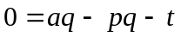
We solve for the competitive premium a as:
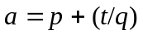 (8.5)
This expression shows that the competitive value of a equals the probability of illness, p, plus the processing (or loading) costs as a percentage of policy value, q, or t/q. If loading costs are 10 percent of the policy value, q, then (t/q) = 0.10. Hence, in equilibrium, if p equals 0.10, then a = p + (t/q) = (0.10 + 0.10) = 0.20. The premium for each dollar of insurance, q, is $0.20. If insurers charge less, they will not have enough money to pay claims. If they charge more, firms like Asteroid will earn excess profits, and other firms (like Comet) will bid down rates in perfectly competitive markets.
Previously, in discussing risk bearing, we considered insurance policies that would compensate Elizabeth against the loss based solely on the probability of the event’s occurring. We refer to such rates as actuarially fair rates. The actuarially fair rates correspond to the rates in which the loading costs t as a percentage of insurance coverage, q (that is, t/q), approach 0, hence:
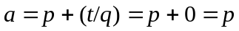 (8.6)
Knowing that premium a equals p under perfect competition (with no loading costs), we now solve for the optimal coverage against any expected loss. To maximize utility, Elizabeth will add coverage up to the point where her expected wealth will be the same whether she is ill or well. In the earliest example, the particular illness occurred with a probability of 0.10 and incurred a loss of $10,000. In a competitive insurance market (ignoring loading costs), Elizabeth’s wealth, if well, will be:
Wealth (if well) = $20,000 − cost of insurance, or:
Her wealth, if ill, will be:
To maximize the expected utility we equate the wealth if well with the wealth if ill:
(8.7)
Subtracting $20,000 − aq from both sides and rearranging terms yields:
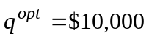
Elizabeth’s optimal level of coverage for a loss of $10,000 in the absence of transactions costs is $10,000, irrrespective of the probability of the event! It is more realistic of course to assume that transactions costs t will be positive; in fact, loading charges are often substantial. Under these circumstances, Elizabeth’s best choice is to insure for less than the full health expense, we show in the examples above, where the transactions costs were positive and optimal insurance q* was considerably smaller than $10,000. This standard result from the mathematics of health insurance contrasts with the propensity of consumers to seek full coverage.
The Case of Moral Hazard
To this point, we have discussed the theory of risk, as well as the demand and supply of insurance when the events and the losses are random. The insurance policies discussed thus far represent indemnity policies, in which the insurer’s liability is determined by a fixed, predetermined amount for a covered event. Indeed, the term indemnity comes from the Latin indemnis, meaning “unhurt.” Insurance renders the insured party financially unhurt by the random event.
In the previous section, we showed that the optimal insurance policy covers the entire loss when there is no transaction cost, and less than the full loss in the more realistic case when transactions or loading costs are positive. We now address the effects of the price system on the provision of insurance.
Our discussions have assumed a fixed loss —that did not change merely because people bought insurance. However, in many cases, buying insurance lowers the price per unit of service to consumers at the time that they are purchasing services. If people purchase more service due to insurance, then we must modify many of the insurance propositions just presented.
Demand for Care and Moral Hazard
Suppose Elizabeth faces the probability 1 – p = 0.5 that she will not be sick during a given time period and so will demand no medical care. She also faces probability, p, also equal to 0.5, that she will contract an illness that requires medical care. Due perhaps to a family history, Elizabeth fears that she will contract Type 1 diabetes—if so, without insulin she will die. In Figure 8-4, panel A, we assume that her demand for insulin is perfectly inelastic, that is, unresponsive to its price – diabetics do not buy more insulin simply because it is cheaper. We saw earlier (ignoring the transactions costs) that Elizabeth would be willing to pay insurance to cover expenditures P₁Q₁, her expenditures if she needs care. An actuarially fair insurance policy would then charge Elizabeth ¹⁄₂P₁Q₁, and she would purchase the policy to insure her against the risk of diabetes.
Consider instead Elizabeth’s demand for dermatological care (skin care for conditions such as acne or psoriasis). Elizabeth’s demand curve for these elective treatments may very well respond to price; that is, the lower the price, the higher the quantity demanded. This is noted in Figure 8-4, panel B. If she purchases insurance that pays her entire loss, this insurance makes treatment (ignoring time costs) free. Because the marginal price to Elizabeth is zero, she would demand Q₂ units of care for a total cost of care of P₁Q₂, shown as rectangle 0P₁CQ₂, which is obviously larger than rectangle 0P₁BQ₁. Why only Q₂ units when the care is “free”? Even free care entails time costs of visiting the provider or filling the prescriptions that keep the full price from equaling zero.
The responsiveness of quantity to price leads to one of two possibilities that was not a problem either in the abstract or for a condition like diabetes:
1. If the insurance company charges the premium ¹⁄₂P₁Q₁ (where ¹⁄₂ refers to the probability of illness) for the insurance, the company will lose money. This occurs because the expected payments would be ¹⁄₂P₁Q₂. Amount P₁Q₂ exceeds P₁Q₁ because the induced demand leads Elizabeth to consume more care (Q₂) with insurance than she would have consumed (Q₁) without insurance.
2. If the insurance company charges the appropriate premium, ¹⁄₂P₁Q₂, for the insurance, Elizabeth may not buy insurance. The insurance expense ¹⁄₂P₁Q₂ may exceed the medical expenses that she would have spent on average had she chosen to put away money on her own, or to “self-insure.” While Elizabeth may be willing to pay more than ¹⁄₂P₁Q₁ to avoid the risk, she may not be willing to pay as much as ¹⁄₂P₁Q₂.
The rational response to economic incentives brought about by the price elasticity of demand is termed moral hazard, the change in consumer behavior in response to a contractual arrangement (here, the decision to insure). In this case, usage of services increases because the pooling of risks decreases the consumer’s marginal costs. Failure to protect oneself from disease, because one has health insurance, would be another form of moral hazard (see Box 8-1 for an example). Our analysis gives a simple measure of the economic costs of moral hazard. Netting out the costs of servicing the insurance (which do not reflect increased use of services), moral hazard is the excess of premiums over Elizabeth’s expected outlays had she not purchased insurance.
Elizabeth’s insurance premium thus has two parts. The first is the premium for protection against risk, assuming that no moral hazard exists. The second is the extra resource cost due to moral hazard. As before, Elizabeth chooses insurance coverage q* by weighing marginal costs against marginal returns, whereas before the returns were the utility gains when Elizabeth was ill. The twist here is that the costs now have two dimensions— the pure premium and the moral hazard. For some categories of care, the second may be important.
This analysis has helped to predict the types of insurance likely to be provided. It is clear that the optimal level of insurance will likely increase relative to the expected loss as the degree of moral hazard decreases. Suppose we use demand price elasticity to indicate the potential for moral hazard. Theory then suggests:
1. Deeper (more complete) coverage for services with more inelastic demand.
2. Development of insurance first for those services with the most inelastic demand, and only later for those with more elastic demand.
Data on current insurance coverage by area of service support the first hypothesis, and historical data support the second.
Box 8-1
Another Type of Moral Hazard—Health Insurance and Insecticide-Treated Bed Nets in Ghana
Although health insurance scholars worry about insurance price effects, health insurance may also influence disease prevention efforts. Yilma, van Kempen and de Hoop (2012) examine the impact of the Ghanaian National Health Insurance scheme (NHIS) on households’ efforts in preventing malaria. The National Health Insurance Act 650 was passed in August 2003 to improve access and quality of basic health care services through a National Health Insurance implemented at the district level. By the end of 2008, every district had enrolled and 61% of the total population was covered. The financing of the NHI includes premiums paid by the insured and the NHI fund that comes from taxes on goods, social security contributions, parliament budget allocation and returns from investment.
Sleeping under an insecticide-treated bed net (ITN) is a prominent malaria prevention strategy in sub-Saharan Africa and parts of Asia. Malaria obviously brings forward a utility loss, and possibly death, but people view sleeping under nets as inconvenient. Participants in a community meeting were quoted as saying, “We have mosquito nets but we don’t use them. If you are insured it is easer to go to the hospital [in the case of malaria].” or, “Why would you spend 8 Ghanaian Cedis [currency] on the bed net while you can take 2 Cedis to go to the hospital?”
In mixed statistical analyses the authors found that health insurance negatively impacted bed net ownership, number of members who slept under an ITN, and the number who slept under an ITN they got re-soaked (with insecticides) after they bought it. While the authors do not have firm evidence on whether the incidence of malaria had increased, they have shown that the insurance for hospital care reduced levels of user self-protection, unintended consequences from a contractual arrangement.

Effects of Coinsurance and Deductibles
This analysis also provides insight into the impacts of deductible provisions and coinsurance in insurance policies. Returning to Figure 8-4, panel B, suppose that Q₁ reflects $500 of expenses (rectangle 0P₁BQ₁) and that Q₂ is three times Q₁ (rectangle 0P₁CQ₂), which reflects $1,500 of expenses. If the insurance contains a deductible, Elizabeth will compare the position she would attain if she covered the deductible and received level Q₂ free, with the position she would attain if she paid the market price for all the medical care she consumed.
Assume again that the probability of illness p equals 0.5. Consider first a policy containing a deductible, which requires Elizabeth to pay the risk premium plus the first $500 of her medical care (expenses indicated by rectangle 0P₁BQ₁), after which all additional care is free. Elizabeth will buy this policy because it protects her from risk and allows her to purchase Q₂ units of medical care for $500. Her gain is the triangle under the demand curve, Q₁BQ₂.
Suppose now that the insurance company raises the deductible from $500 to $700. Will Elizabeth continue to buy the insurance? Recall that without insurance, Elizabeth would have purchased amount Q₁ of health services; the $700 deductible yields amount Q₃. When ill, Elizabeth is paying more for the amount (Q₃ – Q₁) of incremental health care than she believes the value of incremental care to be. The incremental costs are rectangle Q₁BDQ₃; the incremental benefits are the area under her demand curve (trapezoid Q₁BFQ₃). The difference is triangle BDF, and this represents a welfare loss to Elizabeth. However, after paying the deductible, she can get as much additional health care as she wants at zero cost, and she will buy quantity Q₂. This yields welfare gain triangle Q₃FQ₂ (incremental benefits less zero incremental costs). If Q₃FQ₂ (her welfare gain) is larger than BDF (her welfare loss), she buys the insurance, even with the $700 deductible. If BDF is larger than Q₃FQ₂, the loss exceeds the gain, and Elizabeth is better off self-insuring and spending P₁Q₁ (in this example, $500) with probability 0.5.
Hence, the deductible has two possible impacts. A relatively small deductible will have no effect on individual usage, here Q₂. A large deductible makes it more likely that individuals will self-insure and consume the amount of care Q₁ they would have purchased with no insurance.
A wide range of coinsurance coverages have developed. Many analysts have considered how to formulate coverages to promote more economically efficient outcomes. We turn next to that analysis.
Health Insurance and the Efficient Allocation of Resources
This section examines the impact of health insurance on health care demand. Economists commonly examine the efficient allocation of resources, which occurs when the incremental cost of bringing the resources to market (marginal cost) equals the valuation in the market to those who buy the resources (marginal benefit). As we first learned in Chapter 4, if the marginal benefit is greater (less) than the marginal cost, one could improve society’s welfare by allocating more (fewer) resources to the sector or individual, and less (more) resources to other sectors.
Consider Figure 8-5, which shows the marginal cost of care at P₀ and the demand for care for Elizabeth under alternative conditions of insurance. If Elizabeth is not insured, then the optimal choice of health care is Q₀ units. The price (including travel time, parking, and the cost of bringing the service to market) reflects the cost to society of bringing the entire package to the market. Based on the Elizabeth’s (and the physician’s) preferences, the marginal benefit, as described through the demand curve, equals the marginal cost. In economic terminology, this is an efficient allocation.
The Impact of Coinsurance
What happens when Elizabeth pays only a small fraction of the bill, say, at a 20 percent coinsurance rate? If, for example, P₀ was $50 for an office visit, Elizabeth must now only pay P₁, or $10, so her quantity demanded will increase. This is as if a new demand curve (labeled with 20 percent coinsurance) were generated by rotating the original demand curve outward, and leading to a new equilibrium quantity demanded Q₁. The cost of bringing services to market has remained the same, P₀. Services valued at P₀Q₀ are now being provided. The incremental amount spent (incremental cost) is P₀ x (Q₁ – Q₀), or the rectangle ABQ₁Q₀.
The incremental benefit (to Elizabeth) is the area under her original demand curve, ACQ₁Q₀. The remaining triangle ABC represents the loss in well-being that occurs because Elizabeth is purchasing more health care than is optimal. It is a loss because the incremental resource cost ABQ₁Q₀ exceeds the incremental benefits ACQ₁Q₀ by triangle ABC.
What exactly does this mean? It means that the insurance leads Elizabeth to act as if she was not aware of the true resource costs of the care she consumes. It also means that the insurance essentially subsidizes insured types of care (organized health care settings, prescription drugs) rather than other types of health care (e.g., good nutrition, exercise, over-the-counter drugs, uninsured types of care) that may be just as good, or even better. It also subsidizes insured health care relative to nonhealth goods. The degree of this distortion depends on the exact specification (deductibles, maximum payments, rates of coinsurance) of the policy, but it suggests that insurance can distort the allocation of resources among health care and other goods.
Until recently, many insurance policies had flat rate copayments as low as one or two dollars for all drugs, leading to circumstances under which it could cost more to drive to the pharmacy than to pay for the drugs themselves. Then some insurers instituted two-tiered policies such as 5–10 policies, charging $5 for generic drugs and $10 for brand-name drugs. Box 8-2 examines recent changes in coinsurance rates for prescription drugs with four or five tiers. Tier 4 drugs, in this account, often come with coinsurance rates of 25 percent or higher.

Box 8-2

Got Insurance? You Still May Pay A Steep Price For Prescriptions

Having health insurance may help pay for drugs, but they may still be very expensive. Writer Julie Appleby recounted the experience of Ms. Sandra Grooms, a general manager at a janitorial supply company in Augusta, Ga. The chemotherapy drugs that her oncologist (cancer specialist) wanted to use on her metastatic breast cancer were covered by her health plan, but with one catch: Her share of the cost would be $976 for each 14-day supply of the two pills.
Grooms’s response? “I said, ‘I can’t afford it.’”

Appleby notes that, health plans – even those offered to people with job-based coverage – increasingly require hefty payments by patients like Grooms. Some require coinsurance rates of 20 to 40 percent or more of the total cost of medications deemed to be “specialty drugs”. These practices place the drugs in the highest tiers of patient cost sharing. While there may be an out-of-pocket maximum, for many health plans it is often several thousand dollars.
Some patient advocates, writes Appleby, fear that insurers are using high coinsurance rates to skirt the Affordable Care Act’s rules requiring them to accept all enrollees, including those with medical conditions. Their logic: while not rejecting anyone, these plans can discourage patients with health problems from enrolling if they set high payments for drugs for specific medical conditions. Insurers often place specialty drugs, which have no standard industry definition, but are generally the most expensive products, into the higher tiers. Many patients do not have lower cost alternatives.
Grooms did. Her oncologist selected a different drug – an intravenous medication – for which her cost share is $100 a month, as opposed to $1,952 for the higher-tiered alternative.

Source: Appleby, Julie, “Got Insurance? You Still May Pay A Steep Price For Prescriptions,” Kaiser Health News, October 13, 2014, http://khn.org/news/got-insurance-you-still-may-pay-a-steep-price-for-prescriptions/, accessed September 12, 2015.

The impact of moral hazard is intensified through interactions between primary and secondary insurance coverages. This type of interaction sometimes describes “Medigap” plans, which provide additional coverage to the elderly above the amount paid by Medicare. Another example involves insured employees who have secondary coverage through their spouse’s insurance which may magnify moral hazard problems.
Elizabeth’s employer, General National, provides health insurance to all its workers, with policies that pay 60 percent of all medical expenditures. Many of General’s workers also receive coverage under their spouse’s insurance plans, but General’s plan is considered the primary insurer for these dually covered workers. The secondary policies cover 60 percent of the expenses left uncovered by General’s plan.
Figure 8-6 shows a demand curve for visits for the typical General National family if they had no insurance. The family would spend $600 on 12 visits per year, at a price of $50. If General National is the primary insurer, the out-of-pocket price to its insured will fall by 60 percent to $20 per visit. As drawn, the lower out-of-pocket price to patients increases quantity demanded to 24 visits. General National will pay $720, or 60 percent of the $1,200 total cost; its employees will pay $480.
Consider, however, the impact of secondary insurance. By paying 60 percent of the remainder, the secondary insurers reduce the out-of-pocket cost to the employees by another 60 percent, from $20 per visit to $8 per visit. Not surprisingly, the quantity of visits demanded increases again, this time from 24 to 29 visits. The secondary insurers pay $12 per visit, or $348 for the 29 visits. Moreover, the primary insurer, General National, faces increased claims due to demand induced by the coverage of the secondary insurers. General’s liability increases from 60 percent of the original $1,200 in expenditures to 60 percent of $1,450 in expenditures—the higher level resulting from the secondary coverage.
A combination of coverages, while providing additional employee benefits, exacerbates the moral hazard problem brought on in general by health insurance. The inefficiencies and welfare losses that occur when decisions of one firm increase the health care costs facing another pose a difficult problem for policy makers.
Losses may be even more significant in the market context than in the individual context, as described by Figure 8-7. Clearly, as before, more services are used than are optimal. This comprises both a redistribution of resources (from consumers and insurers to providers) and a deadweight loss (referring to a loss that comes from the misallocation of resources between types of goods). At the original price, P₀, and quantity, Q₀, producers were covering the marginal cost to bring the products to market.
The deadweight loss comes from a misallocation of resources among goods (i.e., more health care is provided than should be, according to consumer preferences). Trapezoid Q₀JKQ₁ indicates the incremental benefits induced by the establishment of a coinsurance regime (i.e., the area under the original demand curve).
Similarly, the additional resource costs of bringing the treatment level (Q₁ – Q₀) to society is trapezoid Q₀JFQ₁. The deadweight loss from the insurance-induced overproduction of health services is the difference in areas between the two trapezoids, or triangle FKJ.
The Demand for Insurance and the Price of Care
Martin Feldstein (1973) was among the first to show that the demand for insurance and the moral hazard brought on by insurance may interact to increase health care prices even more than either one alone. Insurance is related to the expected loss; in health care, this is related in part to the price of care. Increased price of care is related to an increased demand for insurance, as noted in the upward-sloping I curve in Figure 8-8.
The second impact is that of insurance on the price of care. More generous insurance and the induced demand in the market due to moral hazard lead consumers to purchase more health care. Line P₁ shows that if the supply curve for health care is horizontal, then increased insurance will not increase the price of care above PC₁. The equilibrium is at point A, with health care price PC₁ and insurance quantity Q₁.
If, however, the product supply curve rises, more generous insurance causes market price to increase. We trace this impact as curve P₂. Start at point A. The increased product price (the vertical arrow) due to the moral hazard brought on by insurance leads to an increased demand for insurance (the horizontal arrow), which again feeds back on price of care and so on. The moral hazard together with the upward-sloping product supply curve leads to a new equilibrium, B, with higher price of care, PC₂, and higher quantity of insurance, Q₂. The combination of factors leads to a higher price of health care and a higher demand for insurance than would have occurred were there no insurance. Many feel that technology-induced price increases along with improved insurance have further increased the price of care.
The Welfare Loss of Excess Health Insurance
From the preceding discussion, one would ask why society would support policies that seem only to result in misallocations of resources. In fact, the foregoing analyses concentrate only on the costs. We emphasize that people willingly buy insurance, taking on additional costs to themselves, to protect against the risk of possibly substantial losses. This protection provides major benefits through the protection against risk; the benefits from protection against risk offset the losses discussed here.
Martin Feldstein (1973) was one of the earliest and most prominent of the researchers attempting to calculate the welfare losses of excess health insurance. He measured the cost of the excess insurance by measuring the demand for health care and the coinsurance rate, and calculating the size of the loss polygons in Figure 8-7.
Measuring the benefits also is straightforward conceptually. One can use Figure 8-1 to measure the horizontal difference between Elizabeth’s expected utility and her actual utility. This represents the dollar amount that she would have been willing to pay for insurance over and above the amount that she was charged. Provision of insurance to Elizabeth at the actuarially fair rate provides a utility gain to Elizabeth through the reduction of uncertainty. Adding these gains across individuals provides a measure of net benefits to compare to the costs of the excess insurance.
In plain terms, insurance policies impose increased costs on society because they lead to increased health services expenditures in several ways:
• increased quantity of services purchased due to decreases in out-of-pocket costs for services that are already being purchased;
• increased prices for the services that are already being purchased;
• increased quantities and prices for services that would not be purchased unless they were covered by insurance; or
• increased quality in the services purchased, including expensive, technology-intensive services that might not be purchased unless covered by insurance.
Any procedures that raise the coinsurance rate will tend to reduce the costs of excess insurance but also will reduce the benefits from decreased risk bearing. Feldstein found that the average coinsurance rate was about one-third, or 0.33; that is, people paid $0.33 of every $1 of costs out of their own pockets. Raising the coinsurance to 0.50 or to 0.67 would cut the amount of insurance purchased, reducing the excess insurance, but also increasing the amount of risk borne by the clients.
The welfare gains from changed coinsurance, then, are:
(8.8)
Feldstein’s analysis considers the welfare gains from increasing the average coinsurance rate from 0.33 to 0.67. He discovers that the costs fall much more than do the benefits as coinsurance rates rise. He estimates the welfare gains to be approximately $27.8 billion per year (in 1984 dollars) under the “most likely” parameter values.
Feldman and Dowd (1991) updated Feldstein’s 1960s estimates with 1980s parameters from the RAND Health Insurance Experiment regarding both price elasticity of the demand curve and attitudes toward risk. They calculate a lower bound for losses of approximately $33 billion per year (in 1984 dollars) and an upper bound as high as $109 billion. For perspective, the upper and lower bounds constituted between 8.9 and 29.1 percent of all 1984 health expenditures.
Manning and Marquis (1996) sought to calculate the coinsurance rate that balances the marginal gain from increased protection against risk against the marginal loss from increased moral hazard, and found a coinsurance rate of about 45 percent to be optimal. Although the impacts of proposed changes depend crucially on the underlying econometric estimates (see Nyman, 1999, for further discussion), the fact that current coinsurance rates have remained far lower than 45 percent suggests a potentially important role for restructuring insurance to reduce excess health care expenditures.
Kowalski (2015) examines the balance between moral hazard and risk protection using the kinds of employer-sponsored insurance policies that are common in the United States. Figure 8-9 shows a health insurance policy where health care is measure in units (or dollars) on the X-axis. Patients pay the full deducitble up to level h₁. From h₁ to h₂, they pay at coinsurance rate c (which is less than 1), and past h₂ a “stop-loss” occurs where all of the expenses are covered, so-called catastrophic insurance. Up to h₁ there is no moral hazard, because patients are paying full price. Past h₁, both moral hazard and risk protection occur, with the risk protection being particularly important for very large expenditures.
Using careful theoretical and econometric models, Kowalski finds that the welfare gain from risk protection is “really small at every point in the distribution – on the order of pennies.” In contrast the deadweight loss is about 100 times larger. That said, she characterizes both quantities as empirically “very small” relative to the money at stake.

Income Transfer Effects of Insurance
John Nyman has argued (1999) that in addition to the conventional insurance theory, we should also view insurance payoffs as income transfers from those who remain healthy to those who become ill, and that these income transfers generate additional consumption of medical care and potential increases in economic well-being. Transfers occur because for most medical procedures, especially expensive procedures for serious illnesses, demand depends on the person’s becoming ill.
The conventional analyses following Pauly’s 1968 model implies that:
1. there are no income transfer effects due to insurance, and
2. all moral hazard is due to pure price effects.
What healthy consumer, asks Nyman, would purchase a coronary bypass procedure (or bowel resection or organ transplant) just because insurance is available and the price has dropped to zero? Although the prices of such procedures may fall for all who purchase insurance, only those who are ill will respond to the reduction. Because only the ill respond, the price reduction is the vehicle by which income is transfered from the healthy to the ill.
Figure 8-10 presents the corresponding demand curve analysis with the original demand curve labeled D. For the type of medical procedures in question, D represents the behavior of only those who become ill. If the price equals 1, quantity m_{u} is demanded, but if the price falls to coinsurance rate c, then quantity m_{e} will be consumed. The demand curve D^{i} illustrates the effect of the insurance contract on the behavior of the consumer who purchases insurance with a coinsurance rate of c and becomes ill, and consumes an amount of medical care equal to m_{i}.
The insurance price decrease is the vehicle for transferring income to the consumer who becomes ill. Figure 8-10, shows this income transfer as the portion of D^{i} that lies above the original price because, if the income were simply transferred, the increase in willingness to pay would shift out demand at any of those prices. For any given probability of illness, the smaller the coinsurance rate that is purchased in the contract, the greater will be the income transfers and the shift in D^{i} compared to the original demand, representing the conventional response to an exogenous price change.
The portion of D^{i} that lies below the original price of 1 reflects both behavior and the mechanics of the insurance contract. This portion of D^{i} is steeper than the original demand because in order to purchase an insurance contract with successively lower coinsurance rates, the consumer must pay successively greater premiums. That is, two changes occur simultaneously as successively lower coinsurance rates are purchased:
• First, the lower coinsurance rates generate a larger transfer of income to the ill consumer, causing the portion of D^{i} above the original price leading to shift horizontally and to the right, leading to point B.
• Second, the larger premiums associated with lower coinsurance rates generate an ever larger differential between demand curves D and D^{i}.
For example, purchasing a coinsurance rate of c < 1 requires a premium payment that causes a demand differential equal to the horizontal difference between points E and Z in Figure 8-9 due to the assumed responsiveness to income. The purchase of a lower coinsurance rate would produce an even larger horizontal difference.
Figure 8-11 illustrates the gain from insurance for the ill consumer who purchases an insurance policy with coinsurance rate 0. The income transfer increases willingness to pay for medical care, shifting out the portion of demand that is above the existing market price of 1. This results in an increase in the consumer surplus of area FBAG. However, we must subtract welfare loss BJZ generated by using a price reduction to transfer this income. Calculate the net welfare gain by subtracting area BJZ from area FBAG. In comparison, under conventional theory insurance only produces a welfare loss, which would be represented by area AKE (shaded in gray).
Here is a numerical example. Suppose that Elizabeth receives a diagnosis of breast cancer at an annual screen. Without insurance, she would purchase a mastectomy for $30,000 to rid her body of the cancer. In this example Elizabeth has purchased insurance for $6,000 that pays for all her care (zero coinsurance rate means that c = 0) if ill. With insurance, Elizabeth purchases (and insurance pays for) the $30,000 mastectomy, a $20,000 breast reconstruction procedure to correct the disfigurement caused by the mastectomy, and two extra days in the hospital to recover, which costs $6,000. Total spending with insurance is $56,000 and total spending without insurance is $30,000, so it appears that the price distortion has caused $26,000 in moral hazard spending.
Is this spending increase truly inefficient? We must determine what Elizabeth would have done if her insurer had instead paid off the contract with a cashier’s check for $56,000 upon diagnosis. After accounting for her $6,000 premium payment, the payoff represents ($56,000 – $6,000) or $50,000 in income transfers that she could spend on anything of her choosing. With her original resources plus the additional $50,000, assume that Elizabeth would purchase the mastectomy and the breast reconstruction, but not the extra days in the hospital. In Figure 8-10, the mastectomy would be represented by m_{u}, the breast reconstruction by (m_{c} – m_{u}), and the two extra days in the hospital by (m_{i} – m_{c}). This implies that the $20,000 spent on the breast reconstruction is efficient and welfare increasing, but the $6,000 spent on the two extra hospital days (induced by the zero copayment) is inefficient and welfare-decreasing, consistent with the conventional theory.
Nyman’s work provides an important extension to the theory of health insurance. The income effects that he identifies are justifiable additions to economic welfare, and we should net them out against potential excess costs brought on by moral hazard.
Conclusions
This chapter has concentrated on the unique role of insurance in the health care economy. No other good in consumers’ budgets is so explicitly tied to the arrangements for insurance. Health insurance arrangements affect not only expenditures for serious illnesses and injuries, but also plans for more routine expenditures, such as children’s well-care visits (for infants and toddlers) and eye and dental care.
We have characterized risk and have shown why individuals will pay to insure against it. Under most insurance arrangements, the resulting coverage leads to the purchase of more or different services than might otherwise have initially been bought by consumers and/or their health care providers. Health care policy experts focus on how to structure insurance policies in order to reduce purchases and minimize insurance costs without compromising the health of the insured.
Summary
1. Many illnesses occur rarely and seemingly at random, but when they do, they entail substantial costs.
2. Insurance reduces variability of people’s assets by creating large pools of customers and operating according to the law of large numbers. Although outlays for a health event may vary significantly for any given unit in the pool, average outlays for the group are fairly predictable. If they are predictable, they can be insured.
3. One should distinguish between insurance, as is provided through the pooling of risk, and government programs, such as Social Security, Medicare, and Medicaid, which also redistribute wealth.
4. Insurance can be sold only in circumstances with diminishing marginal utility of wealth or income (i.e., when the consumer is risk-averse). With constant marginal utility, actuarially fair premiums would leave consumers no better off than if they were uninsured.
5. Expected utility is an average measure; the individual either wins or loses the bet.
6. If insurance companies charge more than the actuarially fair premium, people will have less expected wealth through insuring than through not insuring. Even though people will be less wealthy by purchasing insurance, the increased well-being comes from the elimination of risk.
7. In theory, the optimal amount of insurance in the absence of loading costs leads to full insurance against the expected loss. With loading costs, the optimal coverage is less than the expected loss.
8. Moral hazard refers to the increased usage of services when the pooling of risks leads to decreased marginal price for the services. This suggests:
• more complete coverage for price inelastic services, and
• earlier development of insurance for services that are most inelastic.
9. Insurance policies increase costs to society because they increase expenditures on health services. They provide increased benefits through the reduction of risks.
10. Some analysts have calculated losses due to excess insurance as between 8.9 and 29.1 percent of all health expenditures. This suggests the importance of restructuring insurance to reduce excess health care expenditures.
11. Nyman shows that under many circumstances insurance payoffs represent income transfers from those who remain healthy to those who become ill. In these cases, the income transfers generate welfare-increasing additional consumption of medical care.
Discussion Questions
1. Discuss the difference between cardinal and ordinal utility. Why is cardinal utility necessary for the analysis of risk and insurance?
2. What does the term moral hazard mean? Give examples.
3. The deductible feature of an insurance policy can affect the impact of moral hazard. Explain this in the context either of probability of treatment and/or amount of treatment demanded.
4. Describe the benefits to society from purchasing insurance. Describe the costs. Define and discuss the welfare gains from changes in insurance coverage.
5. If only risk-averse people will buy health insurance, why do many people who buy health insurance also buy lottery tickets (an activity more consistent with risk taking, especially since most lotteries are not actuarially fair)? Speculate on the differences and similarities.
6. The game show Deal or No Deal, popular throughout the world, provides many elements of risk and expected value. Discuss the ways that the decision as to whether to “take the money” or to continue involves evaluation of risk and expected value. In the episode https://www.youtube.com/watch?v=H9CQscwXBt0, is the decision making rational or not?
7. Some brokers (called viatical brokers) offer cash settlements in advance to people with terminal diseases who have life insurance, paying them in advance of their death. Is this practice ethical? Is it ethical for the brokers to offer advance settlements to elderly people simply because they may die soon?
8. Because health insurance tends inevitably to cause moral hazard, will the population necessarily be overinsured (in the sense that a reduction in insurance would improve welfare)? Are there beneficial factors that balance against the costs of welfare loss?
9. By Nyman’s arguments do all increased expenditures become welfare enhancing? Give examples of some that enhance welfare. Give examples of others that do not.

Exercises
1. Suppose that Nathan’s employer provides a health insurance policy that pays 80 percent of $1 over the first $100 spent. If Nathan incurs $1,000 in expenses, how much will he pay out of pocket? What percentage of his expenses will this be?
2. Suppose that rather than flipping a coin, one rolls a die. If the value is 1, 2, 3, or 4, the player wins $1. If it is 5 or 6, the player loses $1. Calculate the expected return.
3. A standard roulette wheel has an array of numbered compartments referred to as “pockets.” The pockets are red, black, or green. The numbers 1 through 36 are evenly split between red and black, while 0 and 00 are green pockets. For every $1 that one bets on red, one wins $1 if the roulette ball lands on red and loses if it lands otherwise. Similarly for black. What is the expected return to a red or a black bet? Why?
4. (a) Draw a utility of wealth curve similar to Figure 8-1 for consumers who are not risk-averse. How would its shape differ from Figure 8-1?
(b) Draw a utility of wealth curve similar to Figure 8-1 for “risk-lovers.” How would its shape differ from Figure 8-1?
5. (a) Show the gains from insurance, if any, in Exercise 4a.
(b) (Difficult) Show the cost of insurance in Exercise 4b.
6. We have discussed the role of utility functions in the purchase of insurance.
(a) Suppose Edward’s utility function can be written as:
What is his marginal utility if income is $1,000 per month? $2,000 per month? Is Edward likely to insure against loss of income? Why?
(b) Suppose instead that Edgar’s utility function can be written as U = 200Y^{0.5}. What is his marginal utility if income is $1,000 per month? $2,000 per month? Is Edgar likely to buy insurance against loss of income? Why?
(c) Suppose that Edmund’s utility function can be written as U = 0.5Y². What is his marginal utility if income is $1,000 per month? 2,000 per month? Is Edmund likely to buy insurance against loss of income? Why?
7. Suppose, if ill, that Fred’s demand for health services is summarized by the demand curve Q = 50 – 2P, where P is the price of services. How many services does he buy at a price of $20? Suppose that Fred’s probability of illness is 0.25. What is the actuarially fair price of health insurance for Fred with a zero coinsurance rate?
8. In Exercise 7, if the insurance company pays Fred’s entire loss, what will Fred’s expenses be? How much will the company pay? Will it continue to offer him insurance at the actuarially fair rate? Why?
9. Suppose that the market demand for medical care is summarized by the demand function:
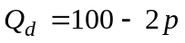
and the market supply is summarized by the supply function:
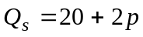
(a) Calculate the equilibrium quantity and price, assuming no health insurance is available.
(b) Suppose that health insurance is made available that provides for a 20 percent coinsurance rate. Calculate the new equilibrium price and quantity. (Hint: How does the demand curve shift?)
(c) Calculate the deadweight loss due to this insurance.
10. Suppose that the market demand for medical care is summarized by the demand function:
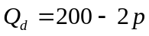
and the market supply is summarized by the supply function:
(a) Calculate the equilibrium quantity and price, assuming no health insurance is available.
(b) Suppose that health insurance is made available that provides for a 10 percent coinsurance rate. Calculate the new equilibrium price and quantity.
(c) Calculate the deadweight loss due to this insurance.
(d) Compare your answers in this problem to problem 9 (a) – (c).
11. Suppose, in Exercise 9, that the coinsurance rate was raised to 50 percent.
(a) Calculate the new equilibrium price and quantity. (Hint: How does the demand curve shift?)
(b) Calculate the deadweight loss due to this insurance.
(c) How does your answer compare to the deadweight loss in Exercise 9?
12. Consider the discussion in the text about Elizabeth’s breast cancer treatment. Using Figure 8-9, calculate the net welfare benefits if m_{u} = 20,000, m_{c} = 40,000, and m_{i} = 44,000. To aid in the calculations, assume that point G has a value of 2 and point F has a value of 3.

New sources

Kowalski, Amanda E., “Estimating the Tradeoff between Risk Protection and Moral Hazard with a Nonlinear Budget Set Model of Health Insurance” International Journal of Industrial Organization 43 (2015); 122–135.

Zelalem Yilma, Luuk van Kempen, and Thomas de Hoop. (2012). “A Perverse ‘Net’ Effect? Health insurance and Ex-ante Moral Hazard in Ghana” Social Science and Medicine, 75(1): 138-147.

Figure 8-1 Total Utility of Wealth and the Impact of Insurance
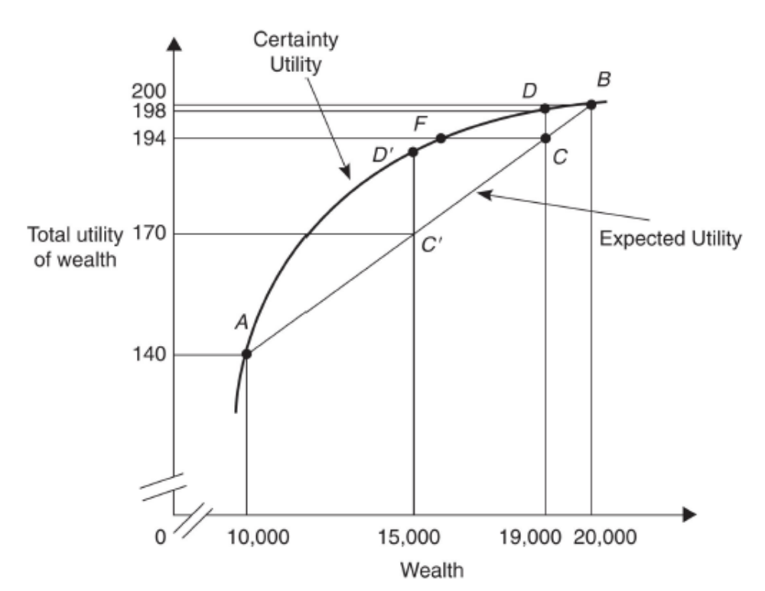
10,400
19,900
X
Y

Figure 8-2 The Optimal Amount of Insurance
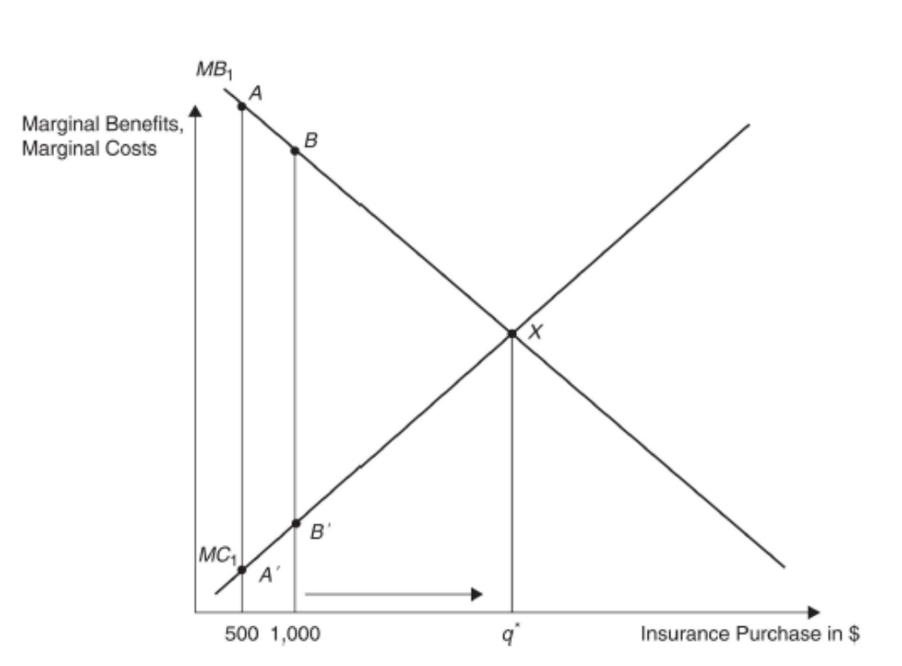

Figure 8-3 Changes in the Optimal Amount of Insurance
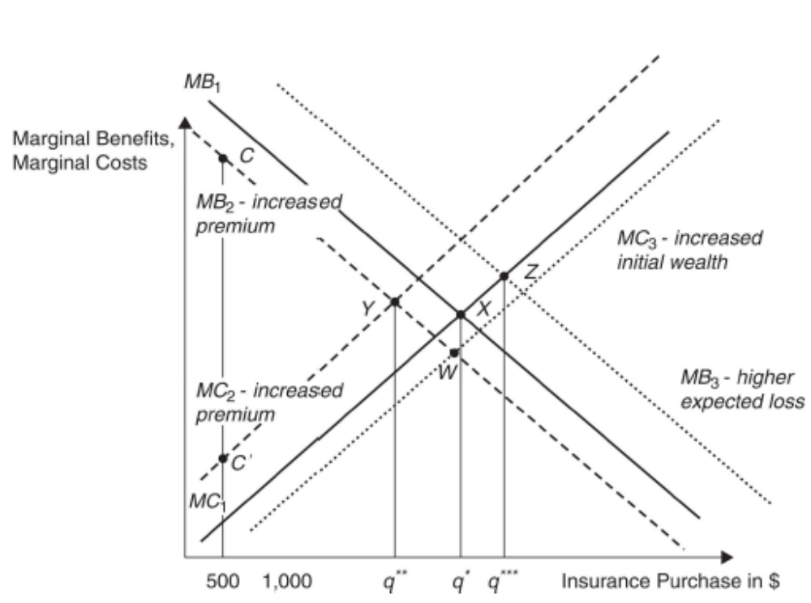

Figure 8-4 Demand for Care and Moral Hazard
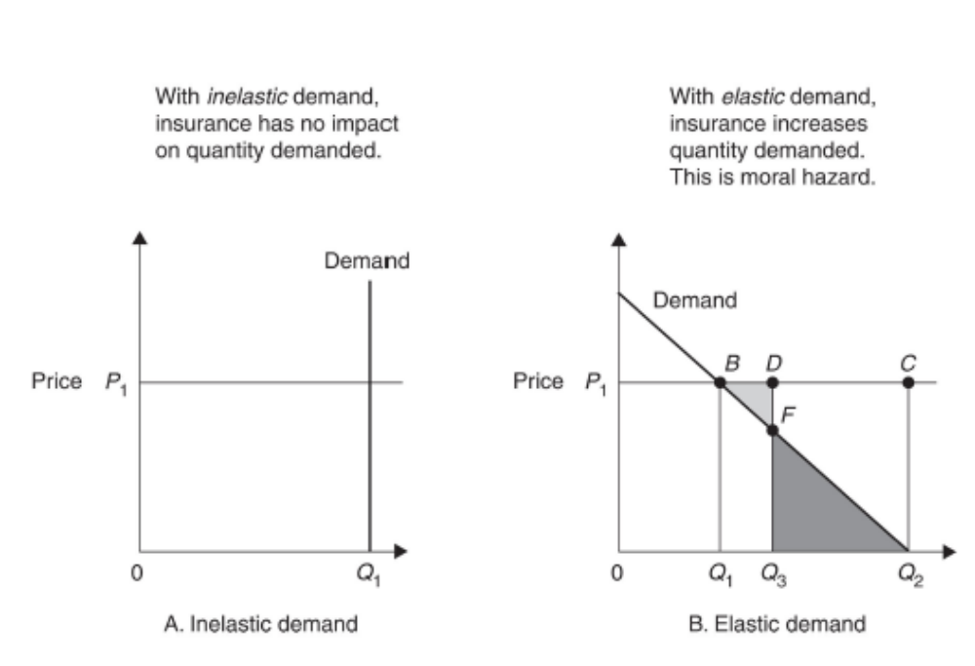
Figure 8-5 Health Care Demand with Insurance
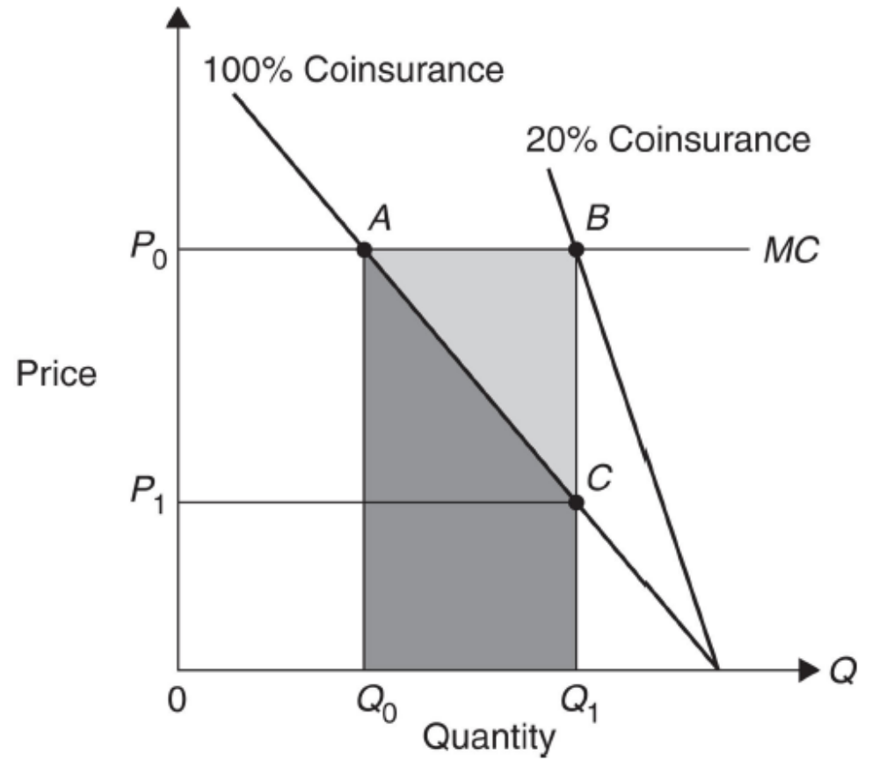

Figure 8-6 Impact of Secondary Insurance on Primary Coverage and Utilization
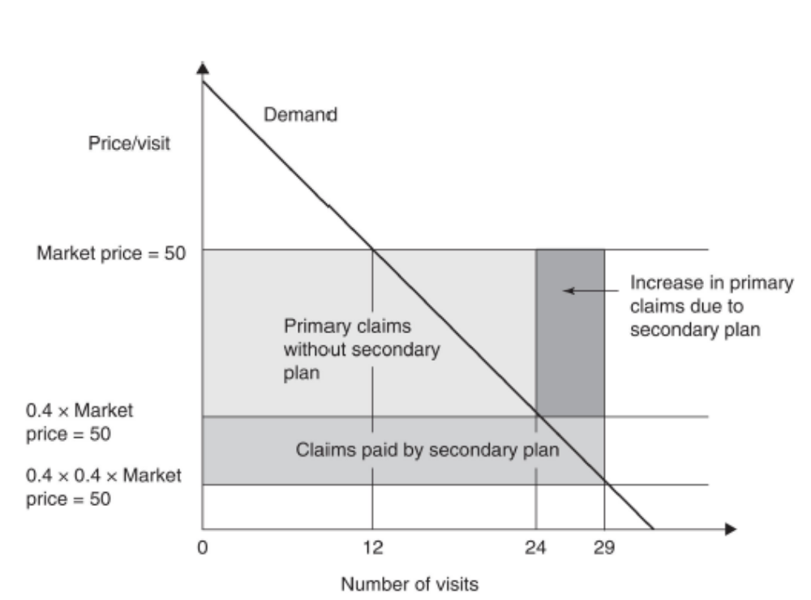

Figure 8-7 The Effect of Insurance Cost Sharing with Upward-Sloping Supply
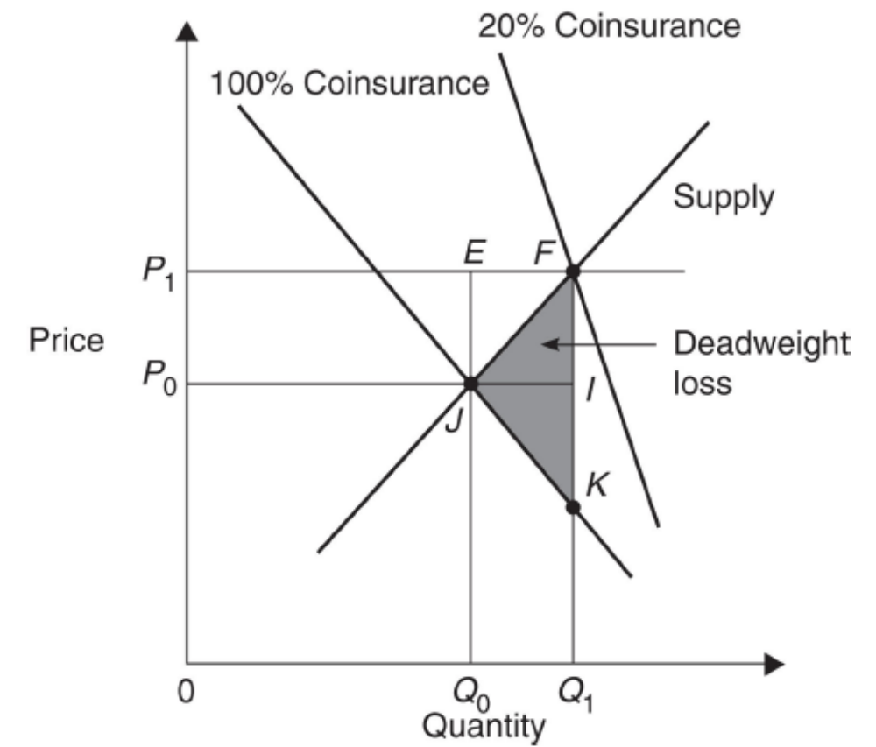

Figure 8-8 The Interaction of Insurance and Price of Care
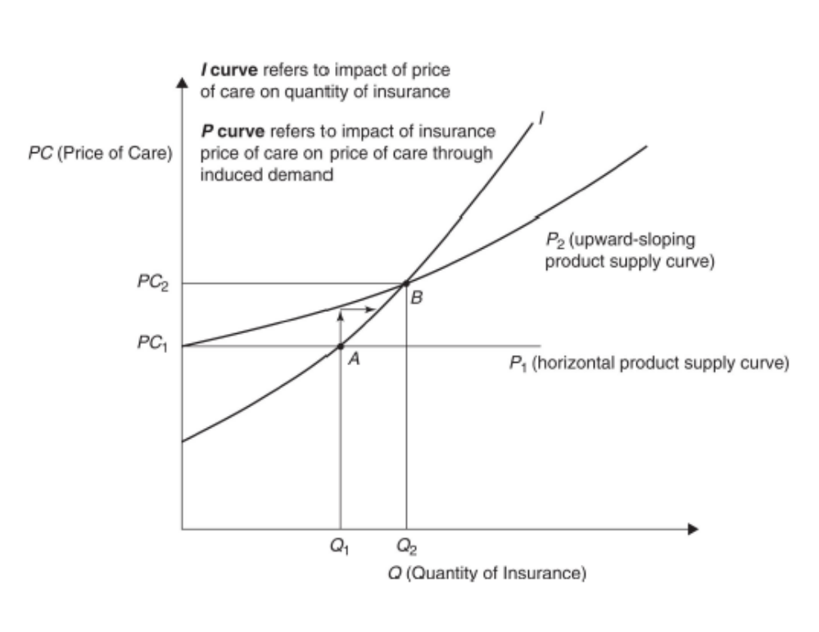

Figure 8-9 – Moral Hazard and Rick Protection with Employer-Sponsored Plans
Incremental out-of-pocket spending under coinsurance after deductible
Out-of-pocket Spending up to deductible
Price
Quantity
1
c
0
h₁1
h₂1
h₃1
Incremental spending under stop-loss
Demand
Figure 8-10 Nyman’s Decomposition of Moral Hazard Using Demand Curves
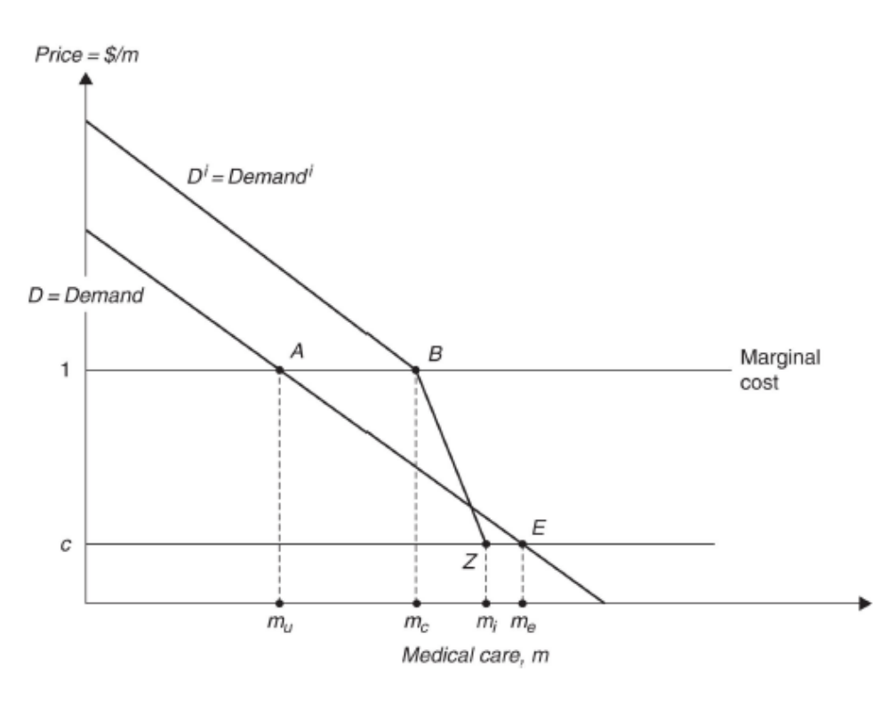

Figure 8-11 The Net Welfare Gain of the Price Distortion Under Income Transfer Effects
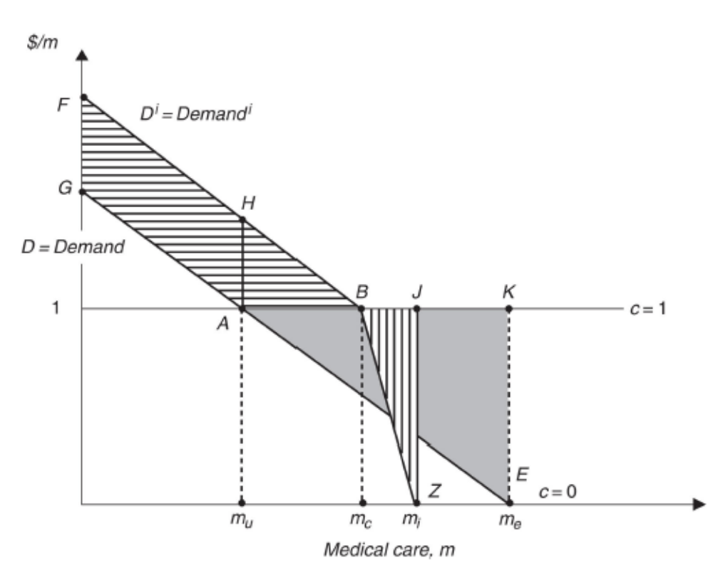

Wealth refers to the sum (or stock) of the consumer’s assets in money terms. It is related to income, which is the flow of funds in any given period in that increased income allows people to buy more assets . We may refer to one or the other for some discussions, but the substance of the insurance analysis refers to both.
Insurers do care whether they are getting nonrepresentative slices of the risk distribution (suppose, for example, the same member files claims year after year, hardly a random event.). Analysts refer to this as adverse selection, and it can lead to financial losses for the insurer. We treat this information problem in detail in Chapter 9.
Students might ask about people whose employers pay the entire insurance bill. Most economists believe that employees choose the insurance in lieu of a compensating take-home wage, thus paying for insurance themselves. We discuss this in detail in Chapter 11.
Nyman and Maude-Griffin (2001) provides the mathematical foundation for this analysis.

