CHAPTER 4
Economic Efficiency and Cost-Benefit Analysis
- Economic Efficiency
- Cost-Benefit Analysis: Background
- Cost-Benefit Analysis: Basic Principles
- Measuring Costs
- Valuing Human Life
- Cost-Effectiveness Analysis
- Cost-Utility Analysis, QALYs
- QALYs Revisited: Praise and Criticism
- Conclusions
- Appendix—Discounting

Health economics policy concerns require that we frequently and systematically evaluate alternatives. Just as rational individuals want to make the best choices given resource constraints, governments, too, face choices constrained by resource availability. For example, legislators and other policymakers must decide whether to spend more on preventive care versus giving more support to acute care facilities, or perhaps to medical research. When government regulates, the actual administrative expenditures may be relatively small. However, the economic consequences of the regulation can be very large, and evaluators must take corresponding care in evaluating the alternative scenarios. Economists base such decisions on the concept of efficiency. In developing the microeconomic tools for this textbook in Chapter 2, we explained the “welfare loss” caused by a monopoly’s restricting quantity of production by charging too high a price. This welfare loss describes inefficiency—society has foregone opportunities for mutual gain. Efficiency applies to a broader range of phenomena than just monopoly, and we begin here by developing the concept more fully.
<H1>ECONOMIC EFFICIENCY
Economic efficiency exists when the economy has squeezed out every opportunity for net benefits possible through voluntary means. Consider a single market, such as a local market for apples. Consumers’ preferences for the apples can be measured by their willingness to pay for them; each person might have a different amount of money in mind. Likewise we measure the opportunity costs to society of an apple by the marginal cost of production. In some cases, there will be extra or “external” costs or benefits involved, but assume here that the private willingness to pay and the marginal costs summarize all benefits and costs. An efficient result for society will require a comparison of consumers’ wants, as reflected in their demand, against the costs to society (either the private or public sectors) of the required production.
Economists use demand and supply analysis to define the efficient allocation of resources in competitive markets, and this idealized sort of market is convenient to explain the concepts. The competitive market is a market form that functions “properly.” We will also see that for markets that do not function properly, or for cases where no markets exist at all, the underlying benefit and cost concepts often still apply.
The demand curve for apples represents consumers’ willingness to pay for various amounts of apples. Marginal willingness to pay is another way of representing the demand function relating the quantity of apples demanded to the price of apples. Imagine, for example, lining up individual consumers from left to right in descending order on the willingness to pay for one apple. At small total quantities (along the market demand curve), the marginal willingness to pay is high, as only those who place considerable value on getting an apple are willing to pay for it. At larger quantities, the consumer’s marginal willingness to pay is lower; additional consumers would not buy unless the price was lower.
At price P₁, in Figure 4-1, consumers together spend amount P₁Q₁. This is a fraction of what the apples are worth to the consumers, and it is also what they pay out. The total value of the apples to the consumers, however, also includes the additional shaded area under the demand curve, referred to as the consumers’ surplus triangle. The consumers would have been willing to pay more than P₁, but did not have to do so. To see this, reconsider the example. Each consumer who buys an apple is willing to pay the price on the demand curve. That price reflects his or her benefit, but one must subtract the market price to get the net benefit. The shaded area then is simply the sum of the net benefits of each individual buyer. Alternatively, the consumers’ surplus at Q₁ equals the total value to consumers (the area under the demand curve up to Q₁) minus the amount that they must spend, P₁Q₁.
Figure 4-2 presents a supply curve which, with competitive markets, measures the marginal costs for producers to bring apples to market—the higher the market price offered to them, the higher the marginal cost they are willing to bear. Suppose that the market price of apples were $10 per bushel, but that some of the producers would supply apples even if the price were only $5. The $10 per bushel that they receive constitutes a surplus of $5 per bushel in excess of the price that is necessary to induce them to transfer resources from other uses to producing apples. Total consumer expenditures P₁Q₁ are apportioned into the resource cost to the sellers (the white area), plus the shaded area showing producers’ surplus.
[Insert FIGURE 4-1 Consumers’ Surplus]
[Insert FIGURE 4-2 Producers’ Surplus]

The economic criterion for maximizing well-being is to maximize the sum of the consumer and the producer surplus. Combining the supply and demand diagrams in Figure 4-3, we see the gains to consumers plus the gains to producers (the total net benefits to society) in the total shaded area.
Figure 4-3 shows that quantity Q₁, where demand equals supply, maximizes the sum of the surpluses. If quantity were less than Q₁, we could increase both consumers’ and producers’ surplus (the shaded areas) by increasing Q. If quantity exceeded Q₁, we could increase the surpluses by reducing Q because the incremental quantity (beyond Q₁) costs more (the supply curve) than it is worth to the consumers (the demand curve).
[Insert FIGURE 4-3 Efficient Quantity ]

Efficiency requires that the optimal quantity come to market. In several places in this textbook we find that monopolies are economically inefficient by bringing too few goods to market. In contrast, polluters generally produce too many goods whose by-products such as smoke or untreated sewage impose costs on society that exceed the goods’ market prices.
In competitive markets, supply and demand provide the efficient quantities of goods to the market—prices ration supply and demand according to consumer preferences and producer costs. However, students will recognize a wide range of goods for which such market signals are not readily available. These include bridges, parks, water purification systems, or mandated clean air. Decisions on whether to screen for breast or prostate cancers or whether to provide vaccines to the public, for example, depend on criteria that do not easily lend themselves to market tests.
With absent or incomplete markets, various evaluation tools have been developed to measure and compare project costs and benefits. Characterized in general as cost-benefit analysis, these tools seek to determine the appropriate quantity by measuring incremental or total costs, and incremental or total benefits. We address these methods in the following section.
<H1>COST-BENEFIT ANALYSIS: BACKGROUND
Early forms of cost-benefit analysis (CBA) appeared over a century ago by the U.S. Army Corps of Engineers to evaluate flood control and other water systems. With the large public works projects during the Depression of the 1930s, it was necessary to justify expensive programs. The introduction of Medicare and Medicaid in 1965 led health economists to focus more on CBA. The federal government continued to improve and standardize methods, and since 1981 all new federal regulations must undergo CBA.
CBA measures the benefits and costs of projects in money terms. This often requires that we place dollar values on years of life or improvements in health and well-being. These challenges have led to the development of new ideas, and health analysts now use the general term economic evaluation to represent the entire collection of tools. Throughout the discussion, we will take the perspective of society as a whole rather than the narrower focus of the individual or firm. This is the appropriate perspective for public projects. We can similarly apply this logic to the investment decisions of a single hospital deciding whether to invest in a PET scanner, or even to the decision problem of a young man or woman considering a career in medicine.
Cost-effectiveness analysis (CEA) and cost-utility analysis (CUA) have emerged as the principal alternatives to CBA. CEA applies to problems where policymakers accept the goal at the start and the problem is to find the least cost means to achieve it. CUA is a special form of CEA that introduces measures of benefits that reflect individuals’ preferences over the health consequences of alternative programs that affect them.
<H1>MEASURING COSTS
Cost-benefit analysis addresses a wide range of measurement problems, often over many periods. It evaluates public investment costs, including those that have no markets to guide them. Likewise it investigates benefits that have no markets, to determine their prices. CBA also addresses public choices involving either benefits or costs that are external to the market they came from. Projects, such as putting a dam across a river or reconsidering the efficiency of a congressional program, are often controversial. Within health economics, controversies over the wisdom of immunization programs, patient screening, or heart transplants, for example, invoke many problems and criticisms that cost-benefit thinking must address.
CBA rests on the premise that a project or policy will improve social welfare if the benefits associated with it exceed the costs. These benefits and costs must include not only those directly attributed to the project but also any indirect benefits or costs through externalities or other third-party effects. Most simply, where B represents all the benefits and C represents all of these costs, a project is deemed worthwhile if B − C > 0. We can also rank projects according to the benefit to cost (B/C) ratio; thus, a higher B/C ratio generally indicates a project that will deliver greater social benefits for a given dollar of costs.
We measure all costs as opportunity costs, what we must give up to get what we want. The most common difference between public and private project evaluation is that public projects often have opportunity costs that have no market to serve as a guide for pricing. On the one hand, a dam project can destroy habitat for animal life, cover historical landmarks under water, and force whole towns to close down. On the other hand, the dam can enhance the fertility of otherwise barren land, provide recreational opportunities, attract waterfowl, and provide campsites and swimming areas for recreation. Many of these examples represent either costs or benefits ordinarily bought or sold in markets. Many of the analytical problems stem from the imprecise task of placing dollar values on these difficult-to-evaluate costs and benefits. In some cases, there are methods for inferring the required values. For example, we can measure the benefits of a newly created lake view by observing how much the market values of nearby homes increase. For many cases, however, there are no easy answers.
The previous example also mentions a second problem. Public investments may produce costs or benefits to people who do not participate in them directly. Consider an immunization program that would offer protection against the flu to a wide cross section the population, concentrating in particular on the elderly and the ill. Analysts can measure the costs of materials and manpower directly, and estimate the benefits to those immunized. The program, however, also benefits people who never get immunized by reducing the number of infected carriers, thus reducing their exposure to the flu. These external benefits must appear in the CBA, but it may prove difficult to estimate them accurately.
A pollution clean-up program raises similar questions of how to treat externalities. For example, factories that discharge contaminants into the air or water create external costs by damaging the environment and adversely affecting third parties. Conversely, pollution abatement creates external benefits to others (e.g., boaters and home owners) who are not directly involved in the firm’s decisions. They typically do not pay for the benefits they receive.
The analyses discussed assume that we have good measures of both marginal benefits and marginal costs. Consider, however, a project of size Q₁ as noted in Figure 4 – 5. Much of the research seeks a “value” for marginal benefit and/or marginal cost and applies it to all of those incurring the costs and/or the benefits. This is equivalent to using the large rectangle for benefits, and the smaller one for costs, and then taking the difference (seeking B – C > 0), or the ratio (seeking B:C > 1). These measures of gross benefits and costs, assume implicitly that all of the beneficiaries (and all of those bearing costs) are the same. Analysts have sought to determine marginal benefits in terms of willingness to pay or willingness to accept, but there has been little work on the cost side. Very often the data are incomplete
In a series of influential articles, Ruger and colleagues develop a micro-costing methodology, a bottom-up approach to data collection that produces precise estimates by directly surveying the units and costs of each input consumed by participants in a given intervention. Micro-costing methods study interventions in particular settings, rather than in a very general group.
Ruger et al. (2012) demonstrate such a micro-costing model for addressing the costs of interventions to treat heroin addiction in Malaysia and 32 comparable countries worldwide. They seek to determine fixed costs, variable costs, and so-called societal costs (i.e. costs to individuals). Examples include:
Fixed Costs – Building and facilities, detoxification, training, quality assurance
Variable Costs – Therapy materials, testing materials, personnel costs, administration of medication
Societal Costs – Participants’ time and travel costs, family members’ time and travel costs, time in detoxification.
The researchers compare drug treatments naltrexone and buprenorphine.
They find that medication, and urine and blood testing accounted for the greatest percentage of total costs for both naltrexone (29–53 percent) and buprenorphine (33 –72 percent) interventions. In 13 countries, buprenorphine treatment could be provided for under $2,000 per patient. For all countries except United Kingdom and Singapore, incremental costs of buprenorphine over naltrexone were less than $1,000. Looking at particular countries, they estimate that full treatment (100 percent) of opiate users in Cambodia and Lao People’s Democratic Republic would cost $8 and $30 million, respectively.
<H2>Risk Equity versus Equality of Marginal Costs per Life Saved
Calamitous events often engage public sympathy to support rescue programs and emergency health care. These programs, in the abstract sense, seek to reduce health risks to the victims—for example, the risk of catching an infectious disease. Some argue that society ought to apply public resources so that health risks are shared equitably across the population. Perhaps equalizing life risks is impossible, but suppose that it were possible. Would it be the best choice for the use of society’s resources?
Viscusi (2000) explains why such a plan would cause society to fall short of its welfare potential. Contrast a plan that follows sound economic principles. Were we instead to distribute public investments so that it equalized the marginal cost of a life saved across publicly funded programs, we would maximize lives saved for a given overall budget. The idea is simply that we should spend each next dollar where it does the most good (marginal analysis in CBA is discussed in detail later in this chapter). What about the interventions that we already have? Does U.S. spending follow this cost efficiency standard? Box 4-1 indicates that increased used of selected interventions could actually reduce net costs.

[Start Boxed Feature] Box 4-1 When is Preventative Medicine a Good Investment?
When is preventive medicine a good investment? While some experts have suggested that clinical preventive services— such as immunizations, screenings, and counseling—are worthwhile when they save more money than they cost, others have suggested that a more appropriate standard should instead be that prevention offer good “value” for the net dollars spent. Maciosek and colleagues (2010) evaluate several readily available interventions including immunizations and screenings.
The study team examined the estimates of costs and savings on the net impact on U.S. personal health care spending would have been in 2006 if a specific package of twenty evidence-based clinical preventive services had been used by 90 percent of the population for which each service was recommended. They calculated both the total costs and savings of providing the total package of services to 90 percent of the recommended U.S. population, and the additional — or marginal—costs and savings of increasing the use of the package from existing rates up to 90 percent.
The following table, derived from their work, ranks the top 5 interventions in terms of annual net medical costs per person by annual net medical costs per person per year. Negative values mean that money is actually saved!
Life Years Saved, Costs, and Savings with Negative Net Costs ($2006)
 |  |  |  | Life-years saved per | Medical cost of | Medical savings of | Annual net medical
 |  |  |  | 10,000 people per year | service per person | service per person | costs per person
 |  |  |  | of intervention | per year | per year | per year
Childhood immunizations |  |  |  | 1233.1 | 306 | 573 | -267
Pneumococcal immunization |  |  |  | 6.4 | 46 | 113 | -67
Discuss daily aspirin use |  |  |  | 63.0 | 21 | 87 | -66
Smoking cessation advice and assistance |  |  |  | 97.5 | 10 | 50 | -40
Vision screening (adults) |  |  |  | 2.1 | 5 | 22 | -17
Alcohol screening and brief counseling |  |  |  | 7.0 | 9 | 20 | -11
Obesity screening |  |  |  | 1.0 | 10 | 15 | -5
Childhood immunizations, for example, would save 1,233.1 life-years per 10,000 children receiving them. The vaccinations costing $306 per year would actually save $573 in service, so the net saving for the additional life-years is $267 per person.
The authors further calculate that increasing use of the package of 20 services from current levels to 90 percent is less than the additional savings, resulting in a small negative net cost—or savings. The additional cost of increasing use from current levels to 90 percent would have been $18.3 billion, or 1.0 percent of U.S. personal health care spending in 2006. The savings resulting from increasing would have been $21.9 billion, and the net cost would have been −$3.7 billion, or −0.2 percent of U.S. personal health care spending in 2006, a net decrease!
<H2>Marginal Analysis in CBA
Figure 4-4 illustrates the marginal analysis principle applied to CBA. The marginal social benefits curve, representing the sum of all beneficial effects from increasing the abatement program by one unit, is downward-sloping. The marginal social costs, representing at each point the sum of all costs of increasing the program by one unit, is the MSC curve. For many pollutants, the marginal social benefits will include the benefits to the public of improved health. As an example, the incidence of cancer and respiratory disease has been linked to various forms of air pollution.
Insert FIGURE 4-4 Efficient Use of Resources Where Marginal Benefits Equal Marginal Costs
Society’s maximum net benefit will occur where marginal social benefits equal marginal social costs. CBA represents an attempt to get the information with which to make the assessment. To illustrate the logic, a project requiring Q₃ is proposed, compared with the current discharge at Q₂. If MSB and MSC are properly measured, valid estimates of the project benefits equal the area under the MSB curve between Q₂ and Q₃, and similarly for costs by the area under the MSC curve. The net benefit equals area A.
Cost benefit principles may help with such a minor decisions as where to eat dinner, or what brand of lawnmower to buy. But the same principles can inform decisions that may very well affect the entire planet. The case at hand in Box 4-2 presents a modest invention that has intriguing possibilities beyond the village.

[Start Boxed Feature]
Box 4-2
Cookstoves, Global Warming, Health in Developing Countries, and CB Analysis
Much of the world burns biomass fuel for cooking and heating. Unfortunately this practice often results in smoky, unhealthful interiors, time lost in handling the material, and emissions of greenhouses gases. Cost benefit analysis proves useful in identifying the best, or at least, the most hopeful solutions. A recent study by Garcίa-Frapolli et al. (2010) illustrates the method and some strong results. The study team focused on the Purépecha region of Mexico and estimated the benefits and costs per year of replacing peoples’ current cookstoves with the more efficient Patsari design as follows:
Benefits/Year per cookstove | $ (Benefits)
Fuelwood savings | 400.8
Job creation and income | 19.1
Health impacts | 208.6
Environmental impacts | 103.2
Total benefits | 731.7
Costs/Year per cookstove | $ (Costs)
Costs of cookstove construction | 83.3
Indirect costs (dissemination) | 25.3
Total costs | 108.6
Ratio of Benefits to Cost* | 9 to 11
*These ratios pertain to an estimated lifetime of the stove and they depend on the discount factor assumed. See the next section for more details on discounting.
For a given year, the benefit:cost ratio is almost 7:1, and because the improved stoves last longer, the lifetime ratio is between 9:1 and 11:1. With a benefit cost ratio this high, they concluded that the project was well worthwhile.
<H2>Discounting
Multi-period projects require that we discount the future costs and benefits to put them on an equal basis with present values. This necessity arises from one of two basic reasons which suggest that future dollars usually are not worth as much to people as present-day dollars. First, a dollar today could be used for something else. That dollar could have purchased an interest-bearing instrument, such as a bond, which would have been worth the dollar plus the interest in next period’s dollars. Conversely, next period’s dollar must be discounted at the market rate of interest to discover its present value.
Second, many people tend to prefer the present when allocating spending. Which would you prefer, a dollar right now, or the same dollar 10 years from now? Most would choose the dollar now. One consequence of this time preference is that the equilibrium interest rate will be positive, the reward for postponing consumption, and a cost for those who cannot wait or simply do not wish to. We discuss discounting in the appendix to this chapter.
Together, the time preference and the potential foregone interest from dollars spent on a project help explain why we discount future money values. The most commonly used method is relatively simple, although not without criticism (Frederick, Loewenstein, and O’Donoghue, 2002). Each period’s costs and benefits are divided by a “discount factor” raised to the power t, the number of the time period, counting from the present as zero. The discount factor is (1 + d), where d is the social discount rate, which for the present we assume is the market rate of interest. The present value equation is then
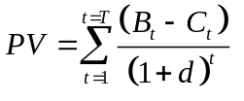 (4.1)
where t is zero for the initial period and increases up to the period T in which the project ends. For example, in the following period (usually taken as a year), the discount factor is raised to the power one, and the net of benefit over cost in this future period is divided by (1 + d). Using a market interest rate of 6 percent for d, then the denominator becomes (1.06).
Notice also that if d is positive, the denominator in (4.1) becomes larger as t increases. This assumes that we discount the more distant future more heavily. This fact of discounting bothered both health care and environmental policymakers. Should those living in the present so disregard future generations? At first glance, time discounting may seem to guarantee that we will bequeath an unhealthful and polluted condition of life to the future generations. For reasons like these, some analysts propose that the social rate of discount, d, be set at a lower level than the current market interest rate or that we apply discount rate patterns that decline over time. The lower the chosen value of d (the closer to 0) the greater is the emphasis placed on the future.
Two ideas clarify economists’ preference to use the market rate of interest. First, economists often temper the claims some people make on behalf of future generations with the knowledge that all human valuations must ultimately come from people living in the present. In a sense, we all speak for future generations through our actions in the capital markets.
Second, using market interest rates also has the advantage of measuring what people actually do as opposed to their responses to more hypothetical questions. Yet many would disagree. In any case, it is ultimately a social decision and one that has surprisingly large consequences. For a practical illustration of these consequences, see Box 4-3, “Discounting and Global Warming.”
A number of other troublesome issues arise, however, when proposing the market interest rate for discounting public projects. Some find the approach inequitable when high and low income groups differ in time preferences. As the feature suggests, the more keenly felt problem at present is the prospective loss of human life and the possibility of permanent damage to the environment. The accompanying feature illustrates the large consequences of choosing a discount rate. Finally, some health economists propose to discount ordinary costs at the market rate but benefits to life and environment at a separate and lower rate (Brouwer et al., 2005; Claxton et al., 2006).
BOX 4-3
Discounting and Global Warming
In October 2006, the British Treasury issued the Stern Review (Stern, 2007), a disturbing report on the potentially cataclysmic consequences of greenhouse gases for our planet’s future. It is widely credited with encouraging the world to understand the urgency of the problem. The discounting issues it raised help illuminate health economic discounting issues in general.
The Stern Review chose a discount rate of nearly zero to treat future losses as (essentially) equal to current losses. William Nordhaus (2007) criticized this choice, arguing that economies grow and that a zero discount rate ignores the fact that greater future wealth could make the estimated loss more affordable. When forced to choose, most economists recommend a discount rate of 3 percent, which is closer to average economic growth rates.
Opponents counter that the population also grows, and the gains from avoiding calamity will be spread over more people. Economists reply that a zero discount rate fails to reflect how real people actually treat future values versus present values, though many allow that environmental rescue ought to get a special rate, say, 1 or 2 percent. Should we discount the value of future lives saved at 0, 1, 2, 3, or 5 percent? Those who view this is as a mere “academic” squabble may be the most surprised at the consequences.
Consider a calamitous climate event 100 years hence that would kill 1 million people, and measure the value of each life in the future as $6 million dollars. How much are we willing to invest today to save those future people? One hundred years from now the loss is $6,000 billion (or $6 trillion!), but what is the equivalent amount in today’s dollars? The formula is

where d is the social rate of discount. The accompanying table reports those calculations.
The rate chosen clearly makes a difference. With a zero discount rate, those future lives are valued at present at nearly one-third of the entire United States GDP. On

Benefit | Social rate of discount, d | Net present value
$6,000 billion  benefit 100 years from now | 0.00 | $6,000 billion
$6,000 billion  benefit 100 years from now | 0.01 | $2,218 billion
$6,000 billion  benefit 100 years from now | 0.02 | $ 828 billion
$6,000 billion  benefit 100 years from now | 0.03 | $ 312 billion
$6,000 billion  benefit 100 years from now | 0.05 | $ 46 billion
the other extreme, with a 5 percent rate, those 1 million lives 100 years from now are viewed as worth less today than what Americans spend annually on “paper and allied products.” (At a 5 percent rate $100, to be delivered 100 years from now, has a present discounted value of $0.76). What rate d, then, is correct in the environmental context? The consequences of a discount rate choice are huge. The Stern Review has forced the right issues into vigorous discussion.
[End Boxed Feature]
<H2>Risk Adjustment and CBA
To apply the market interest rate, however, we must recognize that there are many market interest rates. Riskier projects tend to have relatively higher rates of interest to reward investors, by the nature of the asset, are less sure of a full return. Often evaluators will adjust the social rate of discount to reflect the riskiness of the public project. Even this is conceptually not an easy task, however. Private markets for capital projects have private bidders and sellers, and they are often more capable of assessing perceived riskiness to themselves of adopting a prospective project. In contrast, public projects represent the public at large, whose view of the project’s risk might be difficult to discern.
Nobel laureate Joseph Stiglitz (1988) has recommended that a relatively lower social discount rate better reflects the public’s role. Stiglitz also proposes certainty equivalents to eliminate the biases that can result from including a risk-adjustment factor in the discount rate. Under the certainty equivalent method, the uncertain net benefit in any period, often represented by a probability distribution over project outcomes, is replaced by its equivalent (the value at which the decision-makers are indifferent between the risky set of outcomes and a value received with certainty). The riskier a project, the lower will be the certainty equivalent to someone who is risk averse. The analyst then applies the cost-benefit criterion represented by equation (4.1) using the certainty equivalents for each period. The risk adjustment problem attracts the interest of health economists. Some researchers propose using a risk adjusted rate of return to compare programs with different risks (Sendi, Al, and Zimmerman, 2004).
<H2>Distributional Adjustments
Although cost-benefit analysis seeks primarily to improve efficiency, changes in the income distribution often result from a project. With narrowly focused projects, the tendency is to have a relatively small number of large gainers and perhaps many small losers. To the extent that society is concerned about equity, the distribution of the gainers and losers by income group should be a consideration. At the practical level, after ranking projects according to their net benefits, decision-makers could invoke informal judgments as to the relative effects on the distribution of income and then adjust their rankings. More formally, Stiglitz proposes distributional weights through which the net benefits or losses give lower-income groups more weight than other groups. Of course, the method still will be subjective in that the weights themselves will necessarily reflect the judgments of the decision makers.
<H2>Inflation
Analysts also worry about inflation. Conceptually, macroeconomic inflation is not a problem. Because estimates of the inflation rate often turn out to be incorrect, it is best to measure both benefits and cost in current or real terms and then discount at the real (inflation-free) discount rate. If one introduces an inflation factor, then the discount rate should be increased by that inflation rate to get the nominal rate. It is important, though, that the discount rate reflect that inflation factor and not some other rate.
<H1>VALUING HUMAN LIFE
A November 2013 report from the National Highway Traffic Safety Administration reported 33,561 traffic fatalities in 2012; this was 1,082 more fatalities than in 2011. A simple public health intervention would be the adoption of a 15 mile per hour national speed limit. No one gets killed in collisions at this speed. While such an intervention would be costly in terms of travel time, wouldn’t the lives saved be worth it?
Placing a value on human life is one of the most difficult but often unavoidable tasks in health care CBA. The first of several approaches, known as the human capital approach, estimates the present value of an individual’s future earnings. This approach has been especially favored in legal applications that require estimates of damages. It also measures the loss of national output from mortality and morbidity or the production gains from saving and extending life.
In other ways, however, the human capital approach has flaws as a welfare measure. Retirees or crippled children, for example, have no value with respect to earnings. Also, the human capital approach does not directly measure people’s willingness to pay to avoid risks of death, injury, or illness, nor does it measure what they are willing to accept as compensation for taking on such risks.
<H2>Willingness to Pay and Willingness to Accept
Consider the question, “How much are you willing to pay for the reduction in risks provided by new locks on your door?” The flip side of this concept is the compensation you would require to accept an additional risk to life and limb. The willingness to accept method also has many everyday examples. Its theoretical basis comes from the literatures regarding the compensating differentials paid to laborers across various lines of work.
One of Adam Smith’s successes in The Wealth of Nations was to explain why the wages of workers differed across jobs—explanations that still resonate well with modern economic theory. Smith’s theory was the inspiration for modern-day economists to develop the theory of compensating differentials.
<H2>Contingent Valuation
It is often hard to derive a market test for willingness to pay for a risk-reducing medical treatment. Instead, the method of contingent valuation poses sets of medical contingencies such as: “If you faced an X% (high) risk of heart attack, how much would you be willing to pay for a medical procedure that would reduce your risk to Y%?” The set of questions, visual images (if used), and researcher interactions is called the format. Contingent valuation has enabled practical studies to move forward, but it has proved vulnerable to challenge. Some researchers view problems of “hypothetical bias”, the idea that the subject will not or cannot answer hypothetical questions realistically. Changes in format can induce change in the valuations, a so-called framing bias (Whynes, Frew, and Walstenholm, 2005).
Potential resolution may come from studies that compare willingness to pay based on real-life behavior with measures of the same concept based on a question and answer format. Bryan and Jeott (2010) do this and conclude that the question-and-answer method does reasonably well for the given patient therapy they chose to study.
<H2>How Valuable Is the Last Year of Life?
Health system analysts commonly express puzzlement or dismay over “Why do we Americans spend so much of our health care dollar on the last year of life?” Later in this chapter we describe Quality Adjusted Life Years or QALYS and how this measure implies that a person has no claim on extraordinary health care when he or she gets very old. The elderly spend over one quarter of their total health care expenditures on the last year of life. Even economists using standard utility analysis question why one’s utility of life would get to be so high when one has low natural prospects for living many years and when one’s motive to bequeath to one’s heirs is a ready alternative.
Becker, Murphy, and Philipson (2007) offer an interesting resolution to this puzzle. They begin by arguing against linearity in the calculation of the value of a life year. For example, a commonly used value of $100,000 per life year is based on a linear extrapolation for peoples’ responses to marginal changes in their probability of death. It would seem irrational to us to save a life worth $100,000 by incurring expenses worth $500,000. But the $100,000 would be incorrectly applied to a patient’s valuation of life when the risk change is life versus death right now. People facing a survive-or-die situation are not dealing with a marginal change; for example, a firefighter may increase his risk from 0.010 to 0.015, a marginal change. But the patient at life’s possible end may be considering a hoped-for reduction in the probability of death from 1.00, if not treated, to 0.60, for example, if treated.
Their analysis rests on four intuitive ideas. First, for many of the very old and sick, their resources have very low opportunity costs because they cannot enjoy their wealth once they have died. Second, they may rationally have “hope” for living, including the hope that more advanced health care will be developed within their extended lifetime. Third, their “social” value of life (the value of their life not only to themselves but to family, friends, and community) may be very high. Finally, these authors show that the value of an extended life year may be as high for frail patients as it is for those with better health.
Willingness to accept (WTA), derived from labor economic theory of compensating differentials, and willingness to pay (WTP), derived from consumer purchasing behavior for risk-reducing devices—are nearly two sides of the same coin. A basic difference, however, is that purchasing behavior (for WTP) is limited by a person’s budget; we can afford to pay only so much to reduce our risks. In contrast, the WTA has no theoretical limit, a fact most relevant for the world’s poor.
Researchers in health economics and other disciplines have applied both approaches. However, methods to elicit dollar values differ in practice. “Wage based” estimates of willingness to accept risk for extra pay, for example, observe real life behaviors. “Stated preference” methods ask subjects to state the risk/money tradeoffs they would prefer. Table 4-1 illustrates the wide range of estimates from various applications. Many have studied the value of a statistical life (VSL), and the table summarizes them using meta-analysis. These estimates of VSL use simultaneously all the data from previous work and try to reconcile them to a single value or a range of values. Many choose to describe the value of a human life as a bit over $6 million dollars while $100,000 describes the value of one life year (Cutler, 2007).
Researchers have sought to refine the VSL estimates. Aldy and Viscusi (2008) explore how and why VSL varies with age. On one hand, those aging have fewer life years remaining, suggesting that VSL might decline with age. On the other hand, income and wealth grow with age, and then decline in the later years. It may not be possible to transfer wealth easily between age levels. The authors find that VSL increases in one’s earlier years and then declines, following an inverted “U” shape over age.
<H2>Cost-Benefit Analyses of Heart Care Treatment
Notwithstanding the difficulties of CBA, one finds excellent examples in the literature. Examine a CBA by David Cutler (2007) that compared treatments for patients at risk for recurrence of heart attack. The treatment in focus is “revascularization,” the use of bypass surgery and/or treatment with stents to improve blood flow to the heart. Cutler’s study not only examines econometric issues but also estimates the patient’s lifetime costs and benefits. To model the patient’s lifetime, he acquired data to permit the study of 17 years into the future following the treatment. Table 4-2 reports the change in risk of death at each of the future years; it compares improvements to survival for patients admitted to a revascularization-capable hospital and those admitted to a High Volume (assumed to be high quality) hospital but one not having revascularization capability.

TABLE 4-1 How Much Is One Life Worth? [see pg 75 of Ch4]

Meta analysis of wage based studies | Years covered by the studies | Value of Life in 2009 dollars
Miller (2009) | 1974-1990 | 5.2 million
Mrozek & Taylor  2002 | 1974-1995 | 2.0 to 3.3 million
Viscusi & Aldy  (2003) | 1974-2000 | 6.9 to 9.5 million
Kochi et al (2006) | 1974-2002 | 11.1 million
Meta analysis of stated preference studies | Years covered by the studies | Value of life in 2009 dollars
Kochi et. al. (2006) | 1988-2002 | 3.5 million
Dekker et al.  (2011) | 1983-2008 | 2.7 to 8.5 million
Lindhjem et al.  (2010) | 1973-2008 | 3.2 million
Note: These data are from Maureen Cropper, James K. Hammit, and Lisa A. Robinson, (2011), “Valuing Mortality Risk Reductions: Progress and Challenges,” Discussion Paper, Washington, DC: Resources for the Future.

TABLE 4-2 Costs and Benefits of Medical Technology for a Lifetime [see pg. 76 of Ch 4]
 | Revascularization |  | High Volume Hospital
Time after MI | Survival | Spending | Survival | Spending
1 Year | +0.061 | $ 30,149 | –0.009 | $ 4,065
2 Years | –0.029 | $ 27,339 | –0.005 | $ 5,300
3 Years | –0.067 | $ 25,919 | –0.004 | $ 5,993
4 Years | –0.043 | $ 26,820 | –0.001 | $ 6,560
5 Years | –0.106 | $ 27,517 | –0.005 | $ 7,296
6 Years | –0.119 | $ 29,662 | –0.005 | $ 7,659
7 Years | –0.119 | $ 31,090 | –0.005 | $ 7,953
8 Years | –0.108 | $ 32,919 | –0.004 | $ 7,982
9 Years | –0.111 | $ 36,961 | –0.006 | $ 8,087
10 Years | –0.119 | $ 38,028 | –0.007 | $ 8,314
11 Years | –0.113 | $ 38,191 | –0.006 | $ 8,532
12 Years | –0.120 | $ 40,804 | –0.009 | $ 9,002
13 Years | –0.074 | $ 38,079 | –0.006 | $ 9,161
14 Years | –0.064 | $ 38,708 | –0.005 | $ 9,671
15 Years | –0.047 | $ 36,758 | –0.005 | $ 9,524
16 Years | –0.041 | $ 37,200 | –0.006 | $ 9,599
17 Years | –0.051 | $ 37,990 | –0.007 | $ 9,770
Note: High Volume Hospitals are defined as hospitals that admit 75 or more heart attack patients in a year; these serve as comparisons and they are assumed to be high-quality hospitals in terms of heart care. High-quality hospitals do not necessarily have revascularization capability. “Survival” measures change in the risk of death (+ = higher probability) compared to the hospitals that have neither high volume (quality) nor revascularization capability.
Source: Cutler, David, The lifetime costs and benefits of medical technology, Journal of Health Economics, 26 (2007), 1081–1100; data from his Table 5, p. 1094, with permission. Copyright © 2007 published by Elsevier B.V.

By analyzing all 17 years we see some unexpected patterns. Note that at Year 1, the revascularization estimate shows that it actually worsens the chances of survival. Cutler’s columns labeled “Survival” are measured negatively as changes in the death probability, so a negative value indicates a reduction in death risk. The adverse Year 1 result quickly changes to improve the survival rate for many years. The cost of the advanced treatment is much higher than costs via the control group, those hospitals that lack the revascularization capability and yet treat heart cases in high volume.
Cutler calculated the increased life expectancy attributable to each of the two treatments. Revascularization increased life expectancy in this sample by 1.1 years (the sum of the revascularization survival rates) at a cost of approximately $38,000, thus achieving its gains at a rate of $33,246 for each life year. The High Volume hospitals increased life expectancy by only 0.06 years, and even though their costs were low, their costs per life year saved were $175,719. Estimating the value of a human life year to be about $100,000, Cutler concluded that the $33,246 gain from revascularization easily proved cost beneficial.
<H1>COST-EFFECTIVENESS ANALYSIS
Given the difficulties of placing monetary values on life and health, as well as valuing other intangible benefits, cost-effectiveness analysis (CEA) sometimes provides a more practical approach to decision making than CBA (Garber and Phelps, 1997). CEA compares the costs of achieving a particular nonmonetary objective, such as lives saved. In cost-effectiveness analysis, one assumes that the objective is desirable even if the benefits have not been evaluated in monetary terms (strictly speaking, each project might yield negative net benefits were it feasible to compute those net benefits). Though the valuation of benefits is avoided, the problems of determining costs remain.

The proper evaluation of costs per output in CEA refers to the ratio of incremental costs to incremental output, as noted in equation (4.2). Let the change in social costs incurred due to a particular project be C₁ − C₀, and let the gain in health output be E₁ − E₀. We then compare the various projects by the ratio:
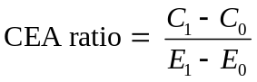 (4.2)
The costs as usual are in dollars, while the outputs are the chosen health status measure. To compare projects with this method, we must measure the outputs in the same units across all projects considered.
<H2>Advantages of CEA
The task under CEA is conceptually similar to a firm’s production decision, which is to produce a chosen level of output at the lowest possible cost. Also, as in the firm-production decision, the objective must be quantifiable and measured in the same units across projects. Otherwise, a clear relationship between costs and output cannot be determined.
For example, the Department of Defense (where modern cost-effectiveness analysis began) has applied cost-effectiveness analysis to determine the most cost-efficient means of achieving a particular level of military preparedness. Quantifying objectives, analysts estimate the most efficient means of achieving the objectives. CBA is not feasible in such cases because of the difficulty in evaluating benefits of the military capability in monetary terms.
As another example, many communities support recycling to the point where mandatory recycling is becoming more widespread. Assuming that a community has decided on the goal of reducing garbage mass, it can use cost-effectiveness analysis to compare recycling with incineration and other waste-management strategies.
Finally, CEA can be a useful first step toward undertaking a cost-benefit study. If the analysts run into significant problems in undertaking a CEA, it is unlikely that a CBA will be feasible. Conversely, good progress in developing a CEA can often determine whether it is possible to take the next step and extend the CEA into a cost-benefit study.
<H1>COST-UTILITY ANALYSIS, QALYS, AND DALYS
The pressing and frequent need for cost-effectiveness analyses of health projects might account for the development of practical variations of the technique of cost-utility analysis. Principal among these is the quality-adjusted life-year (QALY), which evaluates each project on the basis of its incremental costs per extra QALY delivered to the patients or other subjects (Garber and Phelps, 1997; Ried, 1998).
The QALY is a weighting system, typically designed by health professionals, that assigns a value, q, generally ranging from 1 (perfect health) to 0 (death) to represent quality of life for each year. In its welfare economic version, the weights for QALYs are in principle derived by eliciting the individuals’ preferences for different states of health. Analysts often sum QALYs over groups of people. In this case, the procedure departs from standard welfare economics by its comparison and in some cases imposing of interpersonal “utilities” across people summed in a cardinal manner, practices that welfare economists generally avoid. QALYs of improvement are calculated as:
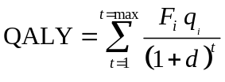 (4.3)
where F_{i} is the probability that the person is still alive at age i; d is the time discount factor; and the value q_{i} is the quality weight, between 0 and 1, assigned to each year of the person’s remaining life until a maximum value, max (Garber, 2000).
Suppose, for example, that a patient has the opportunity for a treatment that will extend life by one year with a probability of 0.9 (F₁ = 0.9) and by two years with a probability of 0.5 (F₂ = 0.5). The patient will die with certainty after two years. Quality weight q₁ is 0.8 in Year 1 and q₂ is 0.6 in Year 2. The discount rate is 0.05 per year. Thus, using equation (4.3) the QALY computation is:
indicating that the expected effectiveness of the treatment is 0.96 QALYs. This serves as the denominator for equation (4.2). Costs per QALY can then be used to compare alternative interventions.
The production of QALYs provides a way to demonstrate the contrasts between equity and efficiency, and distinctions among utility maximization, benefit-cost, and cost efficiency analyses. Figure 4 - 6 considers Ed and Harry, who each start with 10 QALYS at point X. If society gives its entire health budget to Harry (point A), it will achieve 10 additional QALYS, who will now have 20 in all; Ed still has 10. Likewise, if it gives the entire budget to Ed, it will achieve 20 additional QALYS or point B (we intentionally draw the graph to scale) for 30 QALYs in all. The production possibility frontier (PPF) between giving resources to Ed or to Harry is the curve connecting points A and B.
We can draw a set of lines with slopes -1 in the graph. Each line represents a constant number of QALYS. Clearly, we can produce more QALYS if we give all of the resources to Ed. (20 vs. 10). However, if we draw yet another line (with slope -1) representing 20 QALYS from point B, we discover that we could produce still more QALYs in total. Although Ed is more productive totally, he is not more productive at the margin at point B. In short, Ed’s 20th QALY costs much more than 1 of Harry’s foregone QALYs. Moving “southeast” down the production possibility frontier increases the total number produced. The maximum amount of QALYS occurs at point C where the slope of the PPF equals -1.0. This is the most “cost efficient” production point (the maximum production for a given amount of resources) for QALYS. Reading the graph shows a maximum of approximately 23 (additional) QALYS, with Ed having eighteen, and Harry having five.
Suppose we define the most equitable point as one where Ed and Harry have the same number of additional QALYS, or a 45-degree ray from the origin. Allocating resources “equitably” gives both Ed and Harry approximately eight QALYS at point D. Because Harry is relatively unproductive in making QALYS, assuring him the same amount as Ed directs relatively more resources to Harry, and reduces the total production of QALYS. Finally, a utility-maximizing allocation (at point E) may differ from all of the others.
The “take away” from this exercise is that different evaluation criteria lead to different results. QALYs eliminate the need for putting a dollar value on output such as life years, while substituting an equally arbitrary metric (quality-adjusted life years). Further, careful analysis shows that plausibly desirable outcomes (such as equal output for all) may come at very substantial resource costs.
<H1>QALYS REVISITED: PRAISE AND CRITICISM
<H2>Are QALYs Consistent with Standard Welfare Economics?
As we have discussed, cost-benefit analysis rests on the economic standard of efficiency, the Pareto Principle, which states that if an option of society improves the well-being of some people while harming no one then that option enhances welfare. Put simply, CBA has developed to be the standard of modern welfare economics. To say that CUA using QALYs is consistent with CBA would be to say that cost-utility analysis, too, chooses the efficient options for society; in the language of welfare economics, it would be “first best.” Garber and Phelps (1997) and Bleichrodt and Quiggin (1999) argue that very restrictive underlying conditions would be required in theory to cause cost-utility analysis to attain the welfare economic standard. Blomqvist (2002) asserts that CUA cannot, as typically applied, attain the first best result just described.
<H2>Extra-Welfarism
Can a standard outside of standard welfare economics, one perhaps based on very different principles, give us a better world? Standards making this claim are called “extra-welfarist.” Some extra-welfarist bases for decision-making often discard the economist’s idea of utility, and may reject the idea that people make their decisions rationally. Does it matter if we have two different approaches to health care project evaluation, one based within welfare economics and one outside of it?
Health economists Bala and Zarkin (2000) argue that consistency with welfare economics is important in evaluating a public project. The fundamentals of welfare economics describe the net benefits to society of the project. Others argue that the willingness-to-pay principal is appropriately broader than extra-welfarist approaches. Besides counting patients’ willingness to pay for extended life years, it includes their willingness to pay for side benefits to recreation and family life made possible by the treatment (Olsen and Smith, 2001).
The extra-welfarists, however, point to inadequacies in the standard economic welfare framework. The welfarist view, they complain, commonly adds individual utilities without recognizing the interdependencies between people or their identification with the whole. Furthermore, the extra-welfarist approach using QALYs avoids a problem of willingness to pay; it avoids inequities that can be caused by an inequitable income distribution because ability to pay (due to higher income) is an important determinant of willingness to pay.
Amartya Sen (1985), a prominent critic of common conceptions of utility, proposes that each person is entitled to a life in which he or she can use a basic set of capabilities to achieve personal goals in life. Importantly, these capabilities would include basic health and functioning. Using this description, Cookson (2005) praises QALYs by showing that the quality index can be reinterpreted to represent a measure of Sen’s capabilities.
<H2> What People Think
A developing criticism of CUA with QALYs focuses on the method’s linear valuation of medical interventions as the simple sum of quality gains times life-years saved times the number of people treated. It doesn’t matter who you are or what your situation is. A given improvement in functioning is valued the same regardless.
Dolan and colleagues (2005) tested these assumptions by reviewing literature sampling people about QALYs. Here are some examples of many differences they found in ordinary people’s assumptions about QALYs.
- People are willing to sacrifice quality of life gains in order to give priority to the most severely ill.
- People dislike to discriminate by age, although they commonly weight the elderly somewhat lower.
- Health victims with dependent children are given more weight.
- People give much more weight to the health gains of people in the lowest social class.
<H2>The Ageism Critique
It has long been pointed out that QALYs tend to place a reduced value on older people when evaluating a medical intervention. A successful treatment of an old patient saves fewer life-years; those years are already limited by nature. Is this view of the elderly fair?
The issue goes deeper with the philosophical assertion of Williams (2001), who asked a stronger question: Is an extra life year to be valued the same if an older person versus one younger receives it? His “fair innings” approach (coming from cricket, or in the U.S., baseball) argues that the younger person merits more concern (for US readers, imagine a baseball game being ended after the third inning!), a normal human number of years. Note that in this version, the old person’s shorter life expectancy is not the main issue; even an equal gain in QALYs is no longer assumed to have the same value between young and old.
An alternative approach, disability-adjusted life-years, (DALYs) points out that we humans tend to be dependent on the middle-age groups when we are very young or very old. To the adherents of this view, the greater social-related weights should be placed on people in the middle-age groups. The DALY theory provides a “hump-shaped” set of weights favoring the age groups in the middle.
<H2> How are QALYs Used for Evaluation
Over the last three decades an uneasy consensus has developed that $50,000 per QALY represents an appropriate benchmark for medical interventions. Interventions that cost less than this would be looked upon favorably; those that are more expensive would require further justification.
Scott Grosse (2008) has examined this issue in detail. He terms the $50,000 threshold as an “arbitrary decision rule” that lacks theoretical or empirical justification. He continues that the World Health Organization cutoffs of one- and three-times per capita Gross Domestic Product have the advantages of international comparability and automatic indexing for inflation but lack a clear theoretical rationale.
He finishes his argument by noting that it is not clear that people’s willingness to pay for health is closely related to QALYs of that QALY maximization describes preferences. Finally, he reflects an emerging consensus that higher dollar thresholds might be justified for life-saving interventions (such as organ transplants) than for interventions that reduce relatively mild symptoms.
Following up, Neumann, Cohen, and Weinstein (2014) agree with Grosse that the $50,000 threshold needs updating. They recommend that analysts use $50,000, $100,000, and $200,000 per QALY. and argue that if one had to select a single threshold independent of the context of an explicit resource constraint or opportunity cost, they would suggest using either $100,000 or $150,000.

<H1>CONCLUSIONS
The evaluation of prospective health projects has generated substantial interest among health economists both in the theory and in the practical means to conduct evaluations to improve the society’s well-being. Cost-benefit analysis requires the measuring of all benefits and costs attributable to the project both directly and indirectly. The need to identify external effects and to assign values to them in the absence of guidance from active markets poses both difficulty and controversy in practice. Future costs and benefits must also be adjusted to offset their differences from present values. Analysts debate discounting methods to accomplish this task in that projects whose benefits are achieved only in the more distant future tend to benefit from lower rates of social discount.
The most difficult task of all for CBA is probably that of attaching dollar values to human life. Cost-effectiveness offers a lesser but sometimes more practical evaluation result. By avoiding the assignment of dollar values to human life outcomes, the CEA focuses on providing useful guidance to the decision-maker. The problems of measuring costs still apply, but it avoids the most arbitrary and controversial steps of valuing outcomes. The CEA approach requires that the outputs of the various projects be described in common terms. Several methods of output measurement and various discounting techniques have led to variations on CEA as a group called cost-utility analyses.
Most prominent among cost-utility analyses is to measure health output as quality-adjusted life-years, QALYs. These methods and the debate over health economic evaluation in general, seek to improve health policy for society. At its simplest level, economic evaluation recommends projects that achieve net positive benefits to society and prioritizes among these by their relative efficiency in doing so.
Despite its potential, CBA applications in health care still are less prevalent than one would expect. Difficulties in evaluating benefits, especially the value of life and improved quality of life, place limits on CBA and its usefulness to decision-makers. As a result, cost-effectiveness analysis using QALYs has emerged as an important tool for program evaluation.
<H2>Summary
1. Economic efficiency requires the maximization of total welfare, with the optimum quantity reflecting the sum of consumers’ and producers’ surpluses.
2. Unlike private decisions made in the marketplace, (social) cost-benefit analysis (CBA) involves evaluation of social benefits and social costs in public project analysis. Often, markets do not exist to evaluate the benefits and costs of such projects.
3. CBA rests on the principle that society’s welfare will be improved whenever the benefits of a project exceed its costs.
4. CBA represents an example of marginal analysis. The social optimum is achieved when marginal social benefit is equal to marginal social cost.
5. Though CBA appears simple, it can be difficult to apply. The difficulties include identifying all the relevant costs and benefits, including third-party effects, assigning monetary values, and making projections over many years for projects with long lives.
6. Micro-costing methods allow researchers to tailor their results to specific individuals, rather than imposing general measures. This allows for more precise calculation of cost-related evaluations.
7. The monetary values of future net benefits and costs must be discounted. Analysts debate the appropriate discount rate.
8. Health care projects must often value human life. The human capital approach and the willingness-to-pay approach have been the most widely applied methods.
9. Cost-effectiveness analysis can be used when it is difficult to place a monetary value on the benefits of a project. CEA is used to compare the costs under alternative projects of achieving some desired and quantifiable nonmonetary objective, such as the cost of detecting a case of cancer or the cost of a life-year saved.
10. Cost-utility analysis (CUA) is a special case of CEA in which the objective is measured in quality-adjusted life-years (QALYs) or some other indicator, such as disability-adjusted life-years (DALYs), that takes into account individuals’ preferences for health.

<H2>Discussion Questions
1. Would the concept of consumers’ surplus be a sound welfare measure if the income distribution were deemed inequitable? If so, in what way?
2. In what ways is social cost-benefit analysis similar to a consumer’s decision about allocating resources or to a firm’s investment decision? In what ways is it different?
3. What external benefits or costs would you expect from a project designed to develop sanitary waste product disposal in a third-world village? Why do these need to be considered as part of a CBA of the project?
4. Are jobs that are created as a result of a social project considered as a benefit, a cost, or both?
5. Some suggest that a dollar value cannot be placed on life; that is, life is priceless. Explain how the dilemma to social decision created by this view might be resolved.
6. Does it matter whether a higher or lower discount rate is applied to the CBA of a social project? If so, why?
7. Discuss possible reasons why the estimates of the value of life presented in Table
4-1 differ so much.
8. How does the willingness-to-pay principle of welfare economics differ from the valuation of an extra life-year in applying QALYs?
9. Figure 4-6 shows equity as point D, or equal outputs. If we defined equity in terms of equal inputs, how would our answer change? Why?
10. Distinguish between cost-benefit analysis (CBA) and cost-effectiveness analysis (CEA). Can CEA replace CBA in all cases? If not, why not?
11. The text noted that cost-effectiveness analysis began with the military. Consider the planning of a military intervention against an enemy. How (conceptually) would one measure benefits? Is it easy (or possible) to do so?
12. Consider the information provided in Box 4-1, “The Cost of Saving Lives.” If a society has a fixed budget that it can devote to all interventions, formulate a prioritizing rule that would save the greatest number of years of life for a given budget.

<H2>Exercises
1. Using Figure 4-3, explain why a pollution abatement program that reduces discharge beyond Q₁ is inefficient.
2. Consider the following two projects. Both have costs of $5,000 in Year 1. Project 1 provides benefits of $2,000 in each of the first four years only. The second provides benefits of $2,000 for each of Years 6 to 10 only. Compute the net benefits using a discount rate of 6 percent. Repeat using a discount rate of 12 percent. What can you conclude from this exercise?
3. Consider the following table of costs and benefits from a governmental policy to clean the water in a local area.
(a) What level of abatement is most efficient by general economic criteria?
Level of Abatement | Total Costs | Total Benefits
0% | $0 | $0
10 | 10 | 80
20 | 22 | 150
30 | 40 | 200
40 | 70 | 240
50 | 105 | 280
60 | 150 | 320
70 | 210 | 350
80 | 280 | 375
90 | 350 | 385
100 | 420 | 390
(b) Would a 70 percent level of abatement pass a cost-benefit test? Is it efficient?
(c) How would you respond to those who argue for 100 percent abatement?
4. Consider a project that costs $10,000 today. It will provide benefits of $4,000 at the end of Year 1, $3,500 at the end of Year 2, and $3,500 at the end of Year 3. If the discount rate is 6 percent, will this project be approved using cost-benefit analysis? Would your answer change if the discount rate is:
(a) 5 percent?
(b) 4 percent?
5. Consider a hypothetical three-stage screening test for a cancer with the following rates of detection and costs:
Stage | Number of Cases Detected | Total Costs
1 | 100 | $200,000
2 | 105 | 260,000
3 | 106 | 300,000

(a) Calculate the average cost per cancer detected in the three stages.
(b) Calculate the marginal cost per cancer detected in the three stages.
(c) Suppose that the marginal benefit per treated case is $12,000 per person. What would be the optimal screening, given the costs?
[Insert Exercise Figure 1-Apples]
6. Using the diagram, calculate
(a) Total consumer expenditures
(b) Total cost to sellers
(c) Total consumers’ surplus
(d) Total producers’ surplus
(e) The sum of the consumers’ and the producers’ surplus
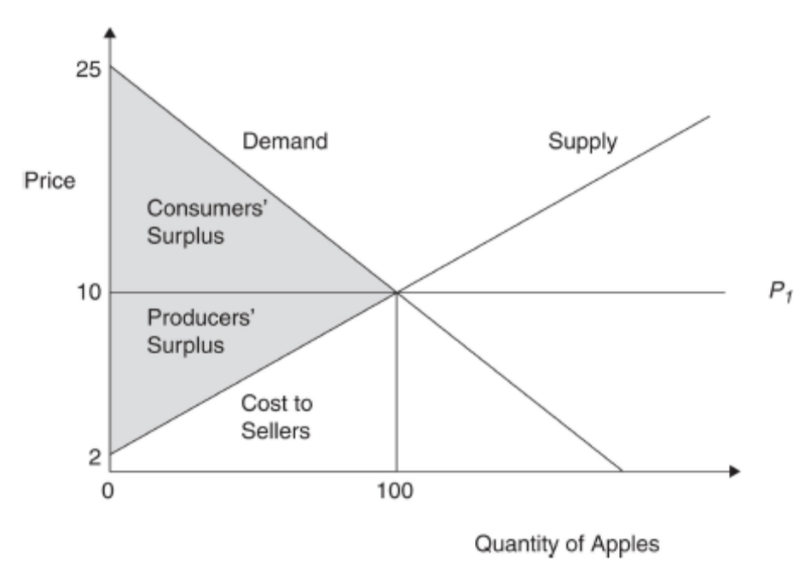
7. Using the diagram, suppose that producers need to have licenses to sell apples, and that only 90 units of apples are licensed (i.e., Q is limited to 90). Calculate
(a) the sum of the consumer surplus and producer surplus
(b) the reduction in consumer well-being because of the licensing
8. In Figure 4-6 suppose that the production possibility frontier was a straight line with slope -2.0. What would be the cost-effective allocation of resources? Why is this the case?
<APP_TTL>APPENDIX—DISCOUNTING
Economists use discounting to compare streams of returns and/or costs over a number of periods. An analyst might be asked to compare Investment A, which provides $2,000 at the end of Year 1 and $2,000 at the end of Year 2, with Investment B, which provides $1,200 at the end of Year 1 and $2,900 at the end of Year 2. Although Investment B returns $4,100 over the 2 years compared to $4,000 for Investment A, most of the return on Investment B comes later, at the end of Year 2. It is often crucial to compare the investments with a criterion that considers the timing of the returns. Discounting is the analytical tool that analysts use for such comparisons.
Suppose George is offered the opportunity to buy a bond that will return $1,000 one year from now. How much is he willing to pay now? George always has the option to keep his money and earn interest rate r. He will buy the bond if he can pay a price far enough below the $1,000 return next year such that that price, multiplied by one plus the interest rate, equals $1,000. Algebraically, if the rate of interest is r and the unknown amount is x₁, then:
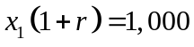
The value for x₁, then, can be solved as:
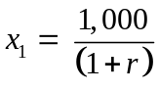
If the rate of interest is 5 percent (or 0.05), then x₁, the discounted value of $1, one year hence, equals 1,000/1.05, or $9,524.

Similarly, the discounted value of $1, two years hence, is:
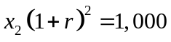
The value for x₂, then, can be solved as:
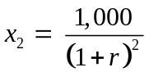
If, again, the interest rate is 5 percent, then x₂ equals 1,000/1.05², or 90.70 cents.

Returning to the preceding example, we can calculate that the present value (the sum of x₁ and x₂), or PV, for Investment A will equal $3,719, or (2,000/1.05 + 2,000/1.05²). The PV of Investment B is $3,773. Thus, George will prefer Investment B.

In summation notation, where term ∑ represents the summation from period 1 to period T, the present value of a stream of returns R and costs C, over time, is:
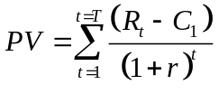
It is easy to demonstrate that the relative PVs of Investments A and B may depend on the interest rate (or in evaluation studies, sometimes referred to as discount rate d) chosen for the analysis. If an interest rate of 15 percent were used instead of 5 percent in the previous example, the PV for Investment A would be $3,251, compared to $3,236 for Investment B. Intuitively, the higher interest rate gives the larger but later return in Investment B less weight.
Reference changes
ADD
Grosse, Scott D. “Assessing Cost Effectiveness in Health Care: The History of the $50,000 per QALY Threshold,” Expert Review in Pharmacoeconomics and Outcomes Research 8(2) (2008), 165-178.
Maciosek, Michael V., Ashley B. Coffield, Thomas J. Flottemesch, Nichol M. Edwards, and Leif I. Solberg, “Greater Use Of Preventive Services In U.S. Health Care Could Save Lives At Little Or No Cost” doi: 10.1377/hlthaff.2008.0701 Health Affairs, 29, no.9 (2010):1656-1660
Ruger Jennifer P., Marek Chawarski, Mahmud Mazlan, Craig Luekens, Nora Ng, and Richard Schottenfeld. “Costs of Addressing Heroin Addiction in Malaysia and 32 Comparable Countries Worldwide,” Health Services Research, 2012; 47(2): 865-87.
Neumann, Peter J., Joshua T. Cohen, and Milton C. Weinstein,. “Updating Cost-Effectiveness - The Curious Resilience of the $50,000-per-QALY Threshold,” New England Journal of Medicine 371 (9) (2014): 796-797.
DELETE
Tengs (1995)
Figure 4-1 Consumers’ Surplus
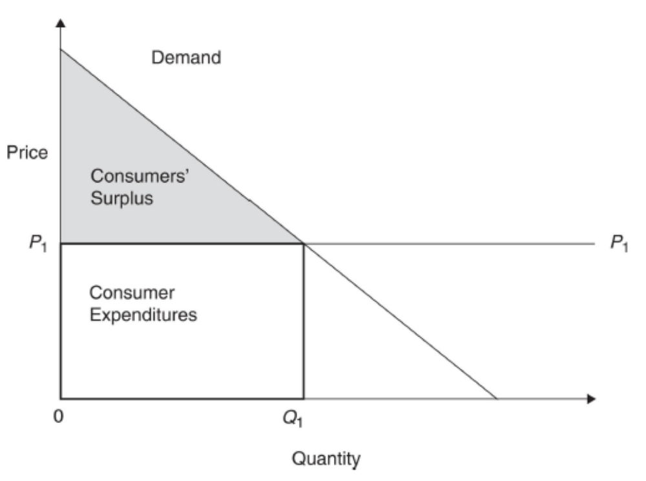
Figure 4-2 Producers’ Surplus
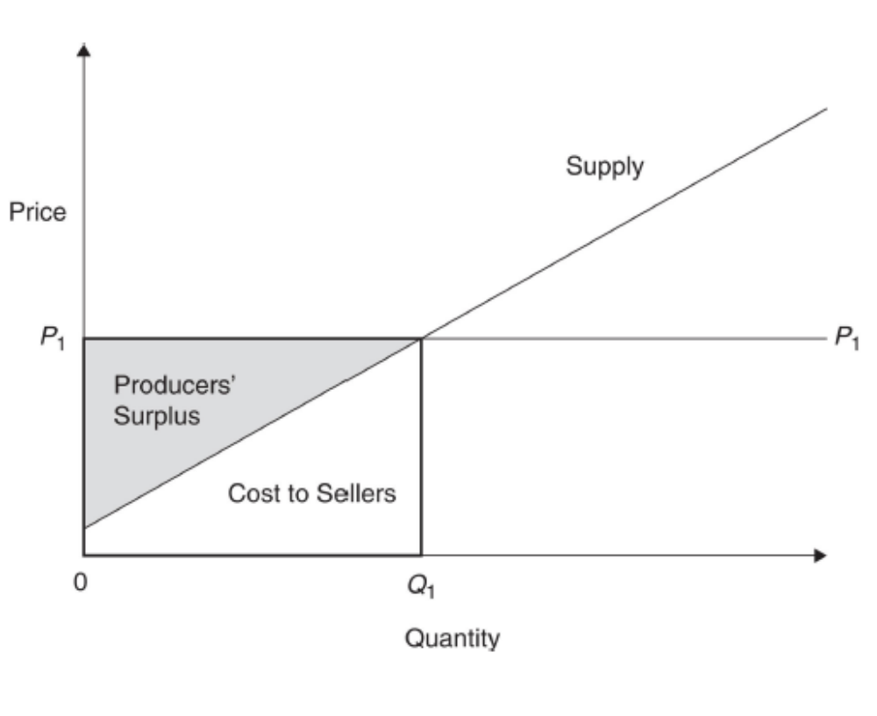
Figure 4-3 Efficient Quantity
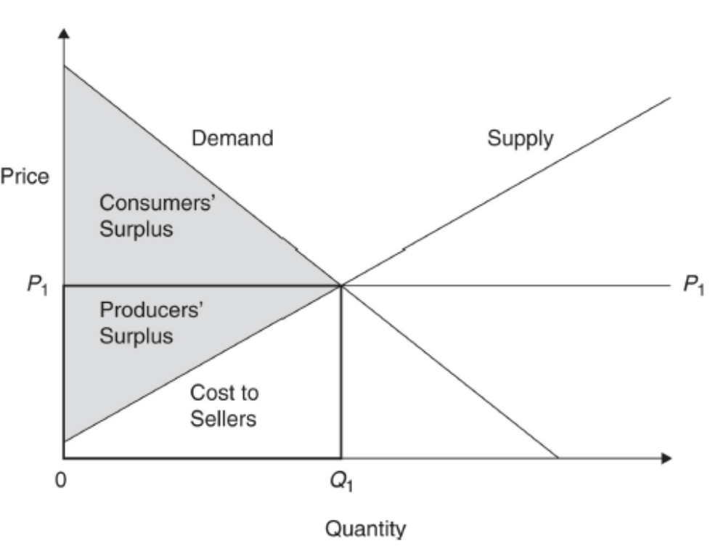
Figure 4-4 Efficient Use of Resources Where Marginal Benefits Equal Marginal Costs
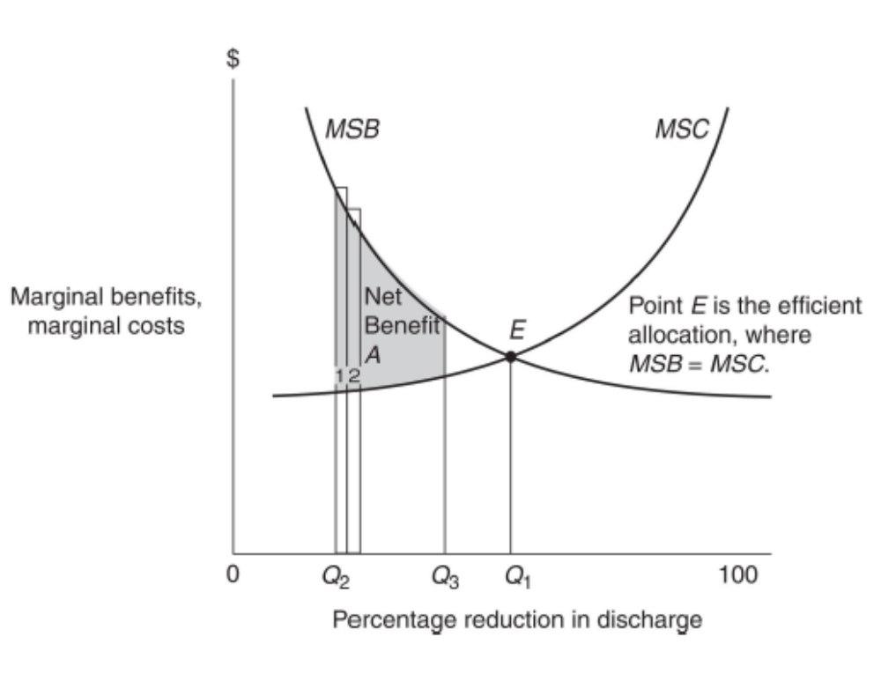

Figure 4 – 5 Gross v. “Micro” Measures in Evaluation
$
MB
MC
Benefits
Costs
MB
MC
Quantity
0
Q₁

Figure 4-6 Cost Efficiency and Utility Maximization with QALYs
Q_{H} + Q_{E} = 20
20
10
30
20
Ed
Harry
45º
Q_{H} = Q_{E} ≈ 8
A
B
Q_{H} + Q_{E} = 10
Q_{H} + Q_{E} = Q_{MAX} ≈ 23
Cost Efficient Output
Maximum Utility
Equal Utility
X
C
D
E
10

Gold et al. (1996) and Drummond et al. (1997) provide excellent comprehensive analyses of many of the issues raised in this chapter. C. Goodman (1998) provides a concise summary of the literature as well as a practical guide to the evaluation process.

