Chapter 7
Demand for Health Capital
 The Demand for Health
 Labor–Leisure Trade-Offs
 The Investment/Consumption Aspects of Health
 Investment over Time
 The Demand for Health Capital
 Changes in Equilibrium: Age, Wage, and Education
 Empirical Analyses Using Grossman’s Model
 Obesity—The Deterioration of Health Capital
 Conclusions
Chapter 5 considered the production of health in the aggregate by looking at the impacts of various factors on health for society as a whole. Here, we show how individuals allocate their resources to produce health. Economists’ understanding of this decision has been deepened by the important work of Michael Grossman and his followers. The model has enabled us to understand thoroughly the roles of age, education, health status, and income in the production of health through the demand for health capital. It also provides a useful format for examining the causes and impacts of obesity (being overweight), an important and current family health topic.
The Demand for Health
The Consumer as Health Producer
Grossman (1972a, 1972b) extended the theory of human capital to explain the demand for health and health care. According to human capital theory, individuals invest in themselves through education, training, and health to increase their earnings. Health investment leads to a myriad of decisions regarding work, heath (and non-health) care, exercise, and the use of consumption goods and bads (such as unhealthy food, cigarettes, alcohol or addictive drugs). In particular, according to this theory:
1. It is not medical care as such that consumers want, but rather health. In seeking health; they demand medical care inputs to produce it.
2. Consumers do not merely purchase health passively from the market. Instead, they produce health, combining time devoted to health-improving efforts including diet and exercise with purchased medical inputs.
3. Health lasts for more than a day or a month or a year. It does not depreciate instantly, and it can be analyzed like a capital good.
4. Perhaps most importantly, health can be treated both as a consumption good and an investment good. People desire health as a consumption good because it makes them feel and look better. As an investment good, they desire health because it increases the number of healthy days available to work and to earn income.
Figure 7-1 provides a simple diagram that explains the concept of health capital. Just as cars or refrigerators, as capital goods (or “stock of capital”) provide streams of services over time, one can conceive of a person’s stock of health capital that provides the ultimate output of “healthy days.” One might measure the stream of health output(s) as a single dimension of healthy days, or in several dimensions of physical health, mental health, and limited activity; for example, one can no longer play singles in tennis, but must play (less strenuous) doubles instead.
Consumers apply sets of health inputs, which might include not only market inputs of health care, but also diet, exercise, and time, to their physical makeup, thus making investments in health capital. These investments maintain or improve the consumers’ stocks of health, which in turn provide them with healthy days. Over time, the health stock may grow, remain constant, or decline (again, like a car or a refrigerator), either slowly with age, or more precipitously with illness or injury. As noted in Box 7-1, there may be many technologies available to produce health capital, using various amounts of time or market goods.
From Figure 7-1 and the accompanying discussion, we see how the end goal of “healthy days” guides consumer decisions as to how much time and money to invest in health stock. We will see that the prices of health care, the people’s wage rates, and their productivities in producing health, will dictate how resources are to be allocated among health capital, and other goods and services that people buy.
Consider a consumer, Ed Kramer, who buys market inputs (e.g., medical care, food, clothing), and combines them with his own time to produce a stock of health capital that produces services that increase his utility. Ed uses market inputs and personal time both to invest in his stock of health and to produce other things that he likes.
These other items include virtually all other things that Ed does. They include time spent watching television, reading, playing with and teaching his children, preparing meals, baking bread, or watching the sun set, a composite of other things people do with leisure time. We shall call this composite home good B.
Time Spent Producing Health
An increment to capital stock, such as health, is called an investment. During each period, Ed produces an investment in health, I. Health investment I is produced by time spent improving health, T_{H}, and market health inputs (providers’ services, drugs), M. Likewise, home good B is produced with time, T_{B}, and market-purchased goods, X.
Box 7-1
Exercise Technology – FitBits or Smart Phones?
Exercise provides a valuable input into the production of health, and exercisers have improved access to a myriad of technological aids to monitor and improve their performance. Many of these aids cost $100 or more. Are they worth it?
A research team at The University of Pennsylvania wondered the same thing. They developed a study to test 10 of the top-selling smartphone apps and devices in the United States by having 14 participants walk on a treadmill for 500 and 1,500 steps, each twice (for a total of 56 trials), and then recording their step counts. Study participants, all healthy Penn adults, wore the following devices during the treadmill trials:
- Waistband: one pedometer and two accelerometers
- Wrists: three wearable devices
- Pants pockets: two smartphones, one running three apps and the other running one
The data from the smartphones were only slightly different than the observed step counts (with a range of -6.7 to +6.2 percent relative difference in mean step count), but the data from the wearable devices differed more (with a range of -22.7 to -1.5 percent). In short, there was no systematic advantage to using dedicated wearable devices
The takeaway is that while smartphones might be a little bulky for vigorous exercise, “increased physical activity facilitated by these devices could lead to clinical benefits not realized by low adoption of pedometers.” The authors felt that their findings may help reinforce individuals’ trust in using smartphone applications and wearable devices to track health behaviors, which could have important implications for strategies to improve population health.
Source: Case, Meredith A., et. al., “Accuracy of Smartphone Applications and Wearable Devices for Tracking Physical Activity Data,” Journal of the American Medical Association 313(6) (2015) : 625-626. doi:10.1001/jama.2014.17841, accessed January 28, 2016

Meredith A. Case, BA¹; Holland A. Burwick²; Kevin G. Volpp, MD, PhD³; Mitesh S. Patel, MD, MBA, MS³

If, for example, we considered good B to be baking bread, the market goods might include flour, yeast, kitchen appliances, and gas, water, and/or electricity. Thus, Ed uses money to buy health care inputs, M, or home good inputs, X. He uses leisure time either for health care (T_{H}) or for producing the home good (T_{B}). Using functional notation:
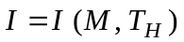 (7.1)
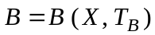 (7.2)
These functions indicate that increased amounts of M and T_{H} lead to increased investment I, and that increased amounts of X and T_{B} lead to increased home good B.
In this model, Ed’s ultimate resource is his own time. Treat each period of analysis as being a year, and assume that Ed has 365 days available in the year. To buy market goods such as medical care, M, or other goods, X, he must trade some of this time for income; that is, he must work at a job. Call his time devoted to work T_{W}.
Because our focus is on the health aspects of living, we realize that some of his time during each year might involve ill health, or T_{L}. Thus, we account for his total time in the following manner:
(7.3)
Recall that his leisure time is spent either improving his health or producing home goods.
Labor–Leisure Trade-Offs
The labor–leisure trade-off illustrates the potential uses of Ed’s time. Our variation on this analysis also helps illustrate the investment aspects of health demand.
Trading Leisure for Wages
In Figure 7-2, the x-axis represents Ed’s work and leisure time. Suppose that he considers his time spent creating health investment to be “health-improvement time” and that he calls T_{B} his leisure. In reality, he may do some health-improving activities at work, may obtain some enjoyment or satisfaction from healthful time, and so on, but assume here that these categories are exclusive. Assume further that the number of days lost to ill health and the number of days spent on health-enhancing activity are fixed (we relax this assumption later). Variables T_{L} and T_{H} refer to time lost and time spent on healthy activities, respectively. The maximum amount of time that he has available to use either for work, T_{W}, or leisure, T_{B}, is thus 365 − T_{H} − T_{L}, so:
(7.4)
Leisure time, T_{B}, is measured toward the right while time spent at work, T_{W}, is measured toward the left. Figure 7-2 shows that if Ed chooses leisure time, OA, then he has simultaneously chosen the amount of time at work indicated by AS.
Recall that Ed’s total amount of time available for either work or leisure is given by point S. If he chose point S for the period, he would be choosing to spend all this available time in leisure; that is, in the pursuit of the pleasures of life (albeit without the wage income to produce them). The y-axis represents income, obtained through work. This income will then purchase either market health goods or other market goods. Thus, if he chooses point S, he will not be able to purchase market goods because he has no wage income.
If, beginning at S, Ed gives up one day of leisure by spending that day at work, to point N, he will generate income equal to 0Y₁, which represents his daily wage. In economic terms, this quantity represents income divided by days worked—that is, the daily wage. The slope of the line VS depicting the labor–leisure trade-off reflects the wage rate (if Ed pays Social Security and/or taxes on his wage, then the slope reflects the after-tax wage rate).
Preferences between Leisure and Income
Consumers have preferences regarding income and leisure, just as they had among other goods in Chapter 2. As before, Ed would like more income and more leisure so the indifference curve map is shaped normally. In Figure 7-2, in equilibrium, Ed’s tradeoff of leisure and income is the same as the market trade-off, which is the wage rate. Here, he takes amount 0A of leisure and trades amount AS of leisure for income, 0Y₂.
In Figure 7-3, Ed has made a different choice with respect to time spent investing in health status. To illustrate, suppose that time spent on health-producing activities, T_{H}, is increased to T´_{H}. Correspondingly, suppose that the number of days lost to ill health has been reduced to T´_{L}. What effect will this change in time have on the horizontal intercept, which is the total time remaining for work or leisure? On the one hand, the time he spends producing health reduces his time available for other activities. Time spent on health investment increases health stock and, in
turn, reduces time lost to illness.
If the net effect of T´_{H} + T´_{L} is a gain in available time, then this illustrates the pure investment aspect of health demand. The health investments “pay off” in terms that both add to potential leisure and also increase the potential income, shifting the income–leisure line outward from VS to RQ. The expenditure of time (and medical care, too) for health-producing activities may later improve Ed’s available hours (because he is sick less) of productive activity.
As a result of his investment, Ed can increase his utility, moving from point E to point E’. Not only does investment in health lead to his feeling better, but it also leads to more future income and may lead to more leisure, as well.
The improvement in health status also might increase Ed’s productivity at work, perhaps resulting in a higher wage and a steeper income–leisure line (why is it steeper?). In any case, the analysis shows that Ed might wish to engage in activities to improve his health, even if the only value of health is its effect on his ability to earn future income.
The Investment/Consumption Aspects of Health
The Grossman model describes how consumers simultaneously make choices over many periods or years. It can also be instructive to represent a whole life span as a single period. This can show the dual nature of health as both an investment good and a consumption good.
Production of Healthy Days
For simplicity, we will view health as a productive good that produces a single output, healthy days, a production function relationship illustrated in Figure 7-4. The horizontal axis measures health stock in a given period. A larger stock of health leads to a larger number of healthy days, up to a natural maximum of 365 days. The bowed shape of the curve illustrates the law of diminishing marginal returns. That is, additional resources have decreasing marginal impacts on the output – all of Ed’s health improvement attempts serve to increase his healthy days, but he still gets sick every once in a while.. Note also the concept of a health stock minimum shown as H_{min}, where health stock becomes arbitrarily small. At this point, production of healthy days drops to zero, indicating death.
Production of Health and Home Goods
Consider the possibilities for producing health, H, and home good, B, given the total amount of time available. Figure 7-5 shows the production possibilities trade-off. The curve differs from the usual production possibilities curve in several respects. First, from point A to point C, health improvements increase the amounts of the home good, B, and health, H, attainable. It is necessary to increase health beyond H_{min} in order to obtain income and leisure time from which to produce B.
Moving along the production possibilities curve, Ed shifts his uses of available time and distributes his purchases of market goods. The move from E to C indicates that he has made more time available for health and that this move has reaped the side benefit (increased leisure time) of increasing the availability of market goods and time used to increase production of the home good, baking bread.
Suppose that Ed desires health solely for its effect on the ability to produce income and the leisure time to produce the home good bread, B. This would imply that his indifference curves between H and B are vertical lines. (Ed places no intrinsic value on H, so he would not trade any B to get additional health.) In such a case, he would maximize his utility by producing as much B as possible. The utility-maximizing choice would be at point C, a point of tangency between indifference curve U₁ and the production possibilities curve. He produces amount B₀ of the home good, and H₀ of health.
Now assume instead that Ed achieves utility not only from producing B, but also directly from health itself (he likes feeling better). In this case, his (dashed) indifference curve, U₂, has the more familiar curved shape in Figure 7-5, sloping downward from left to right. It is more realistic to say that he values health both as a consumption good, as is shown in Figure 7-5, and as an investment in productive capacity. The consumption aspect suggests that he enjoys feeling healthy; the investment aspect, that feeling healthy makes him more productive, thus allowing him to earn more. In general, by including Ed’s “feeling healthy” in this consumption feature of the model, he will choose a higher health stock than under the pure investment model. In Figure 7-5, health stock, H₁, exceeds H₀. The cost of this increase in H involves foregoing some of the home good B, such that B₁ is less than B₀.
Investment Over Time
The Cost of Capital
People make choices for the many periods over their life cycles, rather than just for one representative period. As a beginning point for each analysis, we feature the pure investment version of the model (point C in Figure 7-5). We then discuss the analytical changes when consumers, in addition, value health intrinsically (point D in Figure 7-5). We demand health capital because it helps us earn more and feel better. What does it cost? By analogy, a health clinic purchases thousands of dollars of X-ray equipment. The return to the X-ray equipment is in the future earnings that ownership of the equipment can provide.
Suppose that an X-ray machine costs $200,000, and that its price does not change over time. Suppose also that the annual income attributable to the use of the X-ray machine is $40,000. Is purchasing the machine a good investment? Consider the alternative: Instead of purchasing the X-ray machine, the clinic could have put the $200,000 in a savings account, at 5 percent interest, yielding the following:
For the investment in an X-ray machine to be desirable by these criteria, it should provide at least $55,256 in incremental revenue over the five years.
The problem is more complicated, however, because capital goods depreciate over time. Most students will agree that a five-year-old personal computer is worth almost nothing. Even though it may do everything it ever did, new programs may not work on it, new equipment may not hook up to it properly, and it may be very slow compared to new machines. In economic terms, the machine has depreciated, and if parts like disk drives wear out, it may depreciate physically as well. If the computer originally cost $2,000, and the students have not budgeted $2,000 for replacement, they may find themselves without working computers! In economic terms, depreciation is the budgeting for replacement.
Similarly, suppose that the clinic knows that the X-ray machine will wear out (or depreciate), so that it will be worth only half its original value in five years. The clinic must earn enough not only to cover the opportunity cost from the bank, but also to maintain the value of the machine. For an investment in an X-ray machine to be worthwhile, then, it must not only earn the competitive 5 percent return each year, but it also must provide enough return to cover depreciation. This suggests that the cost of holding this capital good for any one year, as well as over time, will equal the opportunity cost of the capital (interest foregone) plus the depreciation (deterioration of value). In this example, the depreciation cost is $100,000, or half of the $200,000 original cost.
The Demand for Health Capital
Conventional economic analysis provides a powerful conceptual apparatus by which to analyze the demand for a capital good. The cost of capital, in terms of foregone resources (for health capital, both time and money), is a supply concept. The other needed tool is the concept of the marginal efficiency of investment (MEI) a demand concept that relates the return to investment to the amount of resources invested.
Marginal Efficiency of Investment and Rate of Return
The MEI can be described in terms of the X-ray machine example. A busy clinic may wish to own more than one X-ray machine. But how many? The clinic management may logically consider them in sequence. The first machine purchased (if they bought only one) would yield a return as we have discussed. Suppose that return each year is $40,000.
We also can calculate the annual rate of return, which would be $40,000 ÷ $200,000, or 20 percent per year. The management would buy this machine if the incremental revenue brought in covered its opportunity cost of capital and the depreciation. In terms of rates, management would choose to own the first X-ray machine as long as the rate of return, 20 percent, exceeded the interest rate (the opportunity cost of capital) plus the depreciation rate.
If management considered owning two machines, it would discover that the rate of return on the second X-ray machine would probably be less than the first. This is best understood by recognizing that a clinic buying only one X-ray machine would assign it to the highest-priority uses, those with the highest rate of return. If the clinic were to add a second X-ray machine, then logically it could be assigned only to lesser-priority uses (and might be idle on occasion). Thus, the second machine would have a lower rate of return than the first. The clinic would then purchase the second machine only if its rate of return were still higher than interest plus depreciation.
The Decreasing MEI
Other machines probably could be added at successively lower rates of return. In Figure 7-6, the marginal efficiency of investment curve, MEI, describes the pattern of rates of return, declining as the amount of investment (measured on the horizontal axis) increases. The cost of capital (that is, the interest rate, r, plus the depreciation rate, δ₀) is shown as the horizontal line labeled r + δ₀. The optimum amount of capital demanded is thus H₀, which represents the amount of capital at which the marginal efficiency of investment just equals the cost of capital. This equilibrium occurs at point A.
Like the marginal efficiency of investment curve in this example, the MEI curve for investments in health also would be downward sloping. This occurs because the production function for healthy days (see Figure 7-4) exhibits diminishing marginal returns. The cost of capital for health would similarly reflect the interest rate plus the rate of depreciation in health. Understand that a person’s health, like any capital good, also will depreciate over time. As we age, certain joints may wear out, certain organs may function less well than before, or we may become more forgetful. Thus, the optimal demand for health is likewise given at the intersection of the MEI curve and the cost of capital curve (r + δ₀).
Changes in Equilibrium: Age, Wage, and Education
Return to Ed Kramer and to Figure 7-1. Based on the analyses thus far, Ed has chosen an equilibrium level of health stock, by deciding how much to work, how much time to spend on health, what kind of diet, and how much exercise to do. He allocates his resources such that every year he maintains a constant level of health stock, and this provides him with an equilibrium level of healthy days per year. How does his investment in health change in response to changes in age, wage, and education? The model depicted in Figure 7-6 helps us to investigate several important model implications. Consider age first.
Age
How does Ed’s optimal stock of health vary over a lifetime? In this model the age of death is determined as part of the model; death itself is endogenous, meaning that—it doesn’t just happen! (For completeness, an outcome determined outside of the model is termed exogenous). Here, Ed chooses his optimal life span, a life span that is not infinite. By this model, all of us at some time will optimally allow our health stock to dissipate to h_{min}. This feature depends in a critical way on how the depreciation rate (a cost factor) varies with age, as well as how long the person expects to live (and enjoy the benefits of good health).
Looking first at costs, Ed’s health stock may depreciate faster during some periods of life and more slowly during others. Eventually, as he ages, the depreciation rate will likely increase. In other words, the health of older people will likely deteriorate faster than the health of younger people.
Consider then the effect of aging on Ed’s optimal health stock. Return to Figure 7-6. We assume that the wage and other features determining the MEI are not substantially altered by this aging. However, by hypothesis, the depreciation rate, δ, increases with age from δ₀ to δ₁ and ultimately to δ_{D}. These assumptions imply that the optimal health stock decreases with age.
This situation is shown in Figure 7-6 by the fact that the optimal health at the younger age, H₀, is greater than H₁, the optimal stock at the older age. Higher depreciation rates increase the cost of holding health capital stock. We adjust to this by holding more health capital in periods when health is less costly. In old age, health depreciation rates are extremely high, δ_{D}, and optimal health stock falls to H_{min} at point B.
This conclusion is consistent with the observation that elderly people purchase a greater amount of medical care, even as their health deteriorates. Grossman explains the phenomenon:
Gross investment’s life cycle profile would not, in general, simply mirror that of health capital. This follows because a rise in the rate of depreciation not only reduces the amount of health capital demanded by consumers but also reduces the amount of capital supplied to them by a given amount of gross investment. (p. 238)
Turning to returns from investment, consider an analogy to a consumer who has two cars, the same models, built by the same maker. One is two years old, with 30,000 miles of wear; the other is 12 years old, with 180,000 miles of wear. Each car has had the “bumps” and “bruises” that accompany driving in a major city. Suppose that the two-year-old car is damaged in the parking lot and will cost $3,000 to repair. The decision is obvious. However, would the owner incur the same level of costs (more pointedly, would the car insurer reimburse these costs) to repair the 12-year-old car, which is most likely near the end of its useful life?
The analogy to individual health is immediate. A younger person may choose complicated surgery to replace knees or hips, to maintain earning capability or quality of life. An older person may choose not to do so. In Figure 7-6, this suggests that as the expected length of life decreases, the MEI curve shifts to the left, because the returns from an investment will last for a shorter period of time. This will reinforce the decrease in investment that occurs due to increased depreciation.
Other features of the model suggest that people will increase their gross investment (their expenditures) in health as they age. It follow, in turn, that the elderly would demand more medical care than the young, as we frequently note to be the case.
Thus, the pure investment model generates the prediction that optimal health will decline as the person ages. Will this prediction change when we assume more realistically that an individual also will value health for consumption reasons (good health makes one feel better)? The issue relies on whether older persons get more or less direct utility from the enjoyment of healthy days. If people increase their valuation of healthy days as they age, this may offset the predicted health stock decline.
Wage Rate
Figure 7-6 also illustrates the effect of a change in the wage rate on Ed’s optimal level of investment. Increased wage rates increase the returns obtained from healthy days (8 hours’ work will bring in $160 rather than $120 if the wage rate increases from $15 to $20 per hour). Thus, higher wages imply a higher MEI curve, or MEI´.
Assume now that the original MEI curve describes the lower-wage case and yields optimal health stock, H₀. The MEI´ curve, above MEI, shows the marginal efficiency of investment for someone with higher wages. At new equilibrium point C, the higher wage will imply a higher optimal level of health stock, H₂, in this pure investment model. The rewards of being healthy are greater for higher-wage workers, so increased wages will generally tend to increase the optimal capital stock.
The model illustrates one more implication of the wage factor. Consider that when Ed retires, his wage effectively drops to zero because improved health does not help him earn more. The pure investment version implies that he would change his optimal health stock to H_{min} upon retirement. Once he retires, he would make no further investment in health, but instead would allow health to depreciate until death.
How would we amend this analysis by considering the consumption aspects of health—that good health makes people feel good? First, Ed would presumably continue to obtain utility directly from healthy days. Thus, optimal health stock would not necessarily drop to H_{min} directly upon Ed’s retirement, but it would do so only when depreciation rates became sufficiently severe.
Second, if retirees and those who are still working obtain utility directly from healthy days, then the only significant change upon retirement would involve the end of the pure investment motive. Therefore, even when we include the consumption aspects of health, we would expect people to reduce their health stock upon retirement.
Education
Education is especially interesting to those who study health demand. Those with higher education often have better health, and most economists believe that education may improve the efficiency with which people can produce investments to health and the home good. Examples of improved efficiency may include improved ability to follow instruction regarding medicines or better knowledge of harmful effects of obesity, or of potentially harmful activities such as smoking, drinking, or addictive drugs, to name just a few.
Figure 7-6 illustrates the effect of education. Here, the MEI curve illustrates the marginal efficiency of investment for the consumer with a low level of education (measured, for example, by years of schooling), while the MEI´ curve illustrates the same person with a higher level of education. This model indicates that because education raises the marginal product of the direct inputs, it reduces the quantity of these inputs required to produce a given amount of gross investment.
It follows that given investments in health can be generated at less cost for educated people, and thus they experience higher rates of return to a given stock of health. The result, as shown, is that the more highly educated people will choose higher optimal health stocks, H₂,;the less highly educated will choose H₀.
This explains the widely observed correlation between health status and education. Educated people tend to be significantly healthier. However, this explains only the correlation of health status and education from the supply side in that it considers only the increased efficiency with which we produce health. One also might wish to explain education from the demand side.
Educated people most likely recognize the benefits of improved health. They may enjoy preparing and eating nutritious food or doing physical exercise. They may recognize the dangers of smoking and the long-term problems of overexposure to the sun. They may enjoy feeling and looking good. As such, all else equal, they would have a greater taste for health relative to other goods.
The demand for health due to education is difficult to separate from the supply effect of education, which implies more productivity in producing health. Clearly, however, both exist and both are important.
Empirical Analyses Using Grossman’s Model
Hundreds of articles have looked to Grossman’s model for guidance in examining health production, and Box 7-2 discusses briefly the important insights related to addictive behavior. The resulting literature examines the separable impacts of age and education. It also looks at the various time components of health investment within families, and the impacts of health status on the demand for health and health care. We sample several studies here, and look at particular recent examples relating to obesity in the next section.
Sickles and Yazbeck (1998) developed a structural model of the demand for leisure and the demand for consumption for elderly males. Measuring health production is a difficult problem, so the authors use the Quality of Well-Being (QWB) scale, developed by Kaplan and Anderson (1988), based on mobility, physical activity, social activity, and physical symptoms and problems. They find that both health care and leisure consumption tend to improve health. A 1 percent increase in health-related consumption increases health by 0.03 to 0.05 percent. A 1 percent increase in leisure increases health by from 0.25 to 0.65 percent.
Box 7-2
Rational Addiction
Economists Gary Becker and Kevin Murphy (1988) describe conditions under which rational people choose to consume addictive goods. Their work challenges our common moral concepts and attitudes toward addiction. It also offers similarities and contrasts with Grossman’s model of the demand for health.
Becker and Murphy argue that addictive behavior (as most current or former smokers would agree) must provide some pleasure or people would not pursue it. For a good to be addictive, in their model, past consumption (of the good) must increase the marginal utility of current consumption. Past consumption contributes to “consumption capital” of the good in question. Current smoking may entail a learning experience in the sense that future consumption of an additional cigarette becomes more enjoyable. So, also, do drinking coffee or listening to Mozart. Mozart symphonies may become more enjoyable in the future as this learning experience continues. Coffee drinkers learn to enjoy the beverage but discover that stopping usage can lead to symptoms of withdrawal.
Many addictions, however, are harmful. Harmful, in the Becker and Murphy context, means that the capital good—the consumption capital—has harmful effects similar to a reduction in health status in the Grossman model. Smoking cigarettes may reduce healthy days and may reduce income. Such harmful effects are part of what Becker and Murphy call the “full price” of the addictive good.
A potential cigarette smoker or drug user might choose to start, even knowing that it is addictive, if smoking or using tends to increase future enjoyment from smoking more than it increases future harmful effects. This explains why a rational person may choose to ingest a harmful substance, knowing fully its harmful effects.
(See Chapter 24 for a more detailed discussion of rational addiction.)
Gerdtham and Johannesson (1999) estimate health demand with a Swedish sample of over 5,000 adults using a categorical measure of overall health status to measured health capital. They find that the health demand increases with income and education and decreases with age, urbanization, being overweight, and being single.
Another way to test the model involves the demand for preventive care. Kenkel (1994) estimates the determinants of women’s purchases of medical screening services, designed for the early detection of breast and cervical cancer. Annual use of these screening tests decreases with age, a result consistent with women’s rationally reducing care as the payoff period shortens over the life cycle and as the depreciation rate rises. Furthermore, increased schooling tends to increase the use of the screening services, implying more efficiency in producing health.
Mullahy and Sindelar (1993) examine the relationships among alcoholism, income, and working. Poor health may reduce income either by reducing productivity, which results in lower wages, or by reducing labor market participation (whether and/or how much one is working). Alcoholism is an illness that reduces people’s health capital. Mullahy and Sindelar find the labor market participation effects are more powerful than the wage (productivity) effects in reducing earnings, and hence reducing the return to health. By these criteria, successful alcoholism treatment would appear to have significantly positive economic returns.
In a retrospective essay on research achievements and directions in the 30 years after Grossman’s pioneering analysis, Leibowitz (2004) finds that increases in the parents’ valuations of time will also affect the relative costs of alternative inputs to children’s health. As a result, mothers who work outside the home may employ substitutes for their own time that are less effective in producing child health. For example, working mothers can substitute prepared foods for their own time in producing meals for their children. However, these prepared foods are often high-calorie and high-fat, perhaps leading to less nutritious diets for their children (Leibowitz, 2003; Anderson et al., 2003).
In yet another application, Borisova and Goodman (2004) examine the importance of time in compliance of drug abusers with methadone treatment as a substitute for heroin. Because most drug abuse treatment comes at only nominal or zero cost, the time spent traveling to, and receiving, the daily treatment becomes critical. The authors find, as expected, that increased travel and treatment time costs significantly reduce treatment compliance, and decrease the improvement in health capital related to kicking the addiction.
Bhattacharya and Lakdawalla (2006) examine the value to the U.S. labor force of improvements in survival and health over the years 1970 to 1999. They find that survival gains and reductions in the number of work-days missed due to poor health have added about 8 percent to the remaining labor force value of black males, and about the same to the value of 60-year-old white males. They note that these effects are almost as large as a full year of schooling. Gains for younger white males appear to have been approximately 5 percent, and gains for women are around 2 percent. Overall, they estimate that health improvements have added $1.5 trillion to the value of labor market human capital over this period. Even a 5 percent return on this human capital would lead to an increase of $75 billion per year in GDP, a substantial amount!
All of these examples indicate that Grossman’s model has yielded considerable insight into the determinants of health and into the allocation of resources (both time and money) into health-creating activities. It has also crossed fields of economics, including labor, development, and growth economics, and has provided fruitful results in cross-disciplinary demographic and sociological research as well.
Obesity—The Deterioration of Health Capital
Obesity (excess weight) provides many insights in a model of health capital. Aside from aesthetic issues regarding appearance, obesity is a leading risk factor for heart disease, hypertension (high blood pressure), certain cancers, and type-2 diabetes.
According to reports from the Center for Disease Control in 2016, over almost 35 percent of U.S. adults (almost 79 million) people and 17% of U.S. children were obese in 2011-2012. From 1980 through 2012, obesity rates for adults and children have doubled and rates for adolescents have quadrupled. During the past several decades, obesity rates for all groups in society regardless of age, sex, race, ethnicity, socioeconomic status, education level, or geographic region have increased markedly.
Health analysts usually measure obesity in terms of Body Mass Index, or BMI, with the formula 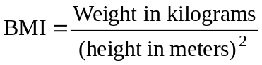. It is not a complete measure. For example, BMI does not distinguish between fat and muscle, and entire rosters of US professional football teams would be termed as overweight or obese by the BMI. Nonetheless is is easy to use, and it adjusts for the fact that tall people are generally heavier. If Ed Kramer weighs 90 kg (almost 200 pounds) and is 1.75 meters (about 5 feet 9 inches) tall, he has a BMI of 29.4. Table 7-1 provides the generally accepted measures of weight relative to body size measured by height.

Table 7-1 Weight Status Classified by Body Mass Index
Category | BMI range
Severely underweight | less than 16
Underweight | 16 to 18.5
Normal | 18.5 to 25
Overweight | 25 to 30
Obese Class I | 30 to 35
Obese Class II | 35 to 40
Obese Class III | 40 and above
Source: World Health Organization. http://www.who.int/bmi/index.jsp?introPage=intro_3.html.

As noted in Table 7-1, a BMI rating of over 25 is classified as overweight. By this criterion, Ed is overweigh, and if he weighted 2 kilograms more, with a BMI slightly over 30, he would be considered (Class I) obese.

Table 7-2 2014 US State Obesity Rates
Alabama |  | 33.5 | Illinois | 29.3 | Montana |  | 26.4 | Rhode Island | 27.0
Alaska |  | 29.7 | Indiana | 32.7 | Nebraska |  | 30.2 | South Carolina | 32.1
Arizona |  | 28.9 | Iowa | 30.9 | Nevada |  | 27.7 | South Dakota | 29.8
Arkansas |  | 35.9 | Kansas | 31.3 | New Hampshire |  | 27.4 | Tennessee | 31.2
California |  | 24.7 | Kentucky | 31.6 | New Jersey |  | 26.9 | Texas | 31.9
Colorado |  | 21.3 | Louisiana | 34.9 | New Mexico |  | 28.4 | Utah | 25.7
Connecticut |  | 26.3 | Maine | 28.2 | New York |  | 27.0 | Vermont | 24.8
Delaware |  | 30.7 | Maryland | 29.6 | North Carolina |  | 29.7 | Virginia | 28.5
Washington DC |  | 21.7 | Massachusetts | 23.3 | North Dakota |  | 32.2 | Washington | 27.3
Florida |  | 26.2 | Michigan | 30.7 | Ohio |  | 32.6 | West Virginia | 35.7
Georgia |  | 30.5 | Minnesota | 27.6 | Oklahoma |  | 33.0 | Wisconsin | 31.2
Hawaii |  | 22.1 | Mississippi | 35.5 | Oregon |  | 27.9 | Wyoming | 29.5
Idaho |  | 28.9 | Missouri | 30.2 | Pennsylvania |  | 30.2
 | Source: http://www.cdc.gov/obesity/data/table-adults.html, accessed January 27, 2016
.
Table 7-2 indicates that 44 states in 2014 in the United States had obesity prevalence (BMI greater than 30) equal to or greater than 25% of their adult populations, ninteen had prevalence between 30 and 35 percent, and three states (Arkansas, Mississippi, and West Virginia) had prevalence greater than 35 percent.

Table 7 – 3 Percent BMI > 30 - 2014
a. Selected Countries
Country | Both sexes | Female | Male
Argentina | 26.3 | 28.9 | 23.6
Australia | 28.6 | 28.8 | 28.4
Brazil | 20.0 | 22.7 | 15.1
Canada | 25.9 | 27.2 | 24.6
Egypt | 26.2 | 34.8 | 17.7
France | 22.0 | 22.3 | 21.8
Germany | 18.5 | 17.2 | 19.9
Ireland | 25.6 | 25.3 | 25.9
Israel | 25.3 | 27.0 | 23.5
Italy | 21.0 | 21.6 | 20.4
Japan | 3.3 | 3.2 | 3.4
Mexico | 25.9 | 30.7 | 20.7
Nigeria | 8.9 | 13.4 | 4.6
Poland | 23.1 | 25.1 | 21.0
Russian Federation | 22.2 | 26.2 | 17.6
United Kingdom | 25.5 | 26.8 | 24.1
United States | 31.2 | 32.5 | 29.8

b. Highest Obesity Values
Country | Both sexes | Female | Male
Cook Islands | 48.2 | 53.1 | 43.5
Palau | 46.1 | 51.0 | 41.4
Nauru | 45.4 | 51.0 | 39.9
Samoa | 41.8 | 50.0 | 34.0
Marshall Islands | 41.7 | 47.8 | 35.6
Tonga | 41.6 | 49.0 | 34.3
Niue | 41.0 | 47.3 | 35.0
Kiribati | 39.2 | 47.2 | 31.5
Tuvalu | 38.4 | 44.6 | 32.4
Qatar | 38.1 | 46.5 | 35.4
Kuwait | 36.8 | 43.2 | 32.5
Micronesia | 35.6 | 42.4 | 29.2
Fiji | 35.0 | 40.9 | 29.4
http://apps.who.int/gho/data/view.main.2450A, accessed January 27, 2016

Obesity is not limited to the United States. Table 7 – 3a (the age-adjusted obesity rate) shows that many advanced countries have well over one-quarter of their populations with BMI greater than 30. Typically, although not always, female rates exceed male rates. The highest obesity rates (as noted in Table 7 – 3b) occur in several Pacific Island nations, as well as some Middle Eastern states.
Obesity describes health capital, in that it may make the body less productive, more susceptible to disease, and possibly cause it to depreciate more quickly. We will therefore look to see what part of the health capital model may explain it. We then consider some of its economic effects and finish with economic explanations as to why it has increased.
An Economic Treatment of Obesity
This discussion closely follows a model derived by Yaniv, Rosin, and Tobol (2009). They note that the human body needs energy to function, with food being the fuel that creates this energy. Potential energy exists in the form of calories burned in the process of daily functioning, and the body accumulates unburned energy in the form of fat tissues that increase bodyweight. People will gain or lose weight depending on the relationship of total calories consumed to total calories expended.
The body expends calories both in physical activity and at rest. The rest component, known as Basal Metabolic Rate (BMR), is the largest source of energy expenditure, reflecting blood circulation, respiration and daily maintenance of body temperature. While the BMR is determined by physical characteristics (such as gender, age, weight and height), calories expended through physical activity, as well as calorie intake through food consumption, are subject to choice. Differing BMRs among individuals indicate why one person can “eat like a horse” and gain little weight, while another may gain weight with far less intake of food.
This economic theory of obesity views weight gain as the outcome of rational choice that reflects a willingness to trade off some future health for the present pleasures of less restrained eating and lower physical activity. Although economic models of obesity usually focus on food consumption in general as the source of energy, foods vary in their calorie content. Junk food, for example, is relatively high in calories, or energy-dense, while healthy food is lower in calories.
Suppose that overweight individuals can determine consumption of junk-food meals, F, and healthy meals, H. They may also choose their level of exercise, x. The model defines the weight gain during a period, or obesity, S, as:
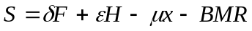 (7.5)
where δ and ε represent calorie intake per junk-food meal F and healthy meal H, respectively (with δ > ε), and µ represents calorie expenditure per instant of physical activity. In plain terms, people who eat too much and do not exercise enough, will get fat.
Yaniv and colleagues note that people may eat even when they are not hungry, in social or stressful situations, and this type of eating may be composed of snacks, which are high in calories (i.e., part of F). Using F^{S} and M to denote snacks and hunger-induced meals, suppose that people can satisfy their hunger through either junk-food F or healthy meals H. Hence,
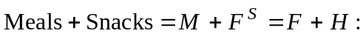 (7.6)
Substituting Eq. (7.6) in Eq. (7.5), the obesity function becomes
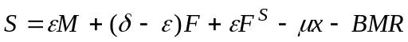 (7.7)
If people satisfy hunger with healthy meals and healthy snacks alone so F = 0, then
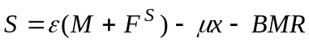 (7.7')
To the extent that they substitute a junk food meal for a healthy meal or a snack, the value of S increases by (δ − ε).
Here, healthy food H does not enter the obesity function explicitly, but it moderates the calorie contribution of junk-food meals that substitute in satisfying hunger and lead to increased weight. In this framework, taxes on junk food (reducing its consumption), or subsidies to healthy food (increasing its consumption) could have important impacts on the formation of health capital.
Economic Effects
This model provides several useful inferences about obesity. Clearly, body weight is a measure of health capital, and most people have at least some say in what happens to their level of health capital. Healthy eating (consuming H rather than F) exercising more (increasing exercise level x), and appropriate diet practices will help maintain appropriate body weight.
From a health investment point of view, obesity is a bad investment, leading to both higher medical expenditures, and lower earnings. Cawley and colleagues (2015) find that in 2010 obesity raised annual medical care costs by $3508. Predicted medical care costs for both men and women just over the threshold of obesity are not significantly higher than those of healthy weight individuals. However, costs rise exponentially in the morbidly obese range (BMI ≥ 35), which indicates that the greatest potential savings may come from facilitating weight loss in that group or preventing additional weight gain among obese individuals.
Cawley (2004) addresses the measured impact of obesity on wages. He cites several previous studies that found negative correlations between body weight and wages among females, with three broad explanations for this finding. First, obesity reduces wages by lowering productivity or because employers discriminate against obese people, paying them less than others. A second explanation is that low wages cause obesity. This may occur if poorer people consume cheaper, more fattening, foods. The third explanation is that unobserved variables such as poor education cause both obesity and low wages.
In careful statistical analysis, he uses ordinary least squares (OLS) results to find that heavier white females, black females, Hispanic females, and Hispanic males tend to earn less, and heavier black males tend to earn more, than their less heavy counterparts. With more complex statistical models he shows that the effect is particularly strong for white females. A difference in weight of two standard deviations (roughly 64 pounds) is associated with a wage difference of 9 percent. The magnitude of this difference is equivalent in absolute value to the wage effect of roughly 1.5 years of education or three years of work experience.
Brunello and D’Hombres (2007) examine nine countries in the European Community Household Panel. While some of their country effects are not significant, due to small sample sizes, when they pool the data on all nine countries, they find that a 10% increase in BMI reduces the wages of females by 1.86% and males by 3.27%.
Why Has Obesity Increased?
Economists often seek to explain behaviors in terms of incomes and prices. Certainly those who are abjectly poor, have too little to eat, so increased incomes will increase weight. For income to explain obesity, one would have to show that as incomes grow, people tend spend relatively more on energy-dense foods (those foods with a high number of calories per unit weight). Such evidence is generally lacking
There is some evidence that the prices of energy-dense foods have fallen relative to others. Cawley (2015) reports findings that from 1990 to 2007, the real price of a 2-liter bottle of Coca Cola fell 34.9% and the real price of a 12 inch Pizza Hut pizza fell 17.2%. In contrast the prices of fresh fruits and vegetables rose faster than inflation. If these food types are normal goods one might expect a shift in consumption to these more energy dense foods.
Cutler, Glaeser, and Shapiro (2003) show that there was increased caloric intake for both men and women from the late 1970s to the late 1990s. Caloric intake increased for both men (almost 13 percent) and women (9.4 percent) over a twenty-year period.
While there are multiple causes, the authors attribute substantial explanatory power to changes in the time costs of food production. Technological innovations—including vacuum packing, improved preservatives, deep freezing, artificial flavors and microwaves—have enabled food manufacturers to cook food centrally and ship it to consumers for rapid consumption.
Table 7-4 shows that in 1965, married women who did not work outside the home spent over almost 138 minutes per day cooking and cleaning up from meals. In 1995, the same tasks took just about half the time. The switch from individual to mass preparation lowered the time price of food consumption and led to increased quantity and variety of foods consumed.
They argue further, that peeling and cutting french fries, for example, is a marginal time cost, while deep frying (in restaurants) is generally a fixed cost (up to the point where the fryer is full). Mass preparation allows a restaurant to share the fixed time component over a wide range of consumers. In addition, mass preparation reduces the marginal cost of preparing food by substituting capital for labor. Finally, mass preparation exploits the division of labor. Food professionals instead of “home producers” now prepare food, reducing both fixed and marginal costs.
Table 7-4 Time Costs by Demographic Group (minutes)
 | 1965 |  | 1995
 | Meal Prep. | Meal Prep. + Cleanup | Meal Prep. | Meal Prep. + Cleanup
Adults
Single male | 13.6 | 18.1 | 15.5 | 17.3
Married male, nonworking spouse | 6.5 | 9.4 | 13.2 | 14.4
Married male, working spouse | 8.1 | 11.9 | 13.2 | 14.4
Single female | 38.1 | 60.1 | 28.9 | 33.1
Married female, working | 58.3 | 84.8 | 35.7 | 41.4
Married female, not working | 94.2 | 137.7 | 57.7 | 68.8
Elderly
Male | 16.6 | 26.3 | 18.5 | 20.2
Female | 65.9 | 104.4 | 50.1 | 60.3
Source: Authors’ calculations from Americans’ Use of Time Survey Archives, 1965 and 1995.
Permission AEA Publications
The authors calculate that reductions in the time required to prepare food reduced the per-calorie cost of food by 29 percent from 1965 to 1995. If the elasticity of caloric intake with respect to price is −0.7, this could explain the increase in caloric intake and the corresponding increases in obesity. If the calorie intake elasticity is a bit less responsive (say −0.5), as is likely, then issues of individual self-control, food advertising, and perhaps lack of information on the true costs of obesity, may also explain the serious increase in obesity over the past 20 to 30 years.
Conclusions
This chapter has addressed the demand for health and medical services from an individual perspective. It has treated health as a good produced like all others, using market inputs as well as an individual’s time. People benefit from health in four important ways:
1. They feel better when well.
2. They lose less time to illness, and hence can work more.
3. They are more productive when they work and can earn more for each hour they work.
4. They may live longer.
By analyzing the demand for health in this way, we recognize that the demands for health care inputs—from physicians’ services, to drugs, to therapy—are demands that derived from the demand for health itself. Consumers, jointly with providers, allocate resources among health care inputs based on the demand for health. We address the specific demand for health inputs in Chapter 9.
Summary
1. It is not medical care as such that consumers want, but rather health itself. Medical care demand is a derived demand for an input that is used to produce health.
2. Consumers do not merely purchase health passively from the market, but instead produce it, spending time on health-improving efforts in addition to purchasing medical inputs.
3. Health lasts for more than one period. It does not depreciate instantly, and thus it can be treated as a capital good.
4. Demand for health has pure consumption aspects; health is desired because it makes people feel better.
5. Demand for health also has pure investment aspects; health is desired because it increases the number of healthy days available to work and thus earn income.
6. Consumers prefer more income and more leisure so indifference curves between income and leisure are negatively sloped. The slope of the line depicting the labor–leisure tradeoff is the after-tax wage rate.
7. Because health is a capital good, the cost of holding health for any one year, as well as over time, will equal the opportunity cost of the capital (interest foregone) plus the depreciation (deterioration of value).
8. The MEI curve for investments in health is downward sloping because the production function for healthy days exhibits diminishing marginal returns. Thus, the optimal demand for health is likewise given at the intersection of the MEI curve and the cost of capital curve (r + δ).
9. The pure investment model generates the prediction that optimal health will decline as the person ages, if the depreciation rate of health increases as a person ages.
10. The rewards of being healthy are generally greater for higher-wage workers so those with increasing wages will generally tend to increase their optimal health stock.
11. Health can be generated at less cost for more highly educated people, resulting in a higher optimal health stock than for less educated people.
12. Obesity is a prime example of health capital analysis. Many feel that decreased time and money costs of energy-dense foods, and food preparation have had substantial impacts on caloric intake, and hence, obesity.
Discussion Questions
1. Why do we treat leisure and earnings as ordinary utility-increasing goods?
2. Describe the aspects of health that make it a consumption good. Describe those that make it an investment good.
3. Give examples of how health is produced from time and market goods.
4. Why is the depreciation of a capital good a cost to society? In what ways does a person’s health depreciate?
5. Why might older people’s health care expenditures increase in the Grossman model even though their desired health stock may be lower?
6. List at least three factors that might increase an individual’s marginal efficiency of investment in health capital.
7. Suppose that a young woman goes on to medical school and becomes a physician. Would you expect her expenditures on medical goods for her own health to be higher or lower than a nonphysician? Why?
8. From your experience, do you think the typical person becomes less healthy upon, or shortly after, retirement? What does the Grossman model predict?
9. People who earn a higher salary can afford more goods, including health care. However, according to Grossman, they will choose a higher desired health stock. Why is this so, according to the model?
10. Knowing the potential negative effects, would a “rational” person ever choose to become obese.
Exercises
1. Draw an isoquant (see Chapters 2 and 6) for medical inputs and other inputs in the production of a given amount of health investment. What does the isoquant mean? How would the isoquant look if substitution was limited? If a high degree of substitution was possible?
2. Suppose that no amount of other goods can compensate for a loss in health. How would the individual’s indifference curves look? Is this a reasonable assumption in terms of what we actually see taking place?
3. Suppose that John Smith gets promoted to a job that causes two changes to occur simultaneously: John earns a higher wage, and a safer environment causes his health to depreciate less rapidly. How would these two changes together affect John’s desired health capital?
4. Suppose that John could work 365 days per year and could earn $200 per day for each day he worked. Draw his budget line with respect to his labor–leisure choice.
5. Suppose that John chooses to work 200 days per year. Draw the appropriate indifference curve, and note his equilibrium wage income and labor–leisure choices.
6. Suppose, in Exercise 5, that John’s wage rises from $200 to $210 per day. Show how his equilibrium level of income and labor–leisure will change.
7. Suppose that John is ill ten days per year. Draw the impact of this illness on the equilibrium defined in Exercise 5. How will it change his equilibrium allocation of earnings and labor vs. leisure?
8. Answer the following.
(a) Depict Sara’s optimal stock of health capital at age 18, with a high school diploma and a wage of $10 per hour.
(b) Suppose that she invests in a college education, expecting to get a better and higher-wage job. Show how her optimal stock of health capital changes by the age of 30 due to the increased wage. Then, show how her education would affect her optimal health stock if education also made her a more efficient producer of health.
(c) Suppose that after age 30 her wage stays the same. As she ages, show what happens to her optimal stock of health capital, assuming that the depreciation rate of health increases with age.
9. Consider Fred’s investment in units of health capital with the following function:
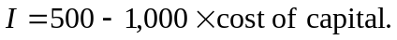
(a) Indicate some of the components of the cost of capital, and why they are costs.
(b) If the cost of capital is 10% each year, what is the equilibrium health investment in terms of units of capital? What is the equilibrium total investment expenditure? Explain both answers.
(c) If the cost per unit of health capital doubles to 20%, what will happen to the equilibrium level of health investment and to equilibrium health investment expenditures? Why?
10. Consider the obesity model where equation (7.7) refers to a daily obesity function. Suppose that Ed can either exercise 0 or 1 session per day, with µ = 300. If Ed substitutes one junk food meal (δ = 800) for a healthy meal (ε = 600) five days per week, how often per week will he have to exercise to avoid increasing S? Why?
New cites

Brunello, Giorgio and Béatrice D’Hombres, “Does body weight affect wages? Evidence from Europe,” Economics and Human Biology 5 (2007): 1–19.
Case, Meredith A., et. al. (Holland A. Burwick; Kevin G. Volpp, Mitesh S. Patel) , “Accuracy of Smartphone Applications and Wearable Devices for Tracking Physical Activity Data,” Journal of the American Medical Association 313(6) (2015) : 625-626. doi:10.1001/jama.2014.17841, accessed January 28, 2016
Cawley, John.. “An Economy of Scales: A Selective Review of Obesity’s Economic Causes, Consequences, and Solutions,” Journal of Health Economics 43 (2015): 244-268.
Cawley, John, et al. (Meyerhoefer, C., Biener, A., Hammer, M., Wintfeld, N.), “Savings in Medical Expenditures Associated with Reductions in Body Mass Index among U.S. Adults with Obesity, by Diabetes Status,” Pharmacoeconomics (2015), http://dx.doi.org/10.1007/s40273-014-0230-2.

Delete
Finkelstein and colleagues (2009)
Figure 7-1 Investing in Health Capital
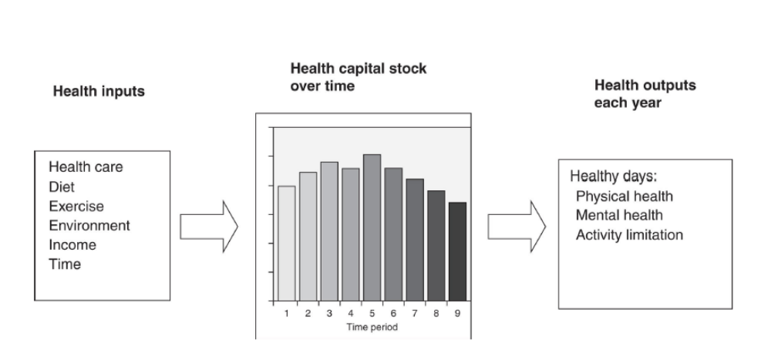

Figure 7-2 Labor–Leisure Trade-Off
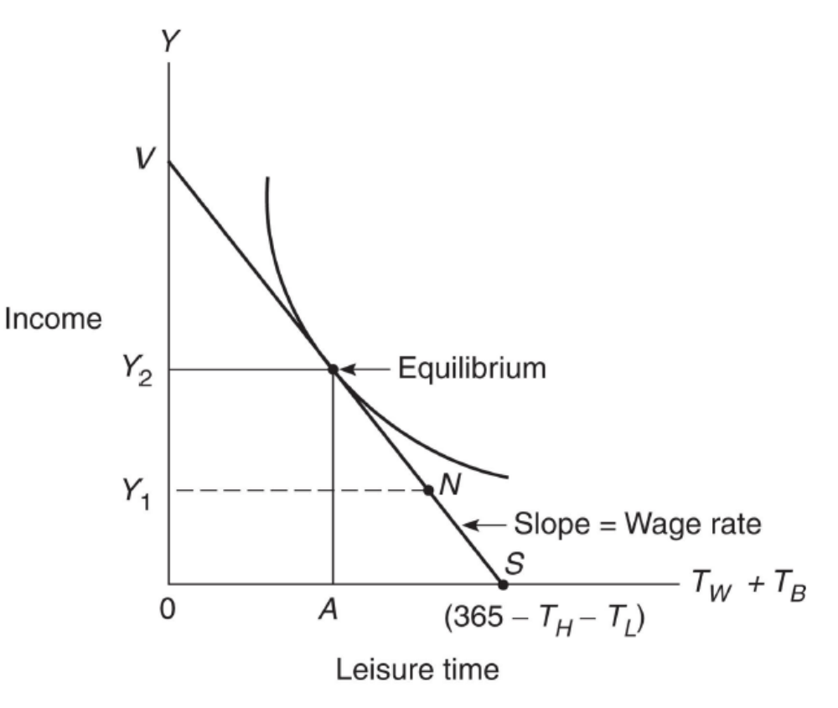
Figure 7-3 Increased Amount of Healthy Time Due to Investment
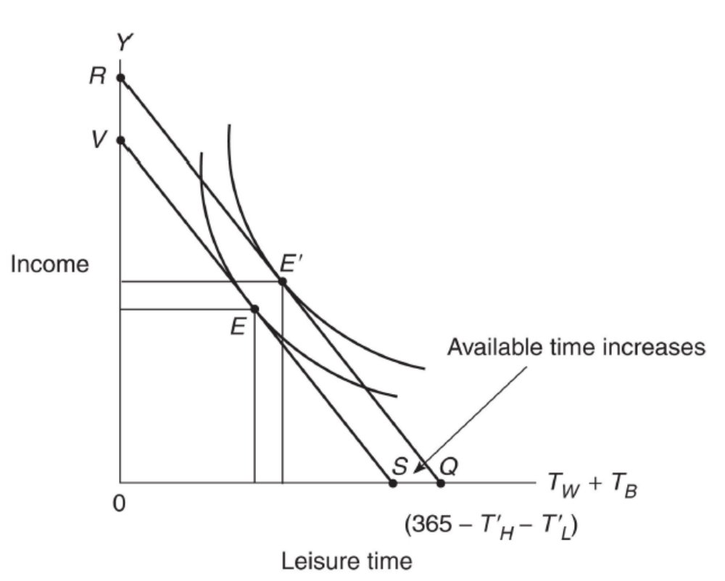
Figure 7-4 Relationship of Healthy Days to Health Stock
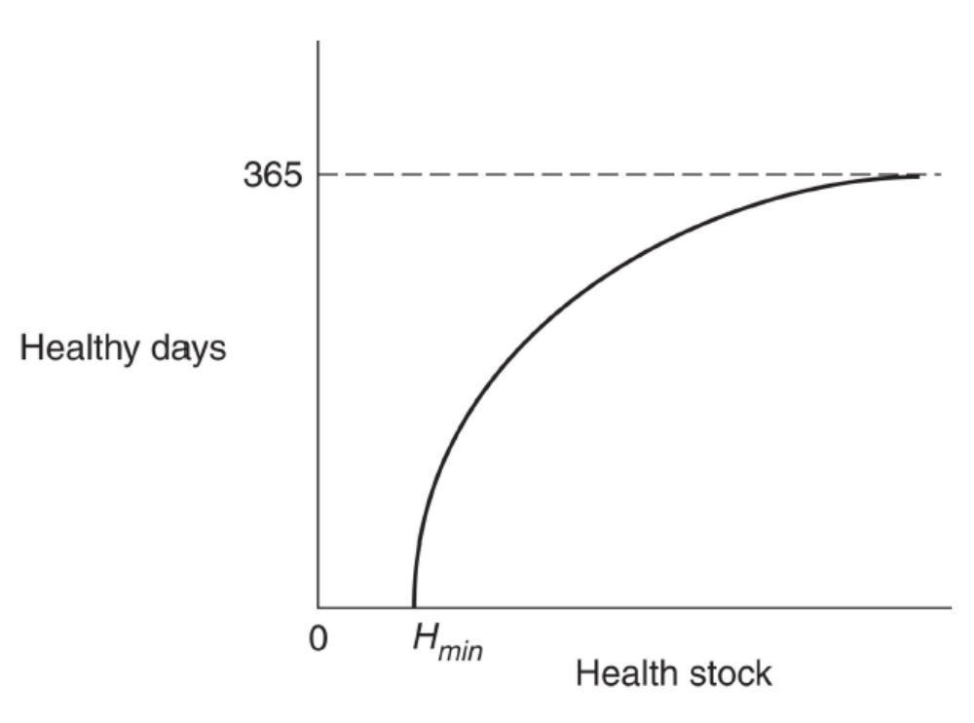
Figure 7-5 Allocation of Production Between Health and Bread
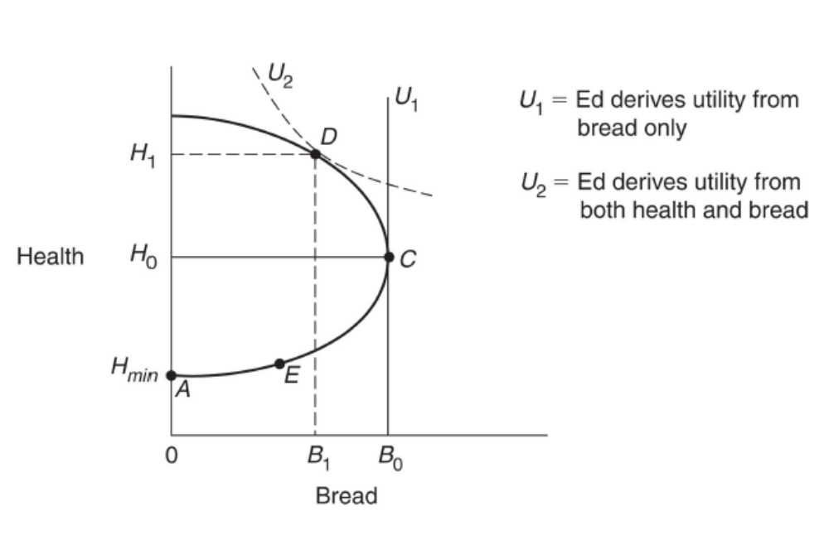
Figure 7-6 Optimal Health Stock

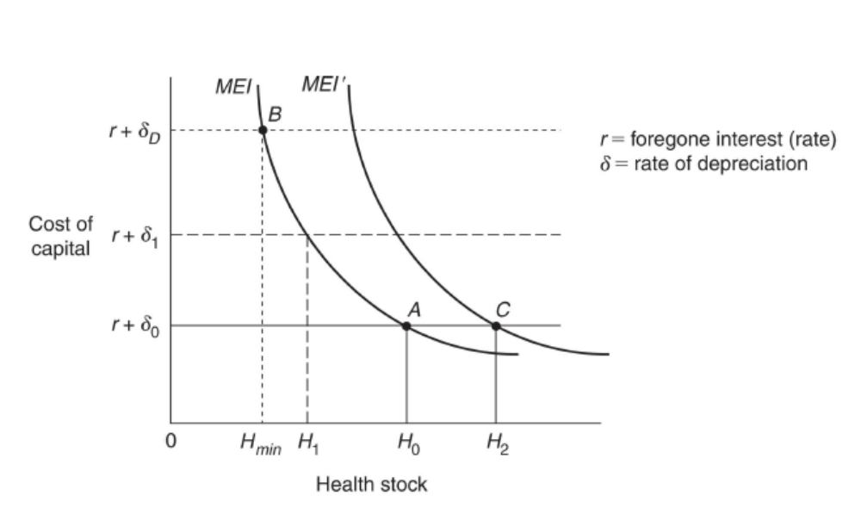

We ignore here income from nonwork efforts—for example, through returns to financial investments, such as saving, stock, or bonds.
Goodman, Stano, and Tilford (1999) provide a more detailed model addressing the production of health and home goods using both market goods, and people’s time.
This result may be ambiguous. Although an increased wage rate potentially increases the return to investment, it also represents an increased opportunity cost of time in producing health investment. If health investment has a large labor component, and wage rises, the MEI curve could shift downward, and it is possible that the equilibrium demand for health investment will fall.

